Course info

### 

#### **Level 1: YouTube Growth System**

**Start Here**:

* Begin with the intro videos to understand the system and decide where to go next.
* Watch videos in order without skipping or using 2x speed, this content is condensed for maximum impact.

Videos cover

1. How YouTube works
2. Positioning
3. Ideation
4. Strategy
5. Thumbnails + titles
6. Writing
7. Planning
8. Filming
9. Editing
10. Measurement

#### **Level 2: Business Growth System**

**Start after watching the level 1 intro videos if the option you select tells you to**:

Videos cover:

1. Building a business brain
2. Creating + optimising an offer
3. Email
4. Community wall
5. Outsourcing
6. Lead magnets
7. Sales systems
8. High ticket launch

#### **Other Courses**

* **Low-Ticket Course**: Learn how to launch simple products like 90-minute workshops.
* **Photoshop and Photography**:  
  + For creating professional thumbnails.
  + Includes lessons on product photography, lighting, and Photoshop basics.

### **3. Key Tools and Resources**

#### **Tasks Document (You’re in one now)**

* **Purpose**: Provides step-by-step instructions for completing specific tasks based on your goals.
* **How to Use**:
  + Identify your focus (e.g., ideation, thumbnails).
  + Follow the linked guides and checklists for each task.

#### **Guides and Checklists**

* **Examples**:
  + Thumbnail strategies and reminders.
  + Video planning templates.
  + Intro writing guides.
  + Storytelling, metaphors, and frameworks.

#### **AI and Prompts**

* **Available Prompts**: Hooks, transitions, story prompts, and metaphor templates.
* **AI Integration**: Use bots for instant feedback on intros, hooks, and scripts.

### **4. Live Calls and Recordings**

* **Purpose**: Weekly live calls provide real-time support and feedback.
* **Access**: Links and forms are available in the course platform under the live resources section.
* **Missed a Call?**: Recordings are uploaded and organized by date and topic for easy access.

### **5. Best Practices for Success**

#### **Stay Organized**

* Follow the course structure—don’t try to watch all videos at once.
* Use the tasks document to prioritize and focus on what matters most.

#### **Ask for Help**

* If you’re stuck, reach out in Discord or ask during live calls.

#### **Avoid Procrastination**

* Don’t spend weeks perfecting your setup—focus on creating and posting content.

#### **Be Patient**

* Results take time; focus on consistent effort and improvement.

START HERE

🚨 **START HERE**

**THIS DOCUMENT IS BEST USED ON DESKTOPS   
  
Step 1:**

* Watch the intro videos in level 1
* Sign up to Discord and introduce yourself
* Watch the productivity/motivation videos in level 1
* Set up your 10x YouTube time in your diary
* Devote a season to the tasks on your list
* Select from option 1-6 below

🏆 10x Goal: Complete the intro videos in Level 1 + set up diary time

**Step 2: Pick from the options below.**

* Once you have chosen the option that sounds most like you from below. Click on the “START HERE” drop down section on the left for your to do list and 10x tasks

🚨 If you have any confusion on which one to pick or just want confirmation you’re on the right track, ask for help in Discord. Don’t get overwhelmed and spend days mulling this over. We can get this decision made fast.

🏆 10x Goal: Pick an option *(please don't spend hours trying to make this decision, ask us for help if it's not instantly obvious where to start)*

**Less than 3,000 views per video**

* **OPTION 1:** Getting less than 3,000 views per video/no offer/no email list
* **OPTION 2:** Getting less than 3,000 views per video/ have an offer/no email list
* **OPTION 3:** Getting less than 3,000 views per video/no offer/have email list
* **OPTION 4:** Getting less than 3000 views per video/have an offer/have an email list

**More than 3,000 views per video:**

* **OPTION 5:** You are getting more than 3,000 views per video, have no offer or no email
* **OPTION 6:** You are getting more than 3,000 views per video, have an offer and no email list
* **OPTION 7:** You are getting more than 3,000 views per video, have no offer and have an email list
* **OPTION 8:**  You are getting more than 3,000 views per video/have an offer and an email

OPTION 1

## **10 X TASKS: Getting less than 3,000 views per video/ no offer/no email list**

[**Watch the explainer video here**](https://www.loom.com/share/7f43c2703d4a419fb9149164044c5830)

Does this sound like you? 👇🏼

* I have less than 3,000 views per video
* I have no offer/product/service
* I have no email list

If so, start on goal one below. Focus intensely on the tasks

**10x Goal 1: Watch & complete “Level one - The YouTube Growth System”**

* Don’t watch on 2x speed
* Take notes

🏆 10x Goal: Complete the level one content

**10x Goal 2: Produce your first 4 videos following the system**  
*(This will take you a while, it will get faster after the first round but if you can get this done in 30 days its a massive achievement)*

* Watch the YouTube Growth System Level 1 videos and follow tasks (*About 6 hours of videos)*
* Use the templates and checklists to stay on track
* Complete the tasks
* Use the Ai bots to help speed you up
* Get feedback and support as advised
* Produce your first 4 videos
* Start launching weekly

🏆10x Goal: Produce 4 videos following the system (don't strive for perfection), use the checklists and guides for each section to follow as instructions.

**10x Goal 3:** **Get to 1k views per video**

* Ready Fire Aim videos
* Try to launch one video a week consistently
* Follow the measurement system to learn and react
* Get feedback and support
* Keep producing videos in batches of 4 for maximum productivity

🏆10x Goal: Hit 1k views per video for at least 3 in a row (in the first 7 days of posting)

**10 x Goal 4**: **Build email sign up**

* Watch the email building content in level 2
* Build an email sign up page/lead magnet (lead magnet must be simple)
* Watch the email list promotion content
* Promote your list on the community wall, in your videos and in your description on a regular basis
* Focus on getting over 300 email subscribers + posting videos (This more videos is 10x)

🏆10x Goal: Get your email list to 300 email subscribers (before you email them)

🏆10x Goal: Keep posting videos (We want to get to 3,000 per videos for at least 5 in a row

**10x Goal 5: Start emailing your list**

* Hit 300 email subs
* Rewatch the level 2 email videos on how to write email
* Start sending weekly emails following the system
* Use the email templates, AI and checklists In the level 2 bank to help
* Promote emails before you send it
* Keep making videos and promoting your list

🏆10x Goal: Goal: Hit 1,000 email subs + 3,000 views per video

**10x Goal 6: Launch product**

* Hit 1,000 email subs + 3,000 views per video
* Watch the “building an offer” module
* Research your offer
* Follow high ticket or low ticket launch system (If you have another idea that isn't a workshop or program contact us)
* Launch offer
* Watch the “building a business brain” videos
* Build your business brain

🏆10x Goal: Launch your offer + Build your business brain

**10x Goal 7: The promised land**

Congratulations, you’re now in the promised land.

* Keep growing your email list
* Keep posting videos to generate more hot viewers
* Promote your product/service
* Improve your product or service
* Update your business brain data

🏆10x Goal: Generate views + emails + sales

In the promised land you work out your next 10x using your business brain, if everything is well optimised you just focus on views

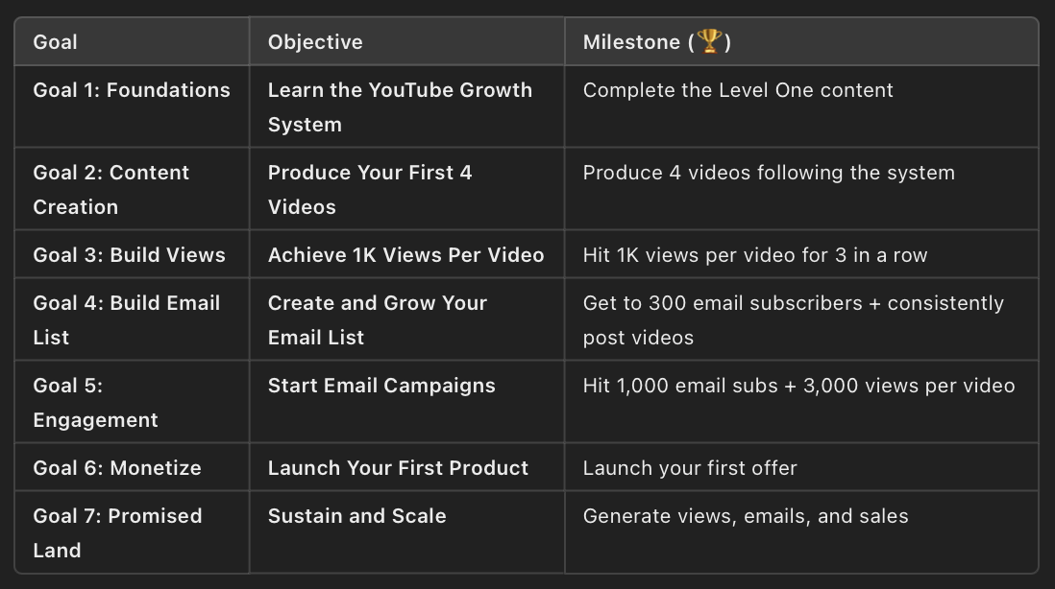

OPTION 2

### **10 X TASKS: Getting less than 3,000 views per video/ have an offer/no email list**

[**Watch the explainer video here**](https://www.loom.com/share/3f57aa279e8a431082bd90e3d1de3151)

If you do not have an offer or anything that is already making sales on a regular basis from outside of YouTube, DO NOT take this path.

“An offer” in this sense is established and making money. If you have an offer that isn't making money already and less than 3,000 views per video, do level 1.

* I have less than 3,000 views per video
* I have an offer/product/service
* I have no email list

### Start on goal one, when you complete a goal move to the next *If you have any confusion on which one to pick or just want confirmation you’re on the right track, ask for help in Discord.*

Focus intensely on these tasks until you achieve the final goal, nothing else matters

**Goal 1:** **Watch “Level 2 - The Business Growth System”**

* Watch the Level 2 intro videos
* Watch the “business brain” videos
* Complete your business brain for your offer’s funnel

🏆 10x Goal: Complete your business brain

**Goal 2: Optimise your funnel**  
Optimise the areas that didn't hit the benchmarks in your business brain

Low sales page conversion?

* Watch the offer formula video/pricing videos
* Send us your existing sales page for feedback
* Watch the sales page /VSL videos + action tasks to optimise
* Get feedback

Low traffic to sales page?

* Make sure your links are high and your CTA is clear on every video.

🏆10x Goal: Optimise your funnel

**Goal 3a Under 1,000 views per video? Do this:**

* Watch “Level 1- The YouTube Growth System
* Produce your first 4 videos
* Add sales page link under every video
* Follow video checklist
* Use the templates and checklists to stay on track
* Use the ai bots to help speed you up
* Get feedback and support as advised
* Start launching weekly + add links to sales page under each video
* Repeat until you hit 1,000 views per video
* Move on to 3b when complete

🏆10x Goal: Hit 1k views per video for at least 3 in a row (in the first 7 days of posting)

**Goal 3b Over 1,000 views per video? Start email list**

* Watch the email content in level 2
* Build an email sign up page/lead magnet (lead magnet must be simple)
* Watch the email list promotion content
* Promote your list on the community wall, in your videos and in your description on a regular basis
* Focus on getting over 300 email subscribers
* Keep making videos + add sales page link + email sign up under your videos

🏆10x Goal: Get to 300 email subscribers + post regular videos

**Goal 4: Weekly emails + Weekly videos**

* Rewatch the level 2 email videos on how to write email
* Use the email templates, AI and checklists In the level 2 bank
* Start sending weekly emails following the system
* Promote emails before you send it
* Keep making videos and promoting your list + offer

🏆10x Goal: Goal: Hit 1000 email subs + 3,000 views per video

**Goal 5: The promised land**

Congratulations, you’re now in the promised land.

* Keep growing your email list
* Keep posting videos to generate more hot viewers
* Promote your product/service
* Keep an eye on business brain data

🏆10x Goal: Make videos/grow your list/generate sales

**Goal 6: (Optional) Build a bigger product/service**

* Watch the content on coming up with an offer
* Follow the high ticket launch course

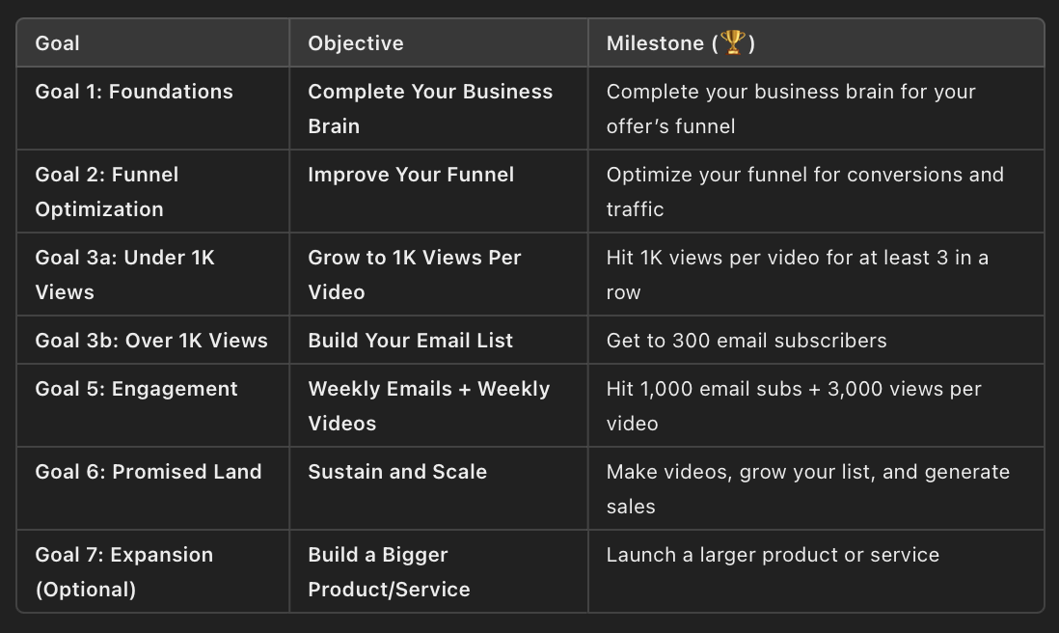

OPTION 3

### **10 X TASKS: Getting less than 3,000 views per video/no offer/have email list**

[**Watch the explainer video here**](https://www.loom.com/share/b3ab43c373544fc5b494ef8cdeb363fe)

* I have less than 3,000 views per video
* I have no offer/product/service
* I have an email list

### Start on goal one, when you complete it, move on to the next *If you have any confusion on which one to pick or just want confirmation you’re on the right track, ask for help in Discord.*

**Goal 1:** **Watch “Level 2 - The Business Growth System”**

* Watch the Level 2 intro videos
* Watch the “business brain” videos
* Complete your business brain section relevant to email

🏆 10x Goal: Complete your business brain for email

**Goal 2: Optimise your email sign up**  
Optimise the areas that didn't hit the benchmarks

* Watch the email module (LEVEL 2)
* Low email sign up conversion? Optimise sign up page
* Low traffic to email sign up? Make sure your links are high and your CTA is clear on every video.
* Get feedback on your work

🏆10x Goal: Optimise your email sign up

**Goal 3:** **Watch “Level one - The YouTube Growth System”**

* Don’t watch on 2x speed
* Ask questions

🏆 10x Goal: Complete the level one content

**Goal 4: Produce your first 4 videos following the system**   
  
*(This will take you a while, it will get faster after the first round but if you can get this done in 30 days its a massive achievement)*

* Follow the YouTube Growth System Level 1 video checklist to follow the system
* Use the templates and checklists to stay on track
* Use the ai bots to help speed you up
* Get feedback and support as advised
* Produce your first 4 videos
* Start launching weekly + add email sign up links

🏆10x Goal: Produce 4 videos following the system (don't strive for perfect)

**Goal 4:** **Get to 1k views per video + 300 email sign ups**

(If you already had more than 300 emails, move on to goal 5)

* Ready Fire Aim
* Try to launch one video a week
* Follow the measurement system to learn and react
* Get feedback and support
* Keep producing videos in batches of 4 for maximum productivity

🏆10x Goal: Hit 1k views per video for at least 3 in a row (in the first 7 days of posting) + 300 Email

**Goal 5: Weekly emails + Weekly videos**

* Keep producing videos in batches of 4 for maximum productivity
* Ready Fire Aim videos following the video system
* Try to launch one video a week
* Get feedback and support
* Send weekly emails following the system
* Promote emails before you send it
* Keep making videos and promoting your list

🏆10x Goal: Goal: Hit 1,000 email subs + 3,000 views per video

**Goal 6: Launch product**

* Watch the “building an offer” module
* Research your offer
* Follow high ticket or low ticket launch system (If you have another idea that isn't a workshop or program contact us)
* Launch offer
* Watch the “building a business brain” videos
* Build your business brain

🏆10x Goal: Launch your offer

**Goal 7: The promised land**

Congratulations, you’re now in the promised land.

* Keep growing your email list
* Keep posting videos to generate more hot viewers
* Promote your product/service
* Improve your product or service
* Update your business brain data

🏆10x Goal: Generate views + emails + sales

In the promised land you work out your next 10x using your business brain, if everything is well optimised you just focus on views

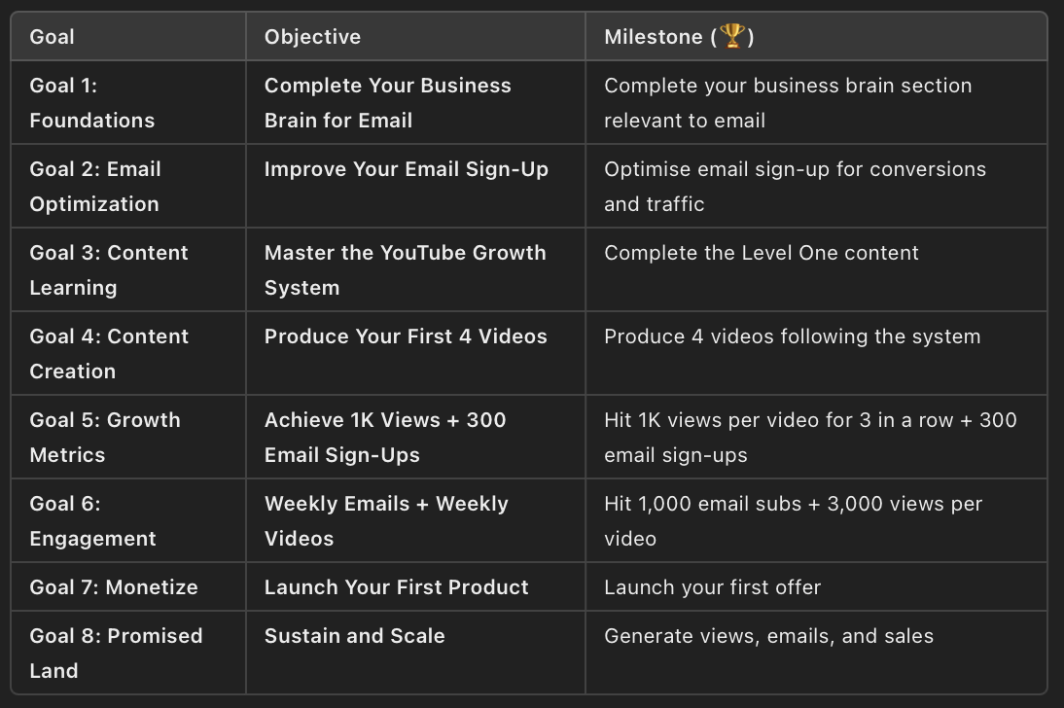

OPTION 4

# **10 X TASKS: Less than 3,000 views per video/have an offer/ have an email list**

* I have less than 3,000 views per video
* I have an offer/product/service
* I have an email list

*If you have any confusion on which one to pick or just want confirmation you’re on the right track, ask for help in Discord.*

Focus intensely on these tasks until you achieve the final goal, nothing else matters

**Goal 1:** **Watch “Level 2 - The Business Growth System” (Only videos listed)**

* Watch the Level 2 intro videos
* Watch the “business brain” videos
* Complete your business brain

🏆 10x Goal: Complete your business brain

**Goal 2: Optimise your funnel (If you don't have any traffic from YouTube yet, move on)**  
Optimise the areas that didn't hit the benchmarks

Low sales page conversion? Watch:

* The offer formula video/pricing videos (Offer module)
* Send us your existing sales page for feedback
* Sales page /VSL videos + action tasks to optimise
* Get feedback

Low email sign up conversion? Watch:

* Email module + action tasks to optimise sign up page
* Get feedback

Low traffic to sales page/email sign up?

* Make sure your links are high and your CTA is clear on every video.

🏆10x Goal: Optimise your funnel

**Goal 3: Watch “Level one - The YouTube Growth System”**

* Don’t watch on 2x speed
* Ask questions

🏆 10x Goal: Complete the level one content

**Goal 4:** **Produce your first 4 videos following the system**   
  
*(This will take you a while, it will get faster after the first round but if you can get this done in 30 days its a massive achievement )*

* Follow the YouTube Growth System Level 1 video checklist to follow the system
* Use the templates and checklists to stay on track
* Use the ai bots to help speed you up
* Get feedback and support as advised
* Produce your first 4 videos
* Start launching weekly
* Promote your email/service inside the videos

🏆10x Goal: Produce 4 videos following the system (don't strive for perfect)

**Goal 5: Repeat until you hit 3,000 views per video**

* Keep posting videos
* Hit 3,000 views per video

🏆10x Goal: 3,000 views per video

**Goal 6: The promised land**

Congratulations, you’re now in the promised land.

* Keep growing your email list
* Keep posting videos to generate more hot viewers
* Promote your product/service
* Improve your product or service
* Update your business brain data

🏆10x Goal: Generate views + emails + sales

In the promised land you work out your next 10x using your business brain, if everything is well optimised you just focus on views

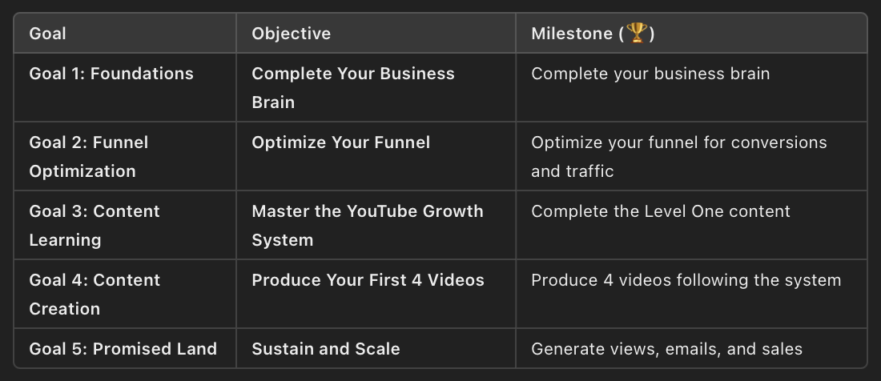

OPTION 5

### **10 X TASKS: Getting more than 3000 views per video/no offer/no email list** [**Watch the explainer video here**](https://www.loom.com/share/87ae60c7eb1245fbb8fb7b844078d090)

* I have more than 3,000 views per video
* I have no offer/product/service
* I have no email list

*If you have any confusion on which one to pick or just want confirmation you’re on the right track, ask for help in Discord.*

Focus intensely on these tasks until you achieve the final goal, nothing else matters

**Goal 1:** **Watch “Level 2 - Intro videos”**

* Watch the Level 2 intro videos

🏆 10x Goal: Understand how YouTube works to make money

**Goal 2**: **Build email sign up**

* Watch the email content in level 2
* Build an email sign up page/lead magnet (lead magnet must be simple if opted for)
* Promote your list on the community wall, in your videos and in your description on a regular basis

🏆10x Goal: Build email sign up

**Goal 3:** Watch “Level one - The YouTube Growth System”

* Don’t watch on 2x speed
* Ask questions

🏆 10x Goal: Complete the level one content

**Goal 4:** Produce your first 4 videos following the system

* Follow the YouTube Growth System Level 1 video checklist to follow the system
* Revisit videos at each section to re-train
* Use the templates and checklists to stay on track
* Use the ai bots to help speed you up
* Get feedback and support as advised
* Produce your first 4 videos
* Drive people to your email
* Start launching weekly videos + promote your email

🏆10x Goal: Produce 4 videos following the system (don't strive for perfect)

**Goal 5: Hit 300 email subscribers? Start emailing your list**

* Rewatch the level 2 email videos on how to write email
* Use the email templates, AI and checklists In the level 2 bank to help
* Start sending weekly emails following the system
* Promote emails before you send it
* Keep making videos and promoting your list

🏆10x Goal: Goal: Hit 1,000 email subs + 3,000 views per video

**Goal 6: Launch product**

* Once you have over 1,000 email subs, watch the “building an offer” module
* Research your offer
* Follow high ticket or low ticket launch system (If you have another idea that isn't a workshop or program contact us)
* Launch offer
* Watch the “building a business brain” videos
* Build your business brain

🏆10x Goal: Launch your offer

**Goal 7: The promised land**

Congratulations, you’re now in the promised land.

* Keep growing your email list
* Keep posting videos to generate more hot viewers
* Promote your product/service
* Improve your product or service
* Update your business brain data

🏆10x Goal: Make videos/grow your list/generate sales

In the promised land you work out your next 10x using your business brain, if everything is well optimised you just focus on views

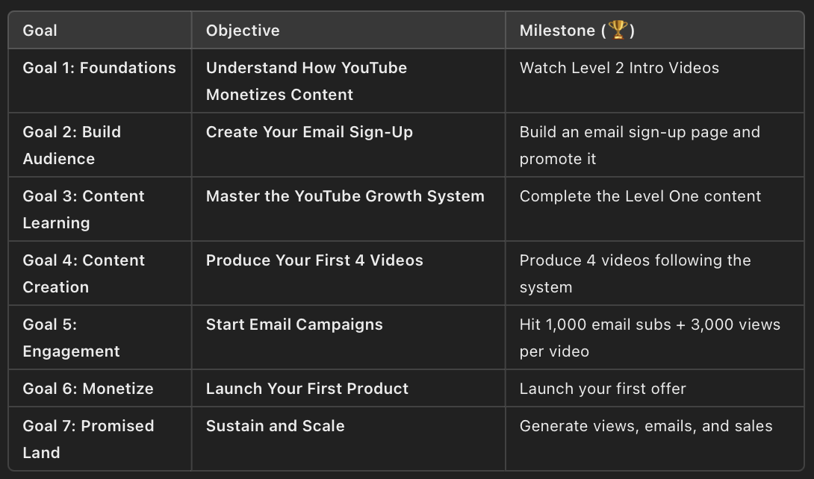

OPTION 6

### **10 X TASKS: Getting more than 3,000 views per video/ have an offer/no email list**

* I have more than 3,000 views per video
* I have an offer/product/service
* I have no email list

### Start on goal one, when you complete a goal move to the next *If you have any confusion on which one to pick or just want confirmation you’re on the right track, ask for help in Discord.*

Focus intensely on these tasks until you achieve the final goal, nothing else matters

**Goal 1:** **Watch “Level 2 - The Business Growth System”**

* Watch the Level 2 intro videos
* Watch the “business brain” videos
* Complete your business brain for your offer’s funnel

🏆 10x Goal: Complete your business brain

**Goal 2: Optimise your funnel**  
Optimise the areas that didn't hit the benchmarks in your business brain

Low sales page conversion?

* Watch the offer formula video/pricing videos
* Send us your existing sales page for feedback
* Watch the sales page /VSL videos + action tasks to optimise
* Get feedback

Low traffic to sales page?

* Make sure your links are high and your CTA is clear on every video.

🏆10x Goal: Optimise your funnel

**Goal 3 Start email list**

* Watch the email content in level 2
* Build an email sign up page/lead magnet (lead magnet must be simple)
* Watch the email list promotion content
* Promote your list on the community wall, in your videos and in your description on a regular basis
* Focus on getting over 300 email subscribers

🏆10x Goal: Get email subscribers + post regular videos

**Goal 4: Weekly emails**

* Rewatch the level 2 email videos on how to write email
* Use the email templates, AI and checklists In the level 2 bank
* Start sending weekly emails following the system
* Promote emails before you send it
* Keep making videos and promoting your list + offer

🏆10x Goal: Goal: Hit 1000 email subs + 3,000 views per video

**Goal 5: Watch & complete “Level one - The YouTube Growth System”**

* Don’t watch on 2x speed
* Take notes

🏆 10x Goal: Complete the level one content

**Goal 6: Produce your first 4 videos following the system**  
*(This will take you a while, it will get faster after the first round but if you can get this done in 30 days its a massive achievement)*

* Watch the YouTube Growth System Level 1 videos and follow tasks (*About 6 hours of videos)*
* Use the templates and checklists to stay on track
* Complete the tasks
* Use the Ai bots to help speed you up
* Get feedback and support as advised
* Produce your first 4 videos
* Start launching weekly

🏆10x Goal: Produce 4 videos following the system (don't strive for perfection), use the checklists and guides for each section to follow as instructions.

**Goal 6: The promised land**

Congratulations, you’re now in the promised land.

* Keep growing your email list
* Keep posting videos to generate more hot viewers
* Promote your product/service
* Keep an eye on business brain data

🏆10x Goal: Make videos/grow your list/generate sales

**Goal 7: (Optional) Build a bigger product/service**

* Watch the content on coming up with an offer
* Follow the high ticket launch course



OPTION 7

# **10 X TASKS: Getting more than 3,000 views per video/ no offer/ have an email** [**Watch the explainer video here**](https://www.loom.com/share/974349aad8e94832b4d50e66fe1a4251)

* I have more than 3,000 views per video
* I have no offer/product/service
* I have an email list

*If you have any confusion on which one to pick or just want confirmation you’re on the right track, ask for help in Discord.*

Focus intensely on these tasks until you achieve the final goal, nothing else matters

**Goal 1:** **Watch “Level 2 - The Business Growth System”**

*You don't need to watch every video, just the ones listed below*

* ~~Watch the Level 2 intro videos~~
* Watch the “business brain” videos
* Complete your business brain but just the data relevant to email

🏆 10x Goal: Complete your business brain for email

**Goal 2: Optimise your email**  
Optimise the areas that didn't hit the benchmarks

* Low email sign up conversion? Watch the email sign up page video + action tasks
* Low traffic to email sign up? Make sure your links are high and your CTA is clear on every video.
* Get feedback on your work
* Watch the videos on writing emails and action any relevant tasks
* Promote your email via community wall + videos
* Promote every email via community wall

🏆10x Goal: Optimise your email sign up

**Goal 3a: If you have less than 1,000 emails, Watch “Level one - The YouTube Growth System” + post videos**

*(This will take you a while, it will get faster after the first round of 4 videos but if you can get this done in 30 days its a massive achievement )*

* Don’t watch on 2x speed
* Ask questions
* Follow the YouTube Growth System Level 1 video checklist to follow the system
* Use the templates and checklists to stay on track
* Use the ai bots to help speed you up
* Get feedback and support as advised
* Produce your first 4 videos
* Start launching weekly

🏆10x Goal: Produce 4 videos following the system + get 1,000 emails

**Goal 3b: If you have more than 1,000 emails, build an offer:**

* Watch the “building an offer” module
* Research your offer
* Follow high ticket or low ticket launch system (If you have another idea that isn't a workshop or program contact us)
* Launch offer (You might want to post a few videos in the run up to this)
* Watch the “building a business brain” videos
* Build your business brain

🏆10x Goal: Launch your offer

**Goal 4: The promised land**

Congratulations, you’re now in the promised land.

* Keep growing your email list
* Keep posting videos to generate more hot viewers
* Promote your product/service
* Improve your product or service
* Update your business brain data

🏆10x Goal: Make videos/grow your list/generate sales

In the promised land you work out your next 10x using your business brain, if everything is well optimised you just focus on views

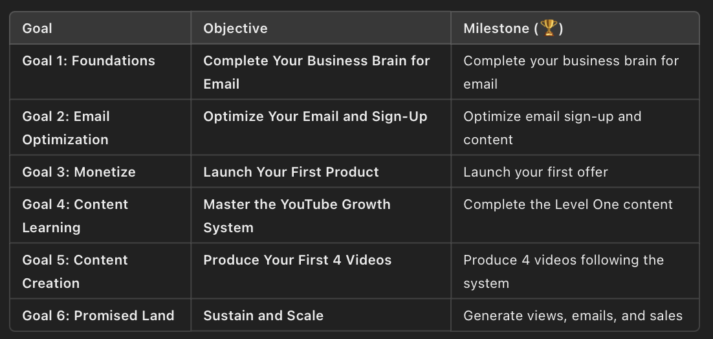

OPTION 8

# **10 X TASKS: More than 3,000 views per video/have an offer and an email** [**Watch the explainer video here**](https://www.loom.com/share/014c5e2c454b429187ab2fe1c1a22b3d)

* ~~I have more than 3,000 views per video~~
* ~~I have an offer/product/service~~
* ~~I have an email list~~

*If you have any confusion on which one to pick or just want confirmation you’re on the right track, ask for help in Discord.*

Focus intensely on these tasks until you achieve the final goal, nothing else matters

**Goal 1:** **Watch “Level 2 - The Business Growth System” (Only videos listed)**

* ~~Watch the Level 2 intro videos~~
* Watch the “business brain” videos
* Complete your business brain

🏆 10x Goal: Complete your business brain

**Goal 2: Optimise your funnel**  
Optimise the areas that didn't hit the benchmarks

Low sales page conversion? Watch:

* The offer formula video/pricing videos (Offer module)
* Send us your existing sales page for feedback
* Sales page /VSL videos + action tasks to optimise
* Get feedback

Low email sign up conversion? Watch:

* Email module + action tasks to optimise sign up page
* Get feedback

Low traffic to sales page/email sign up?

* Make sure your links are high and your CTA is clear on every video.

🏆10x Goal: Optimise your funnel

**Goal 3: Watch “Level one - The YouTube Growth System”**

* Don’t watch on 2x speed
* Ask questions

🏆 10x Goal: Complete the level one content

**Goal 4: Produce your first 4 videos following the system**   
  
*(This will take you a while, it will get faster after the first round but if you can get this done in 30 days its a massive achievement )*

* Follow the YouTube Growth System Level 1 video checklist to follow the system
* Use the templates and checklists to stay on track
* Use the ai bots to help speed you up
* Get feedback and support as advised
* Produce your first 4 videos
* Start launching weekly
* Promote your email/service inside the videos

🏆10x Goal: Produce 4 videos following the system (don't strive for perfect)

**Goal 5: The promised land**

Congratulations, you’re now in the promised land.

* Keep growing your email list
* Keep posting videos to generate more hot viewers
* Promote your product/service
* Improve your product or service
* Update your business brain data

🏆10x Goal: Generate views + emails + sales

In the promised land you work out your next 10x using your business brain, if everything is well optimised you just focus on views



Complete Video System

**Complete Video System  
  
ONLY USE THIS AFTER COMPLETING THE COURSE**

* This document will walk you through everything you need to tick off every time you make a video.
* Come back to this any time you want to make a video
* Complete the Level 1 Content + Tasks before using it
* Use the recommended assets in each section to remind you of how each section works
* Before asking for feedback on anything, tick off each box to ensure common mistakes are not made and you save yourself time

### **Step 1: Find an idea**

* Raid YouTube or your pattern bank for outliers
* Pick an idea
* Does it relate to the top of your umbrella?

**Assets to use:**

* **Ideation section: Build dummy account**
* **Ideation section: Patten bank set up**
* **Ideation section: Ideation from pattern bank**

### **Step 2: Construct 4 titles based on the outliers for 4 new videos**

* Is your title under 50 characters?
* Does it have plenty of BENS?
* Is it based on outliers?
* Does it appeal to the top of your umbrella?
* Are there any words that could put off a viewer?
* Have you avoided using a colon in the title? (Ai always adds these, please avoid)

**Assets to use:**

* **Ideation section: Ideation from pattern bank**
* **Ideation section: Title bank**
* **Title Writing Guide**

### **Step 3: Create 3 draft thumbnails for 4 videos**

[Click me for thumbnail strategies](https://app.milanote.com/1T67YZ1Mm4WUc9?p=m24YFl8Nuyc)

* Doodle 3 different strategies
* Doodle 3 versions of each thumbnail strategy
* Screen shot and add to vision board with outlier inspiration

**Assets to use:**

* **Thumbnail section: Thumbnail Creation Process**
* **Ideation section: Ideation from pattern bank**
* **Thumbnail section: How to get a click**
* **Thumbnail section: Thumbnail Strategy**

### **Step 4: Get feedback on thumbnail and title**

⚠️ Before submitting for feedback, tick off the below.Are your thumbnail drafts based on outliers?

* Do they create curiosity?
* Do they have a clear hero?
* Do they give context to the topic?
* Do they appeal to the top of your umbrella?
* Have you added them to a vision board with the outliers

**Assets to use:**

* **Ideation section: Ideation from pattern bank**
* **Thumbnail section: How to get a click**
* **Thumbnail section: Thumbnail Strategy**
* **Thumbnail section: Thumbnail Creation Process**

### **Step 5: Turn doodles in to complete images**

* Make your thumbnails using AI, photos and or Photoshop

**Assets to use:**

* **Ideation section: Ideation from pattern bank**
* **Thumbnail section: How to get a click**
* **Thumbnail section: Thumbnail Strategy**
* **Thumbnail section: Thumbnail Creation Process**
* **AI section: Thumbnail Bot**

### **Step 6: Submit for final feedback**

⚠️ Before submitting for feedback, tick off the below to avoid common mistakes that slow down your workflow.

###### **Click me to tick off the common thumbnail mistakes**

* Click me to make sure you’re not making common design mistakes
* Your image isn't cluttered or over crowded?
* Your text has spaces around its edges so it's not rammed to the side?
* Is the gap between two lines of text too big? Keep text tight.
* Is anything in your image pulling attention away from the hero?
* What do you notice first? If it's not the hero, fix.
* Is there a lot of empty space in the image?
* Is anything important in the bottom right corner being blocked by the time stamp?
* Have you limited the text to no more than 4 words?
* Is the background overcrowded and stealing attention from other elements?
* Are you making an over the top expression? If so swap for a more authentic look

**Assets to use:**

* **Ideation section: Ideation from pattern bank**
* **Thumbnail section: How to get a click**
* **Thumbnail section: Thumbnail Strategy**
* **Thumbnail section: Thumbnail Creation Process**

### **Step 7: Skyscraper (Plan your videos)**

* Find one outlier on the topic
* Watch it and note down what they talk about
* Paste the script + up to 200 comments in to [**Skyscraper Bot**](https://chatgpt.com/g/g-WB8ISCLFq-skyscraper-bot)
* Plan the content of your video. Include what they spoke about, add something new & find interesting, simple ways to present your information
* Order the plan

**Assets to use**

* **Writing section: How to skyscraper**
* **Writing section: Wireframe plan**
* **Ai section: Skyscraper Bot**

### **Step 8: Write an intro (work on one video at a time)**

**Click me to tick off the common intro mistakes**

* Have you completed your packaging BEFORE you write your intro?
* Is your intro around 15 seconds long?
* Does it contain lots of BENS?
* Does the intro make it clear what massive value they’ll gain from the video?
* Have you tried to add something to raise your credibility?
* Does your intro relate to the thumbnail and title so viewers don't feel clickbaited?
* Have you used the AI bot for feedback?
* Submit your intro for feedback

**Assets to use**

* **Writing templates: Intro Brick**
* **Ai Bot Instructions: Intro Bot**

### **Step 9: Write your script**

* Write your draft and get to the end fast
* Edit each brick in the middle
* Use Point Bot for each bricks feedback
* Edit the end screen
* Final edit, ready through out loud and adjust
* Move on to the next script

**Assets to use**

* **Writing templates: Middle Brick**
* **Ai Bot Instructions: Point Bot**

⚠️ **Things to check in your script before submitting for feedback**

* Have you paid off everything you set up?
* Have you paid off any points too early?
* Have you used transitions between points?
* Do the transitions make it clear what the big problem/result the viewers will get is if they listen to the next point?
* Have you used the same word multiple times in close proximity?
* Have you used complex words/jargon/industry terms instead of simple ones (AI Adds these)
* If you used metaphors, did they align with the point you're making?
* Is your metaphor simple? (metaphors that need way too much explanation make things harder to understand)
* Have you given an example after the payoff? This will make viewers bored
* Have you told the viewer you’re going to tell them a story without making it clear why they need to listen?   
    
  EG BAD “To understand, I need to tell you a story about…”   
    
  EG GOOD “ To understand im going to show you how to overcome this problem the fastest way possible”

### **Step 10: Film (Click me for pre production check list)**

* Batch film 3/4 scripts

**Assets to use**

* **Filming Checklist**

### **Step 11: Edit**

* Batch edit 3/4 videos
* Send to editor

**Assets to use**

* **Editing checklist**
* **Outsourcing: Editor workflow (Level 2)**

### **Step 12: Upload**

* Upload and schedule videos

**Assets to use**

* **Launching & Measurement:Upload checklist**

### **Step 13 Measurement**

Learn from your results

**Assets to use**

* **Launching & Measurement:Upload checklist**
* **Launching & Measurement: Understanding Data**

Productivity/Mindset

**Productivity/ Mindset index**

In this section there are written guides to show you how YouTube works.

Select them from the drop down.

**1. 10x Tasks 101** - Understanding 10x tasks and why they matter

**2.Get Productive -** The productivity system to get more done  
  
**3. Stay Motivated** - How to not let the big tasks ahead of you destroy your head space

**4. The Staircase Of Pain -** Set your expectations and learn to deal with hate

**🏆 10x Tasks:**

* Watch Intro videos
* Carve out 10x time in your diary
* Set a yearly goal
* Commit to a 90 day season

10X Tasks 101

### **10x Tasks 101 Understanding 10x tasks**

Success on YouTube (and beyond) comes from focusing on **10x tasks**—the activities that deliver results 10x faster than others. Here's how to identify and prioritize these tasks, avoid distractions, and achieve faster results.

### **What Are 10x Tasks?**

* **10x Tasks:** Activities that deliver massive results and move you closer to your goals.
* **2x Tasks:** Tasks that feel productive but deliver only marginal results.
* **-10x Tasks:** Time-wasters that take energy without contributing to growth.
* **Life Crap Tasks:** Necessary but unrelated to your goals (e.g., errands, emails).

By focusing only on **10x tasks** and eliminating or outsourcing everything else, you’ll achieve faster results, even if you’re not working full-time.

### **Why 10x Tasks Are Critical**

* Splitting focus across 2x, -10x, and life tasks slows progress.
* Success comes from intense focus on **one priority goal** at a time, not juggling multiple goals.

### **Simmie’s 10x Example**

1. **Start with Audience Growth:**Simmie focused on creating YouTube videos and building her email list. This was her 10x task.
2. **Shift to Monetization:**Once she had enough views and email subscribers, she created and promoted a low-ticket product to quit her job.
3. **Build a High-Ticket Program:**She took 6 months off YouTube to develop and run a high-ticket program, which sold out.
4. **Return to YouTube:**With more knowledge about her audience, Simmie resumed creating videos that resonated even more, rebuilding her pipeline with a deeper understanding of her viewers.

Get Productive

### **Get Productive Productivity: Maximize Your Output and Achieve Your Goals**

This guide will help you structure your time, focus on what truly matters, and sustain long-term productivity while avoiding burnout. Follow these steps to create a clear, actionable plan for getting more done.

### **Step 1: Define Your Priorities (10x Tasks)**

* **10x Tasks:** Focus on the activities that will have the biggest impact on your goals. These should align with your long-term objectives and yield significant results. (You will have selected them from one of the 6 options)
* Ignore or minimize everything else

### **Step 2: Find and Block Time**

1. **Identify Available Time:**
   * Assess your schedule and locate blocks of free time. This may involve making sacrifices (e.g., waking up earlier, reducing screen time).
   * Example: Ed found 31 hours weekly by cutting back on leisure activities and restructuring   
     his day.
2. **Sacred 10x Time:**
   * Block out your most productive hours for 10x tasks in your calendar.
   * Treat this time as untouchable: no emails, calls, or distractions.
3. **Batch Tasks:**
   * Group similar tasks together to maintain focus and efficiency:  
     + Ideate 4 video concepts in one session.
     + Write all scripts before filming.
     + Batch film multiple videos to save setup time.
     + Edit or upload all videos in a single session.

### **Step 3: Plan Weekly and Daily Tasks**

1. **Weekly Planning:**
   * List 3–4 key tasks for the week that directly contribute to your 10x goal.
   * Avoid overloading yourself; focus on achievable priorities.
2. **Daily Focus:**
   * Maintain a simple task list for the day.
   * When distracted or unsure what to do, return to the list.

### **Step 4: Work in 90-Day Seasons**

* **Why Seasons Work:**
  + Break large projects into focused 90-day periods to maintain momentum and motivation.
  + Example: Launching a new product or growing a YouTube channel.
* **Seasonal Structure:**
  + Dedicate full focus to a single goal for the season.
  + Reduce or pause other commitments (e.g., additional projects, email responses, podcasts).
  + After the season, take a brief rest period before starting the next.

### **Step 5: Eliminate Distractions**

1. **Phone and Social Media:**
   * Remove distracting apps like Instagram or Facebook.
   * Limit time spent on short-form video content to improve focus.
2. **Environment:**
   * Create a workspace that minimizes distractions.
   * Use tools like website blockers if needed.

### **Step 6: Set Annual Goals**

1. **Write Your Yearly Objectives:**
   * Define what you want to achieve in the next 12 months.
   * Include financial, professional, and personal goals.
2. **Align with 90-Day Seasons:**
   * Plan your seasons around these yearly goals.
   * Example: "Grow YouTube channel to 200k subscribers" → Season 1: Consistent content creation → Season 2: Product launch.

### **Step 7: Deal with Overwhelm**

* **Simplify:** Focus on one major task at a time. Avoid jumping between unrelated activities during a single session.
* **Ready, Fire, Aim:** Start even if conditions aren’t perfect. Life happens—there’s never a perfect time to begin.

### **Step 8: Maintain Balance**

* **Prevent Burnout:**
  + Use weekends or specific times to recharge.
  + Reward yourself after completing big projects.
* **Social Support:**
  + Find accountability buddies or mentors to share wins, challenges, and feedback.
  + Join a community of like-minded individuals to stay motivated.

### **Weekly Checklist**

1. **Time Blocking:**
   * Schedule daily 10x task sessions.
   * Include buffer time for unexpected events.
2. **Task Planning:**
   * Write down 3–4 weekly tasks that align with your goals.
   * Create a daily "Today" list for focused work.
3. **Batch Workflow:**
   * Group similar tasks to maintain focus.
4. **Evaluate Progress:**
   * Review achievements at the end of each week.
   * Adjust plans for the following week as needed.

### **Monthly/Seasonal Checklist**

1. **Review Annual Goals:**
   * Ensure your current focus aligns with your yearly objectives.
2. **Plan 90-Day Seasons:**
   * Select a single focus for the season.
   * Eliminate or pause other commitments.
3. **Evaluate Results:**
   * Reflect on what worked and what didn’t.
   * Make adjustments for the next season.

### **Key Reminders**

* **Sacrifice for Short-Term Growth:** Allocate as much time as possible to your 10x tasks. Progress depends on consistent effort.
* **Stick to the System:** Follow your weekly plan and avoid adding extra tasks.
* **Embrace Imperfection:** There will never be a perfect time—start now and adapt as needed.

By consistently applying this system, you’ll maximize productivity, stay focused on what matters, and achieve your goals faster.

Stay Motivated

### **Stay Motivated How to Stay Motivated When Everything Feels Sh*t**

Motivation often wanes when things take longer than you expected or don’t go as planned. That means you are going to want to quit YouTube and business on a regular basis.   
  
Here’s how to keep going at the worst of time

### **1. Shift Your Mindset: Be Your Own Team**

* **Support Yourself:** Imagine you’re on a team. When someone misses a shot, the team encourages them to try again. Do the same for yourself.
* **Stop Self-Criticism:** If things go wrong, resist the urge to beat yourself up. Remember, your job as a "team of one" is to support, not tear down.

### **2. Turn Pain Into Progress**

* **Find the Upside:** When things go wrong, ask, “What good came out of this?”  
  + Example: A setback (e.g., illness, burnout) could teach you new efficiency strategies or highlight areas for improvement.
* **Learn and Adapt:** Every failure offers lessons. Use the pain to identify mistakes and adjust your approach. Over time, solving these problems leads to exponential growth.

### **3. Reframe Challenges**

* **Embrace Mistakes:** Progress often feels slow because it’s a process of identifying and fixing problems. This is normal.
* **Big Goals Are Built on Small Wins:** Focus on the lessons from each setback rather than the big picture when feeling overwhelmed.

### **4. Push Through the “I Don’t Want To” Moments**

* **Overcome Resistance:**
  + Start immediately. Often, the thought of a task is worse than the task itself.
  + After 15 minutes of working on something, you’ll likely forget you didn’t want to do it.
* **Use Pain as a Driver:**
  + Tell yourself, “Nobody else would push through this. If I keep going, I’ll achieve what others won’t.”

### **5. Raise the Stakes**

* **Public Accountability:**
  + Announce a deadline publicly or set a high-stakes goal.
  + Example: Set a launch date for a product or video and commit to it.
* **High-Stakes Motivation:**
  + Tie progress to significant outcomes. For example, delaying a project might directly impact your income or opportunities.

### **6. Build Resilience**

* **Flip the Narrative:**
  + When things go wrong, shift focus to what you can control and learn.
  + Example: A flopped video isn’t failure—it’s data for improvement.
* **Celebrate Small Wins:**
  + Acknowledge even minor progress. This builds momentum and reinforces positive habits.

### **Quick Motivation Hacks**

1. **Ask Yourself:**
   * “What would I tell a teammate if they were in my situation?”
   * “What can I learn from this?”
2. **Take the First Step:** Start working on a dreaded task for 5 minutes. Momentum will likely carry you forward.
3. **Focus on the Long Game:** Remind yourself that most people quit when things get tough. Pushing through tough moments sets you apart.

### **7. Understand the Reality of Big Goals**

* **Mistakes Are Part of the Process:** Building something significant involves constant trial and error.
* **Stay the Course:** Remember that temporary sacrifices (time, energy) are investments in long-term freedom and success.

### **Next Steps**

* Revisit your goals and remind yourself why they matter.
* Identify one actionable task you can do today, even if it’s small.
* Commit to a daily routine where you spend focused time on your priorities, no matter how you feel.

When everything feels overwhelming, remember: success isn’t about never failing; it’s about turning every failure into fuel for growth. Keep moving forward, you’ve got this.

The Staircase of Pain

# **The Staircase of Pain**

YouTube and business growth is not a smooth, linear journey.   
  
Instead, it’s a series of highs and lows that can be mentally and emotionally exhausting. This guide breaks down how to navigate these challenges, protect your mental health, and stay focused on long-term success.

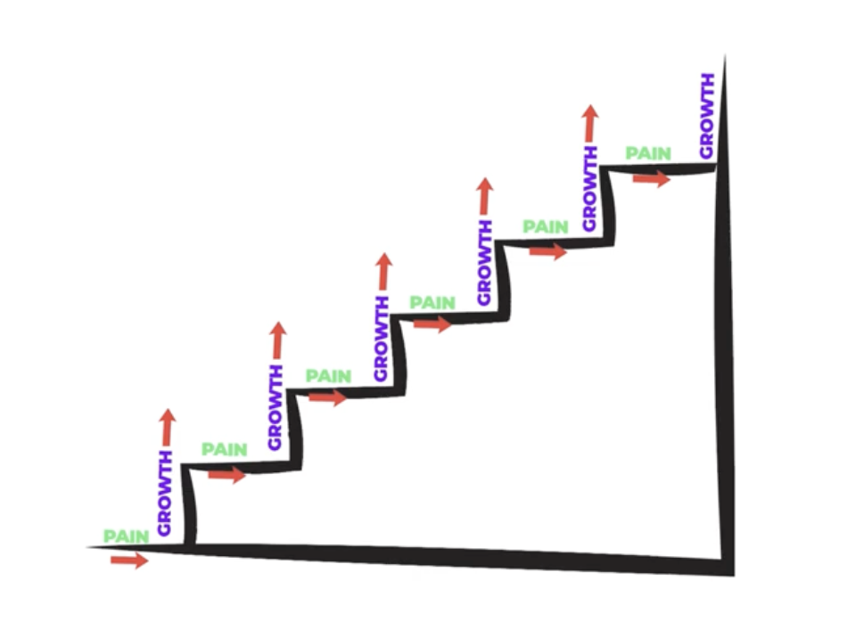

### **1. Understanding the Staircase of Pain**

* **The Reality of Growth:**
  + Growth happens in steps: long periods of stagnation followed by brief spurts of success.
  + Each "step" resets your expectations. A 1,000-view video feels great until your baseline grows to 10,000, then 50,000.
  + This constant resetting creates a cycle of dissatisfaction, even during times of success.
* **Key Insight:**
  + Most of your time on YouTube will feel like you're failing. The true challenge is enduring these periods and staying consistent.

### **2. Reframe the Lows**

* **Every Flop Is a Lesson:**
  + Ask: *“Why did this flop?”*
  + Use each “failure” as an opportunity to refine your strategy.
* **Be a Student of YouTube:**
  + Early on, accept that you’re learning. Allow yourself to make mistakes without judgment.

### **3. Avoid the Comparison Trap**

* **Focus on Your Goals, Not Others’:**
  + Views are public, but they don't reflect someone's income or business success.
  + Example: Some creators with fewer views earn more because they focus on business rather than chasing metrics.
* **The Pitfall of Envy:**
  + Comparing yourself to faster-growing creators can lead to burnout and poor decision-making.
  + Remember, success looks different for everyone.

### **4. Protect Your Mental Health**

#### **Ignore Unhelpful Advice:**

* **Bad Comment Advice:**
  + One negative comment can ruin your day. Responding to trolls only feeds their egos.
  + Use the “Hide User” feature for toxic commenters. They’ll see their comments, but no one else will.
* **Fan Feedback:**
  + Positive comments can inflate your ego, leading to a harder crash when things don’t go well.
  + Stay humble, and don’t let validation dictate your worth.

#### **Manage Expectations with Cold Audiences:**

* When videos reach a broader audience, expect more criticism. Cold viewers aren’t familiar with your style or value.

### **5. Prioritize Quality Over Quantity**

* **Level 1 (Beginner):**
  + Post weekly to build skills and learn from feedback.
  + Avoid overcommitting—quality matters more than quantity.
* **Level 2 (Building a Business):**
  + Shift focus to creating a product. Reduce uploads to twice a month or pause entirely if necessary.
  + Example: Missing a week or month won’t harm long-term growth.
* **Established Channels:**
  + Consistency is key, but two high-quality videos a month are often more effective than frequent, low-quality posts.

### **6. Practical Tips to Stay Sane**

#### **Remove Emotion from Analytics:**

* **Lesson Over Ego:**
  + A video flopping isn’t a failure; it’s feedback.
  + Focus on improving targeting and staying aligned with your system.

#### **Take Breaks When Needed:**

* **Avoid Burnout:**
  + Missing an upload isn’t the end of the world. Breaks help you reset, reduce stress, and make better decisions.
* **Think Long-Term:**
  + Missing a month won’t derail your 10-year goals. It’s better to pause than to push yourself to the point of burnout.

#### **Set Realistic Goals:**

* Aim for sustainable growth and avoid unrealistic expectations fueled by vanity metrics like views.

### **7. Final Thoughts**

YouTube is a mental marathon. You’ll face trolls, inconsistent analytics, and the constant pressure to perform. However, by focusing on your goals, trusting the process, and removing unnecessary emotional weight, you can turn this journey into one of fulfillment and sustainable growth.

### **Action Steps:**

1. **Reframe "Failures":** Treat them as opportunities to learn, not reasons to quit.
2. **Limit Comment Interaction:** Focus on genuine questions and positive interactions. Ignore trolls.
3. **Set Posting Goals:** Determine a frequency that balances growth with mental health.
4. **Focus on Your Journey:** Stop comparing yourself to others and measure success against your own goals.
5. **Celebrate Progress:** Recognize how far you’ve come, even during slower periods.

Stay the course and trust the system. Growth on YouTube is a staircase, not a rocket, and every step—no matter how small,brings you closer to your goals.

How YouTube Works

**How YouTube Works Index:**   
  
In this section there are written guides to show you how YouTube works.

**1. Viewer satisfaction - How YouTube “Scores” Your Videos**

* Understanding Viewer Satisfaction
* Key Metrics That Matter
* Consequences of Low Satisfaction
* Why Viewer Buckets Matter
* Key Takeaways for Growth

**2. Traffic sources - How YouTube Decides Where To Push Your Videos**

* What are YouTube Traffic Sources
* Main Traffic Sources (Homepage, Search, Suggested)
* Other Traffic Sources (External, Direct, Channel)
* Algorithms Vary by Traffic Source
* How to Analyze Traffic Source Data

**3. Watch History - How YouTube Works Our Your Viewers Interests**

* What is Watch History?
* How YouTube Uses Buckets to Group Viewers
* Initial Testing of Videos in Buckets
* Broadening Reach Based on Viewer Satisfaction
* Key Takeaways

**4. How YouTube Serves Your Content**

* Understanding Viewer Buckets (Hot, Warm, Cold)
* How Viewer Satisfaction Impacts Video Performance
* Outcomes of High and Low Viewer Satisfaction Across Buckets
* Strategies to Convert Cold Viewers into Fans
* Key Metrics YouTube Uses to Promote Content

Viewer Satisfaction

**Viewer Satisfaction**If you want to build a YouTube channel that:

1. Grows
2. Keeps viewers coming back
3. Generates a loyal audience
4. Makes money

You need to understand how YouTube serves your videos to people.   
  
This guide explains **how YouTube uses “buckets” and viewer satisfaction** to determine which videos get views and why some succeed while others flop.

**1. What is Viewer Satisfaction?**

Viewer satisfaction is YouTube’s way of measuring how much **value** and **engagement** a viewer gets from your video.

The more satisfied viewers are, the more YouTube pushes your content to other people.

## **2. Viewer Satisfaction Metrics**

To work out if your video is the right fit for viewers YouTube measures it by these key metrics.   
If you “score” high satisfaction, it'll push it to more viewers, if it's low, less.

### **1. Click-Through Rate (CTR)**

* **What It Is**: The percentage of people who clicked your video after seeing it (e.g., in their feed or suggested videos).
* **Why It Matters**: A high CTR tells YouTube your video is **interesting** and worth testing with more viewers.
* 🚨 Check out the doc in the “Measurement” section called “ Understanding CTR” to reveal a deeper dive on his works. Sadly it’s not as black and white as “high” = good” it can be the opposite.

### **3. Watch Time**

* **What It Is**: Total time viewers spend watching your video (not just the percentage).
* **Why It Matters**: Videos with high watch time perform better because they keep people on YouTube longer.

### **4. Engagement Signals**

* **What They Are**: Likes, comments, shares, and subscribes.
* **Why They Matter**: These actions tell YouTube that viewers found value in your video.

### **5. Session Time**

* **What It Is**: How long viewers stay on YouTube after watching your video.
* **Why It Matters**: If your video keeps people watching other videos on YouTube, YouTube rewards you by promoting your content.

### **6. Returning viewers**

* **What It Is**: Viewers come back and watch more of your content
* **Why It Matters**: If your video keep bringing people back then YouTube’s going to reward you

## **What Happens When You Get Low Viewer Satisfaction?**

When your video gets **low viewer satisfaction**, YouTube's algorithm makes quick decisions to prioritize other content, which can have significant consequences for your channel's performance.   
  
Here’s how it works and what it means for you:

### **1. Your Video Gets Replaced**

* If viewers aren’t satisfied with your video

YouTube will:

* + Stop promoting it to viewers
  + Suggest another video (from inside or outside your niche) that has higher satisfaction metrics.

### **2. Other Creators Take the Spotlight**

* If your viewers are watching another creator who releases a video that has very high satisfaction, that video may be prioritised over yours..
* Even if your video is good, *mindblowing videos* from experienced creators or influencers can dominate the algorithm, leaving less room for your content.

### **3. External Events Can Disrupt Performance**

* Sometimes, **external factors** can cause your views to drop, even if your video is performing well:  
  + Major news events (e.g., global conflicts or viral stories) dominate the platform, taking attention away from your niche.
  + Example: When the War in Ukraine began, many creators (including my clients) saw a significant drop in views as YouTube prioritized news-related content.

### **4. Key Viewer Satisfaction Takeaways**

* **YouTube’s Goal**: To keep viewers on the platform by serving them the most satisfying and engaging content based on their preferences and watch history.
* **High Satisfaction**: YouTube will keep promoting your video.
* **Low Satisfaction**: YouTube will stop promoting your video, favoring others instead.
* **Competition Is Tough**: Your videos compete against everything else your viewers watch, that means you’re up against professionals and people who have been making videos for decades.

Traffic Sources

**Traffic Sources**

Most people think YouTube has an algorithm. But it doesn’t. It has multiple which try to work out your viewers satisfaction and where on YouTube to push your video more or less based on “traffic sources”

A traffic source is where a viewer clicked on your video to watch it. It's the source of the traffic to your video.

**The three main traffic sources:**

1. **Homepage (Browse)**: Videos displayed on a user’s YouTube homepage.
2. **Search**: Videos shown when users type queries into YouTube’s search bar.
3. **Suggested**: Videos displayed down the side or after the video a viewer is currently watching.

**Other traffic sources:**

1. **External**: Views that come from sources outside YouTube, like social media, Google, blogs, or websites.
2. **Direct/Unknown**: Views from links that can’t be traced to a specific referrer (e.g., bookmarks or direct shares).
3. **Other YouTube Features**: Includes playlists, notifications, and subscriptions.
4. **Channel**: Views from your channel page

Each traffic source has its own algorithm that operates differently. Your video might have high viewer satisfaction in one traffic source but low in another meaning YouTube will push it in one place, not the other.   
  
**Example: The Sink Problem**

* **Search**: A viewer looks up "how to unblock a sink," watches a few videos, and solves their problem. Your video performs well in **Search** because it’s practical and solves a direct need.
* **Homepage (Browse)**: The same viewer later visits YouTube to relax. If their homepage is filled with sink-related videos, they’re unlikely to click. This traffic source values broader appeal.

So the sink video could then have low watch time/ctr in browse but high in search so YouTube keeps pushing it in search but replaces it with someone else's video on the homepage.

### **How to check traffic source data**

1. **Analyze Channel Traffic Source Data**
   * Go to **YouTube Analytics → Advanced Mode → Traffic Sources**.
   * Here you can see the traffic sources most active on your channel
2. **Analyze Video Traffic Source Data**
   * **Click on a video → Go To Its Analytics → Advanced Mode → Traffic Sources**.
   * Here you can see the traffic source data for your video

Watch History

**Watch History / Viewer Buckets**  
  
**What Is Watch History?**

Just like your internet browser has a history, on YouTube you have a watch history too.

This is a record of all the videos a user has watched on YouTube.   
  
YouTube uses this data combined with viewer satisfaction to profile a viewer so they can determine what kind of content to show them.

If you watch a video on camera, you see more camera content. If you stop watching a channel, you eventually stop seeing the channel .

### **How YouTube Pushes Videos To Viewers**

Imagine YouTube organizes viewers into "buckets" based on their watch history..   
  
Each bucket contains groups of people with similar watch histories.

#### **Examples of Buckets:**

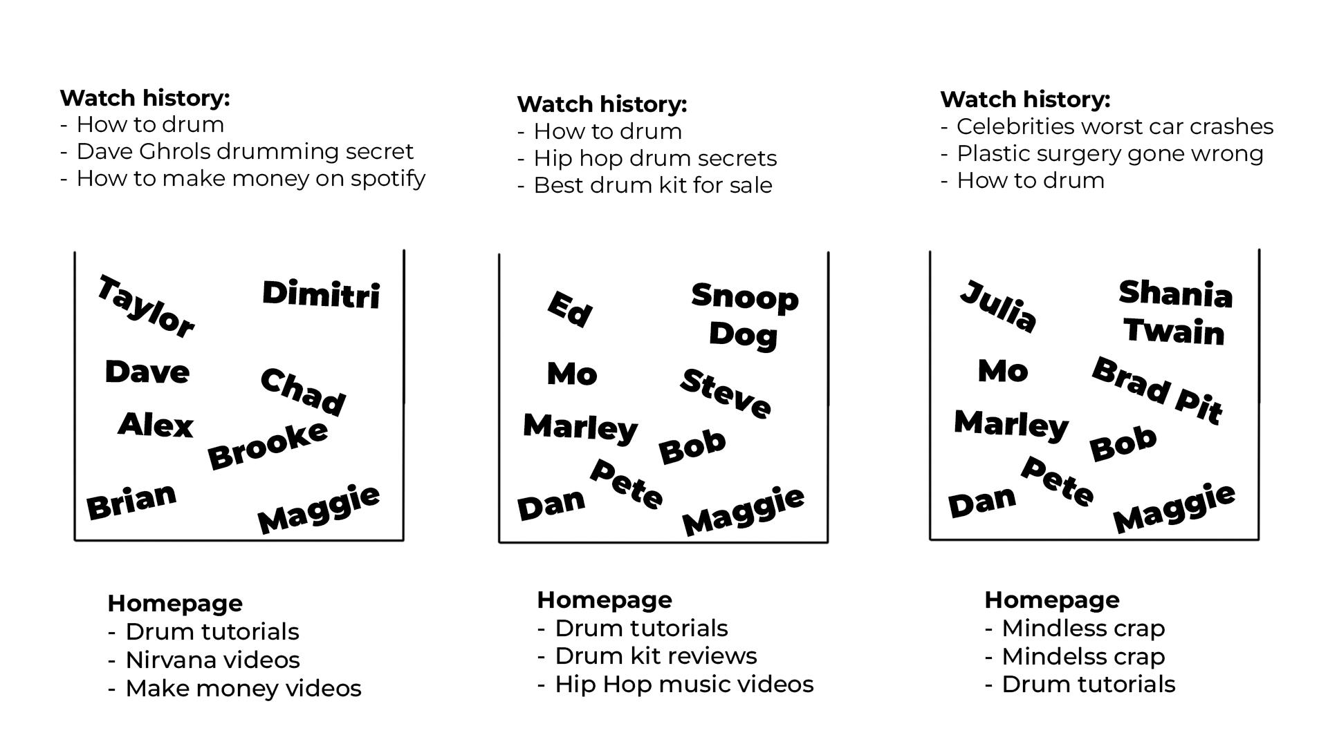

### **How Buckets Affect Your Video**

When you post a video, YouTube tests it with specific buckets that it thinks might be interested in your video based on their watch history.   
  
If viewer satisfaction within those buckets is high, YouTube will push it to more people in that bucket. If it is low, then it’ll stop pushing it to that bucket.

#### **What Happens During Testing:**

1. **Initial Testing:**
   * YouTube shows your video to a small group within a bucket.
   * If these viewers show high satisfaction (e.g., watch time, likes, engagement), YouTube pushes the video to more viewers in that bucket.
2. **Broadening Reach:**
   * If the video performs well, YouTube may test it with other similar buckets
3. **Underperformance:**
   * If viewer satisfaction is low, YouTube may reduce or stop pushing your video to that bucket.

### **Key Takeaways**

* **Watch history** groups viewers with similar interests into "buckets."
* YouTube tests your videos in these buckets to gauge performance.
* High satisfaction leads to broader promotion, while low satisfaction can halt distribution.
* Creating content aligned with your audience's interests is essential for success.

By understanding watch history and how YouTube uses buckets, you can create videos that not only reach your target audience but also keep them coming back for more.

How YouTube Serves Your Content

**How YouTube Serves Your Content to Viewers**

To understand why your videos might stop getting pushed or why they thrive, it’s essential to grasp how YouTube serves content.   
  
Here’s a breakdown of how it works

### **Three Levels of Viewer Buckets**

The simplest way to understand YouTube is to imagine there are the three levels of buckets it tests your content with.

1. Hot
2. Warm
3. Cold

*(If you don't know what a bucket is, watch the level 1 intro module and check out the docs “How YouTube works” from the start.*

#### **🔴 Level 1: Hot Viewer Buckets (Fans )**

These are the most important viewers in the world, they build your business, they come back and support you, they become fans.

* **Characteristics**:  
  + Come back to your content on a regular basis
  + Love your topic and channel.
  + Provide high viewer satisfaction to your videos.
  + Buy your stuff
* **Outcome of new video**:  
  + If “Level 1 - Hot Viewers” show “high viewer satisfaction” on a new video, YouTube pushes it to more people in the Level 1 buckets with high satisfaction and tests it with more people like them.
  + If “Level 1 - Hot Viewers” show “low viewer satisfaction” on a new video, YouTube pushes it to less people in the Level 1 buckets or stops.

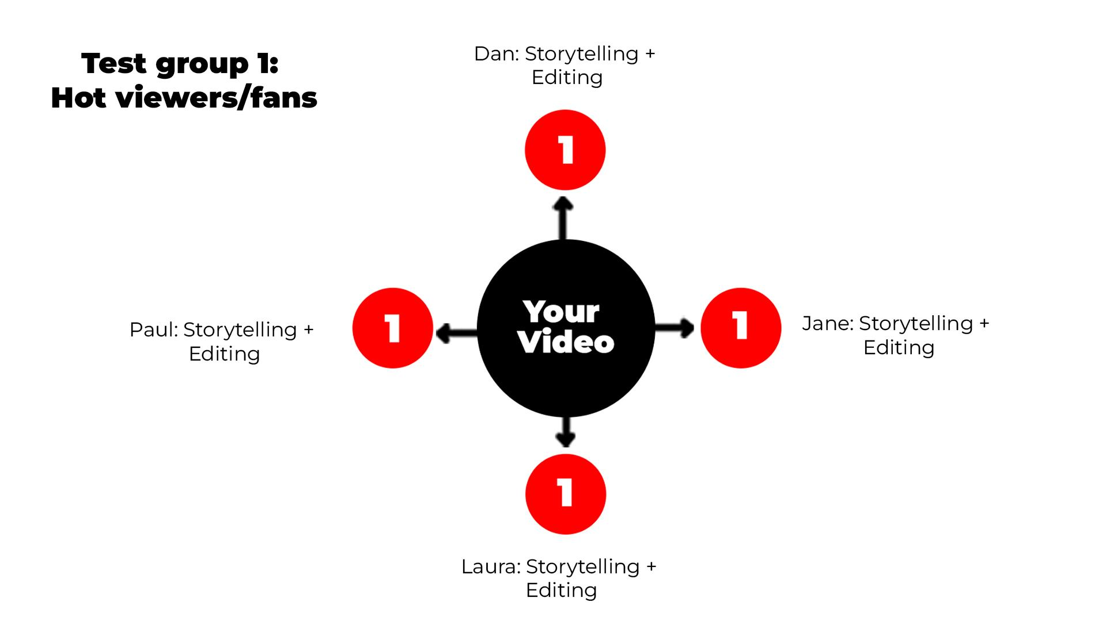

#### **🟠 Level 2: Warm Viewers**

* **Characteristics**:  
  + Watched you before but haven’t returned recently.
  + Interested in your topic but haven’t discovered you yet.
  + Similar viewing behavior to your Level 1 - Hot Viewers.
* **Outcome**:  
  + If “Level 2 - Warm Viewers” show “high viewer satisfaction” on a new video, YouTube pushes it to more people in the Level 2 buckets with high satisfaction and tests it with more people like them.
  + If “Level 2 - Warm Viewers” show “low viewer satisfaction” on a new video, YouTube pushes it to less people in the Level 2 buckets or stops.

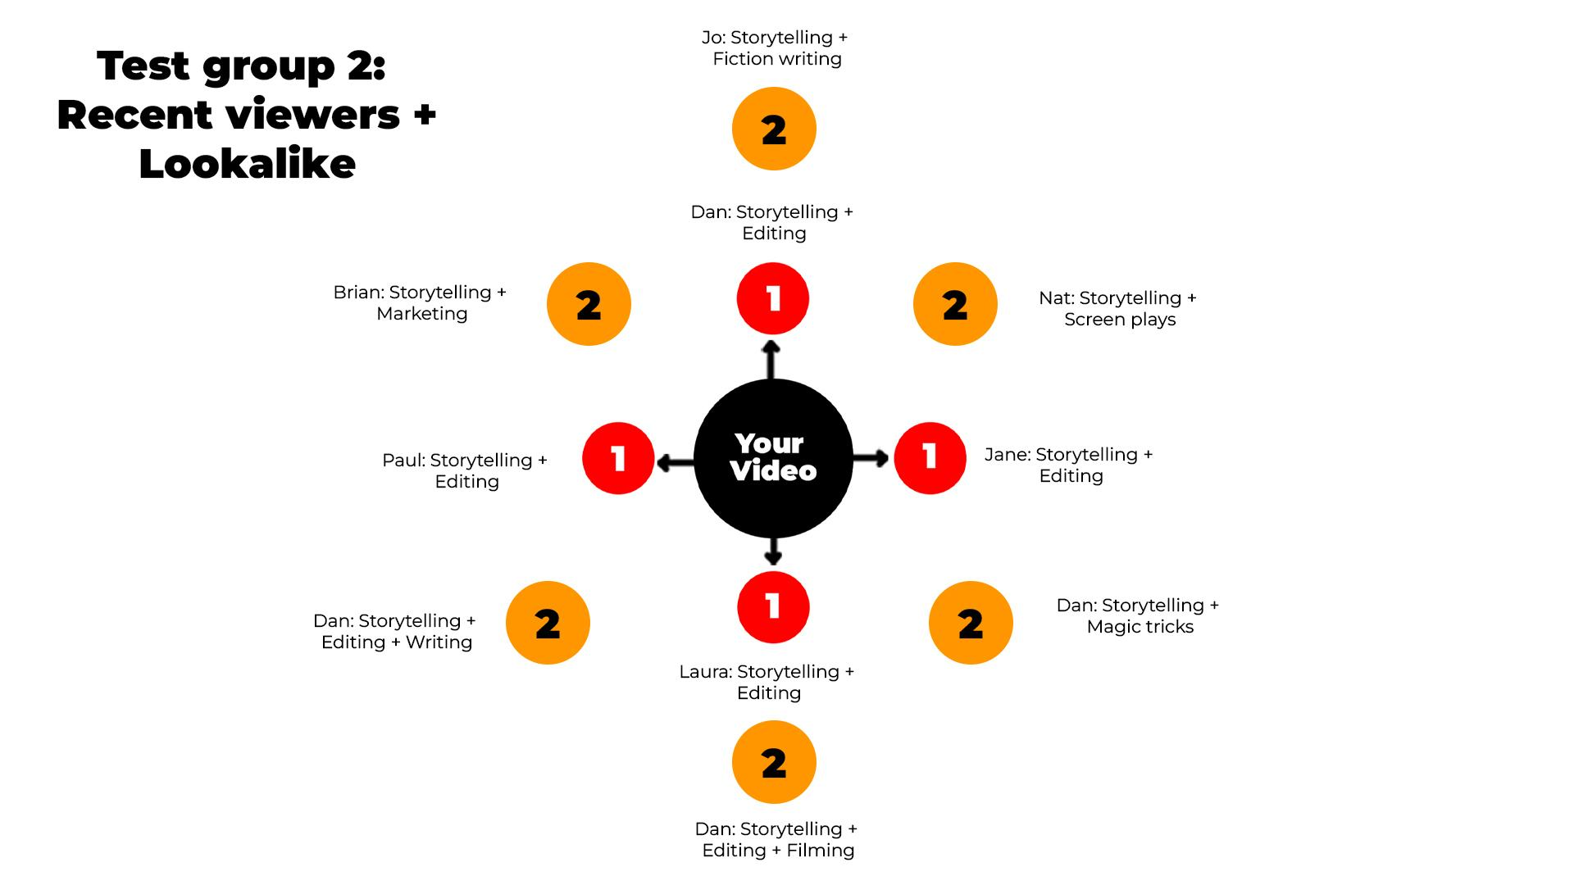

#### **🔵 Level 3: Cold Viewers (New)**

* **Characteristics**:  
  + Never seen your channel before.
  + May have similar interests to your Hot/Warm viewers or none at all.
  + Could be totally random
* **Outcome**:  
  + If “Level 3 - Cold Viewers” show “high viewer satisfaction” on a new video, YouTube pushes it to more people in the Level 3 buckets with high satisfaction and tests it with more people like them.
  + If “Level 3 - Cold Viewers” show “low viewer satisfaction” on a new video, YouTube pushes it to less people in the Level 3 buckets with low satisfaction or stops.

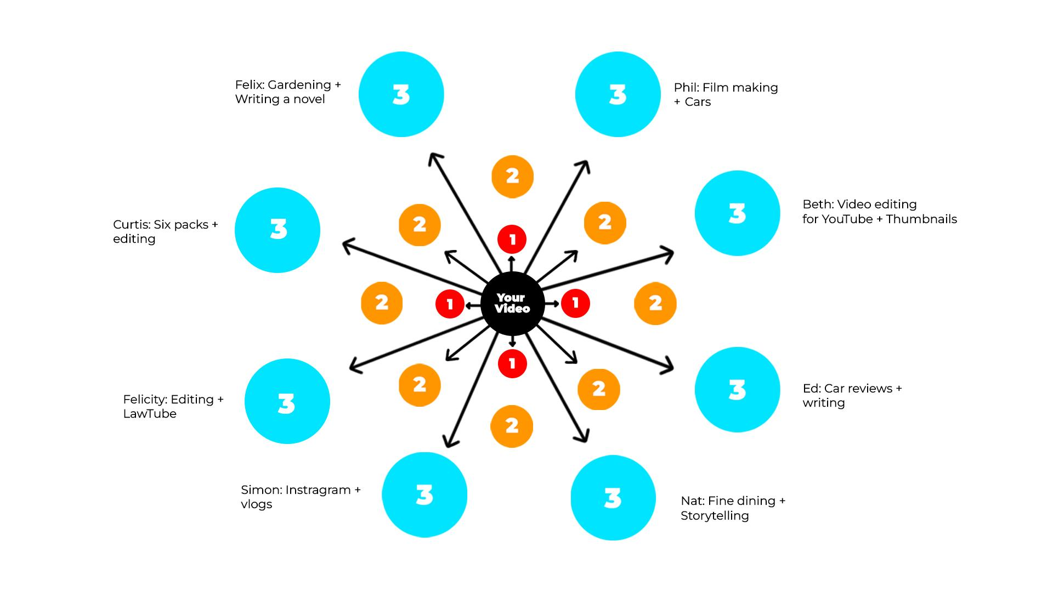

### **Chart: How YouTube Tests and Serves Content**

| **Level** | **Viewer Type** | **Tested Bucket Response** | **Outcome** |
| --- | --- | --- | --- |
| **1** | **Hot Viewers (Fans)** | ✅ High satisfaction | Push to more Level 1- Hot buckets. |
|  |  | ❌ Low satisfaction | Stop pushing to disinterested buckets but continue with performing ones (If there are any) |
| **2** | **Warm Viewers** | ✅ High satisfaction | Push to more warm viewer buckets. |
|  |  | ❌ Low satisfaction | Stop pushing to disinterested buckets but continue with performing ones (If there are any) |
| **3** | **Cold Viewers (New)** | ✅ High satisfaction after initial test | Push to more cold viewer buckets (this can take weeks or months). |
|  |  | ❌ Low satisfaction | Stop pushing to disinterested buckets but continue with performing ones (If there are any) |

### **Key Points to Remember**

1. **Initial Testing**: YouTube tests videos with small samples from each bucket level. Positive responses lead to broader distribution within the same level.
2. **Independent Buckets**: Each bucket is evaluated on its own merit. Poor performance in one doesn’t stop YouTube from testing others.
3. **Cold Viewers Take Time**: Cold buckets are the hardest to penetrate. A video might perform poorly initially but gain traction later. Expect this to take weeks to hit a cold audience. (Unless targeting a trend or a news story)
4. **Growth Strategy**:  
   * Turn Cold Viewers into Warm and eventually Hot Viewers by making consistent content targeting the top of your umbrella.
   * Build a loyal Level 1 audience (Hot Viewers) for reliable traffic and revenue.
5. **Small Channels**: If you’re just starting, expect slow growth as you don’t have any Level 1- Fans or Level 2 - Warm viewers yet.   
     
   Success depends on breaking into Level 3 buckets over time. This won't happen fast.

**How YouTube Serves Content to Viewers Simplified**

YouTube tests your videos with three viewer levels:

1. **Hot (Fans)**: Loyal viewers who love your content.
   * **High satisfaction**: Pushed to more fans and similar viewers.
   * **Low satisfaction**: Stops pushing to disinterested fans but may test warm/cold viewers.
2. **Warm**: Past viewers or potential fans interested in your topic.
   * **High satisfaction**: Pushed to more warm viewers.
   * **Low satisfaction**: Limited to warm viewers, might still test with fans.
3. **Cold**: New viewers who’ve never seen you.
   * **High satisfaction**: Gradually pushed to more cold viewers.
   * **Low satisfaction**: Stops pushing entirely.

**Key Tip**: To grow, turn cold viewers into fans by making engaging content they’ll love.

Positioning

**Positioning your channel**

Positioning is the single most powerful strategy for growing a channel that attracts new viewers, keeps them coming back, and stands out in a saturated YouTube landscape.   
  
This guide will show you step-by-step how to position your channel effectively so every video you make works *together* to grow your audience and business.

**🏆 10x Tasks:**

* Learn how positioning works

**What is Positioning and Why Does It Matter?**

Positioning is about aligning your channel’s content with a **specific problem or desire** that your target audience cares about.   
  
Every video you make should appear to solve that big problem. If you can do that, new viewers will find you and then every video you make will bring them back because it is inline with the thing they discovered you for.

**Why Most Channels Fail   
  
Most channels fail because:**

* They target too many problems
* They try to help everyone
* They don’t make videos about the things that brought viewers in initially.
* They worry niching down means they’ll lose variety or potential viewers.

**The Truth**:

* A well-positioned channel attracts *more* views because it becomes **THE channel** for a specific audience and problem.
* A well-positioned channel will make you more money because you can build products that solve the problem you are known for meaning you will sell more easily

**How To Position Your Channel: The Umbrella**

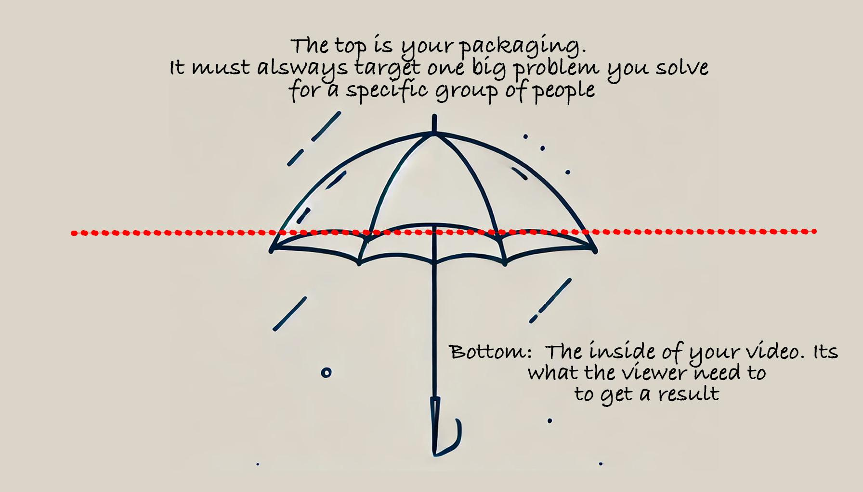

Think of your channel like an umbrella:

**1. The Top of the Umbrella**

* The **big problem** or result your viewers care about and know they have.
* This is what your video’s thumbnails and titles target.
* You need to come up with one statement that says “I help [SPECIFIC PERSON] get [BIG RESULT]  
    
  **Examples**:
* I help garden lovers grow vegetables faster
* I help men land more dates using apps
* I help women grow Etsy stores

**2. The Bottom of the Umbrella**

* The **specific topics** you can talk about within your videos.
* These are the things viewers need but might not know they need.

**3. How To Position Your Channel: Step by step guide**

**Step 1: Identify Your Target Audience and Their Big Problem**

Ask yourself:

* Who do I want to help?
  + Be specific: *“software developers,” “beginners in SaaS,” “people over 60.”*
* What is their BIG problem or desire?
  + “They want to grow vegetables at home.”
  + “They want to start a business and quit their job.”

This is the **top of your umbrella**.

🚨 The avatar + research videos will help you work this out. You don't have to commit to anything until after the research.

**TASK: Write a draft umbrella statement “I help X get Y” (Just take an educated guess right now, we will build on this)**

**Step 2: Find Out What Viewers Actually Care About**

* Study other channels:  
  + What problems are their most-viewed videos solving?
  + What titles and thumbnails resonate most with their audience?
  + The pattern spotting videos will teach you how to do this
* Look for underserved areas in your niche.  
  + Example: BGO avoided competition in the broad “business” niche by focusing on *software developers starting businesses*.
  + Its not always possible to find this, but we want to keep it in mind.

**Step 4: Differentiate Yourself from the Competition**

To stand out in a crowded niche:

* Position your channel to serve a **specific audience** with a **specific problem**.
* Example: Shrey’s channel grew to 100k subscribers in 9 weeks by focusing on *helping people over 60 become more mobile*.

✅ **Checklist for Differentiation**:

* Are you solving a specific problem?
* Are you targeting a group no one else is targeting?
* Are you delivering a unique perspective or method?
* Are you credible in solving this problem?

**Step 5: Refine and Adjust Your Positioning Over Time (Ready, fire aim)**

You won’t position your channel perfectly from day one. It's a game of starting out with a research and then reacting to what happens when you post your videos.

* Some videos will perform better, so you figure out why, and do more of that. (The measurement modules will help with this)
* Some videos will perform worse, so you figure out why, and do more of that. (The measurement modules will help with this)

The basics of this with regards to packaging are, If a video underperforms:

**Ask why viewers might not have clicked**:

* + Does the title assume too much knowledge?
  + Is the thumbnail confusing or unclear?
  + Is the topic not of interest ?
  + Was the video idea not validated by outliers?

**5. Positioning Checklist for Every Video**

Before releasing a video, ask:

* ✅ Does the title and thumbnail target the big problem I want my channel to become known for?
* ✅ Will my target audience instantly know this is for them?
* ✅ Does this video align with the umbrella top?
* ✅ Am I solving a problem or delivering a result my audience knows they have and care about?

### **Understanding the 3-in-10 Rule**

1. On average, only **3 in 10 videos** made by top YouTube educators break out to new cold viewers and grow their channel significantly.
2. Of those 3:
   * 1 achieves **1.5x average views** (a solid performance).
   * 2 achieve **2x average views** (strong growth).
3. Only **2 in every 100 videos** go truly viral with over **5x the average views**.

**Key Takeaway**: Even the best creators rarely hit the bullseye, so consistent effort and testing are critical.

### **Why Posting More Helps Your Channel Grow**

Channels that post more often tend to have more videos that break out. This isn’t just about volume—it’s about:

1. **Refining Through Practice**: Each video acts as a dart thrown at a bullseye, helping you adjust your aim for the next one.
2. **Learning Faster**: Frequent posting lets you quickly identify what works and what doesn’t.
3. **Reaching New Audiences**: More videos mean more opportunities for YouTube to push your content to new viewers.

### **The Ready Fire Aim Method**

**What It Means**: Post a video, analyze the results, and make adjustments for the next one instead of trying to make everything perfect upfront.

**Why It Works**:

* Helps you discover your audience's preferences faster.
* Builds a feedback loop to improve your content over time.
* Simplifies decision-making—just test and learn.

### **Repeating What Works**

When a video gains traction:

1. Identify what made it successful (e.g., title style, thumbnail, topic).
2. Create another video using the same style or format but with slight variations.
3. Save time by reusing proven concepts instead of reinventing everything.

### **Expect Slow Starts Before Growth**

If you’ve pivoted your channel’s focus, your initial videos may get fewer views as old viewers adjust or leave. **Stay consistent**, as those initial videos will gain traction when a new video breaks out and introduces your channel to cold viewers.

### **The Long-Term Strategy**

1. **Ready Fire Aim**: Post, analyze, and adjust to refine your positioning over time.
2. **Consistent Posting**: Aim for one video per week to maximize learning and growth.
3. **Focus on Positioning**: Ensure every video is aligned with your audience’s biggest problem and interests.
4. **Repeat Success**: When something works, reuse and adapt it.

### **Why This Works**

YouTube’s algorithm rewards consistency and relevance. By targeting the same problem repeatedly, you’ll:

* Build trust with your audience.
* Create a catalog of content that works together to drive views and growth.

Avatars

### **Avatars** [**Use this link to build your avatar**](https://docs.google.com/spreadsheets/d/12u7Q3HSdrV-eunaBP0YoMYb2FN38eJkFVoc4boUa6vA/copy)

🏆 Goal: Build your avatar sheet + come up with your draft top of umbrella

An **avatar** is a detailed profile of your ideal viewer.   
  
By understanding who you're creating content for, you can make videos that deeply resonate, turn cold viewers into loyal fans, and grow your channel effectively.

### **Why You Need an Avatar**

1. **Clarity**: You can’t help everyone. A focused audience allows you to create tailored content that resonates deeply.
2. **Consistency**: People return to channels that solve their specific problems, not those that jump between unrelated topics.
3. **Connection**: When you understand your audience, you can speak their language, share relatable stories, and build trust.
4. **Guide Content Creation:** Ensures your topics, tone, and style align with your audience’s needs.

### **How to Create Your Avatar**

1. **Step 1: Start With Yourself:**
   * If you’ve experienced the problem your audience faces, you’re your own avatar a few years ago. Use your experiences and relatable stories.
   * If you are not your avatar then we take an educated guess first.
2. **Step 2: Demographics:**
   * **Sex:** Who resonates with you most? Men, women, or both?
   * **Age:** Narrow it down to a specific range (e.g., 30-40), not 18-60.
   * **Location:** English-speaking countries? Specific regions? Understand cultural nuances.
   * **Marital Status:** Single, married, or mixed?
   * **Employment & Income:** Tailor content to your audience’s financial reality and work life.
3. **Step 3: Psychographics:**
   * **Fears:** What keeps your avatar up at night? (e.g., fear of failure, burnout, wasting time).
   * **Goals:** What do they want to achieve? (e.g., financial freedom, personal growth).
   * **Problems:** Identify specific challenges your avatar faces and rank them in order of importance.
4. **Step 4: Identify Viewer Preferences:**
   * **Casual Beginners:** Basic content wrapped in entertainment.
   * **Enthusiasts:** In-depth, creative content with strong storytelling.
   * **Learners:** Educational, accessible content that’s easy to follow.
   * **Experts:** Deep dives and advanced insights.
5. **Step 5: Refine with AI**
   * **Input Demographic and Psychographic Data**:

Provide the AI with the demographic details (sex, age, location, etc.) and psychographics (fears, goals, problems) you’ve brainstormed for your avatar.   
  
(You can upload your sheet as a CSV to to this or copy/paste)

* + **Prompt**:

Example prompt:  
*"Based on this audience demographic and psychographic data, what additional fears and goals might they have? What are the top problems this audience faces, and can you rank them by significance?"*

* + **Use the Output as a Foundation**:  
    1. Take the expanded list of fears, goals, and problems the AI provides and use it as the starting point for refining your avatar over time.

These instructions emphasize that AI is a tool for refining your educated guesses, not replacing them entirely, and that the avatar will evolve as you create more content and gather insights.

1. **Pick a Viewer Type**:

Choose one of the four main viewer types based on what aligns with your content and your avatar’s needs:

* **Casual Beginners**:  
  + Characteristics: New to the topic, want light, entertaining content that's not too advanced.
  + Content Style: Heavily story based videos, short talking heads, vlogs, short interviews, a day in the life of videos, reaction content, and reviews.
  + Example Channels: Mark Tilbury, Veritasium.
* **Enthusiasts**:  
  + Characteristics: Intermediate knowledge, seeking in-depth info with engaging delivery.
  + Content Style: Heavily story based, challenges, documentaries, deeper talking head videos with large elements of creativity, editing,.
  + Example Channels: Johnny Harris, Cleo Abram.
* **Learners**:  
  + Characteristics: Beginners focused on education, prefer clear and straightforward information.
  + Content Style: Tutorials, longer talking head videos, interviews, podcasts.
  + Example Channels: Ali Abdaal, Elizabeth Filips.
* **Experts**:  
  + Characteristics: Advanced knowledge, want deep dives and detailed information.
  + Content Style: Long podcasts, advanced interviews, or highly detailed talking heads, white boards.
  + Example Channels: Huberman Lab, Chris Williamson.

**How to Decide**:

* Reflect on your strengths and what you’d enjoy creating.
* Consider the content style most appealing to your avatar.
* Start with one type and refine as your channel grows.
* You can try all different types but I’d advise just starting with one until you’re comfortable producing it.

1. **Write your *draft* top of umbrella:**   
     
   **Example**: “I help single moms find fulfilling careers.”

**Example**: “I help men in their 50s retire early and live the life they’ve always wanted.”  
  
This is your **draft** avatar statement—it will evolve as you refine your channel.

### **Key Takeaway**

Building an avatar is a **continuous process** of understanding your audience’s fears, goals, and preferences. You don’t just “Get this right” straight away.   
  
By staying focused on one type of person and problem, you’ll learn more about them and start to create content that appeals to them over the long term.

BENS Guide

### **BENS - Guide to Using the BENS Framework for YouTube Success**

The **BENS framework** is a powerful tool for crafting titles, thumbnails, and scripts that grab attention and keep viewers engaged. It focuses on four key elements that make your content irresistible.

#### **What is BENS?**

BENS is an acronym that stands for:

* **Big**
* **Easy**
* **New**
* **Safe**

Each element evokes curiosity and builds trust, leading to more clicks, views, and audience retention.

### **B: Big**

Make a bold, attention-grabbing claim.  
Viewers are drawn to content that promises a *significant* result or impact.  
  
**Example:** 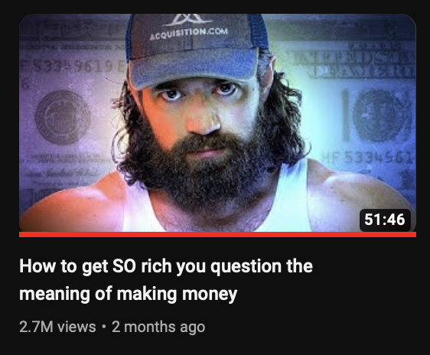

### **E: Easy**

Make it feel effortless or achievable.  
Frame your content as simple and approachable to lower viewer hesitation.  
  
**Example:** 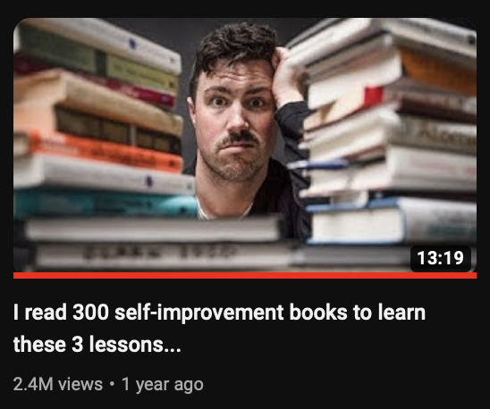

### **N: New**

Offer fresh, unique, or surprising information.  
People crave novelty, especially if they've been frustrated by past solutions.

**Example:** 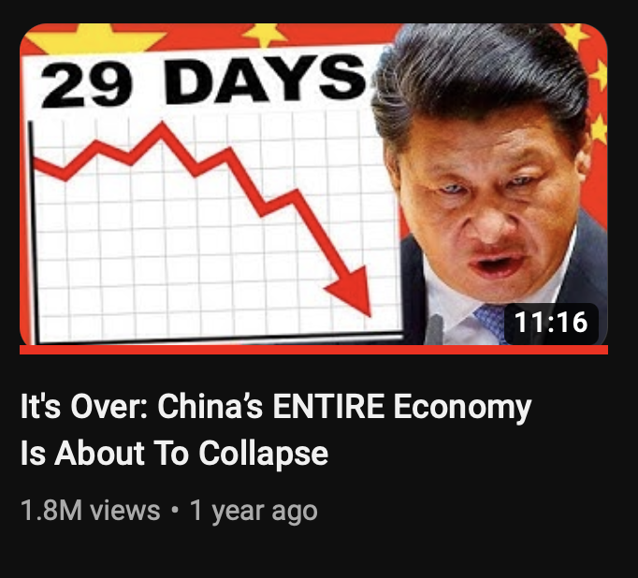

### **S: Safe**

Build trust and credibility.  
Leverage familiar faces, specific results, or reputable sources to make your content feel reliable.

**Example:** *“*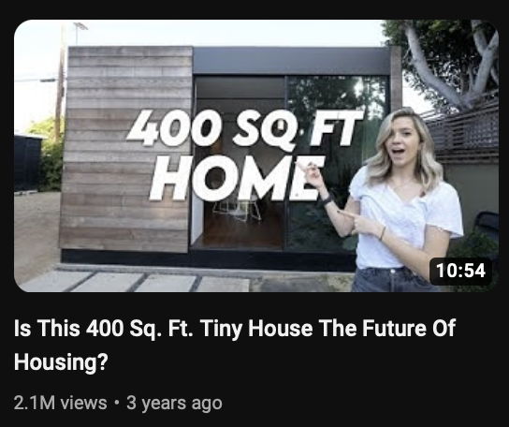

### **How to Use BENS**

1. **Titles:** Combine BENS elements to craft clickable titles.  
   Example: *“Why You’re Losing Money (And How to Fix It in 5 Minutes)”*
2. **Thumbnails:** Use visuals and text to amplify curiosity and trust.  
   Example: A thumbnail showing a graph with *“The 3-Step System That Made Me Rich”*.
3. **Scripts:** Open with BIG claims, NEW insights, and EASY-to-follow steps. Weave in credibility to make the information feel SAFE.
4. **Sales copy:** In your sales and marketing use BENS to make your offers more interesting, believable and engaging.

### **Additional Tips**

* **Specifics Matter:** Use numbers, times, or measurable results for credibility.  
  Example: *“How I Made $10,000 in 14 Days” (This is true for titles thumbnail and scripts)*
* **Create Urgency:** Add stakes to titles and scripts to compel immediate action.  
  Example: *“This Mistake Could Cost You $5,000”*

### **Summary**

The **BENS framework** helps your content stand out by making it:

* **Big**: Meaningful and impactful.
* **Easy**: Simple and achievable.
* **New**: Fresh and intriguing.
* **Safe**: Trustworthy and reliable.

Master these principles, and you’ll make your videos irresistible to your audience.

Ideation/Research

**Ideation/Research Section Index:**

In this section we have everything you need to ideate and come up with video ideas.   
After you have built your pattern bank, use the “Ideating from pattern bank” doc to guide you every time you make a video.

1. **Outliers**

* What is an outlier
* Why Outliers help you get more views
* How to find outliers

1. **Dummy account set up instructions**

* Creating a new YouTube account for research
* Preparing the account for research
* Watching videos like your viewers
* Triggering YouTube’s recommendation system
* Next steps: move to the "Pattern Bank Set Up" document

1. **Pattern bank set up instructions**

* Building a pattern bank
* Identifying outlier videos
* Analyzing titles, thumbnails, and topics
* Organizing and spotting patterns
* Expanding to adjacent niches

1. **How to ideate thumbnails and titles from your pattern bank**

* Building titles from pattern bank
* Designing thumbnails using proven strategies
* Testing and refining thumbnails with feedback
* Finalizing thumbnail strategy
* Split testing thumbnails upon video launch

1. **Title bank**

* Get inspiration from a list of titles

Outliers

### **Outliers**

Outliers are videos that significantly outperform the average content on a channel.   
  
For example, if a channel’s videos typically get 10,000 views, but one video receives 50,000 views, that video is an outlier.   
  
It hit the “bullseye” and resonated with the audience in a way others didn’t so we can take what worked from that and apply it to our own videos.   
  
That might be a word in a title, thumbnail style, hook, idea.

### **Why Outliers Help You Get More Views**

1. **They Reveal What Works**: Outliers show you the topics, titles, thumbnails, and formats that capture attention and drive clicks. They provide a blueprint for what resonates with your target audience.
2. **Attract Cold Viewers**: If it worked once to attract more people, it can work again.
3. **Guide Future Content**: By analyzing outliers, you can identify patterns and replicate successful elements in your own videos, increasing the likelihood of creating more hits.
4. **Shortcut Your Learning Curve**: Instead of guessing what might work, outliers provide proven data from real-world success stories in your niche.

### **What Makes an Outlier?**

* **Small Channel**: (under 100,000 views per video on average)  
    
  For channels of this size outlier is any video that has **3x or more views** than the channel's average. For example, if a small channel typically gets 1000 views per video, an outlier might have 5000+ views.
* **Big Channel**:(Over 100,000 views per video on average)  
    
  On a large channel, an outlier is a video with **2x or more views** than the channel’s average.   
    
  For example, if the average video on a big channel gets 100,000 views, an outlier might have 200,000+ views.

### **How to Find Outliers**

**Software for finding outliers**

1of10 Is a tool that will help you find outliers (See video in Level 1 Ideation - AI + 1of10 for tutoria)

* [Sign up to 1of10](https://1of10.com/?via=ed-lawrence) (Affiliate link)
* Get 20% off of 1of10: CODE = FB20

**Manually finding outliers**

#### **Step 1: Pick a channel**

#### In your niche

* In an adjacent niche E.G: If you are a guitar channel, drum channels are adjacent

#### **Step 2: Compare Views to the Channel’s Average**

* Look for videos on the channel with **more views** than the channel’s typical performance.  
    
  Example: If the average video gets 10,000 views, an outlier would have 2,0000+ views.
* Use tools like the [**1of10 Chrome Extension**](https://chromewebstore.google.com/detail/1of10com-optimization-too/gkfdnmclhbgbidnpmimfdobgjpeblckn), which shows how many times a video exceeds a channel’s baseline views (e.g., 2x, 5x, 10x).

**YouTube’s Built in Features**

* **Sort by “Most Popular”**: Look for recent videos (from the past 12–24 months) in the “Most Popular” tab. These are likely to be outliers.
* Check out your “audience also watches” in YouTube studio in the “audience tab”

**Dummy account**

* **Set up a dummy account:** Follow the “build dummy account” instructions and have YouTube show you new outliers from channels you might have never seen before.

**Outlier to Pattern Bank**

Once you find an outlier, add it to your pattern bank and then use these information to ideate your videos.

See “Ideating from pattern bank” for step by step instructions on how to do this

Build Dummy Account

Building Dummy Account Instructions

**1. Create a New YouTube Account**

**2. Prepare the Account for Research**

* Go to [YouTube.com](https://www.youtube.com/) and log in with your new account.
* DO NOT upload videos, comment, or subscribe to any channels yet.

**3. Watch videos your viewers might watch**

* Watch 5 videos from the same creator in full.
* After each video: Click on another video from the recommended sidebar by the same creator.
* Like videos you watch to show engagement.
* Subscribe to the channels you’re analyzing.
* Continue watching videos in full without skipping.
* Repeat this process for 3 creators in your niche.
* Avoid clicking unrelated videos to keep the algorithm clean.

**4. Trigger YouTube’s Recommendation System**

* Return to your YouTube homepage.
* Look for videos your audience might be very interested in appearing on the homepage.
* Click on any video that might interest your ideal viewers.
* Watch 3-5 videos from the recommended homepage suggestions.

This will now reveal to you new channels and outliers YouTube wants to push at your audience

Move on to The “Pattern Bank Set Up” document next

Pattern bank set up

Pattern Bank Set Up Instructions

[Use this sheet to build a pattern bank](https://docs.google.com/spreadsheets/d/1kSOSJkExAkU0_7xL0uPXyyNq-PHFfZHbRw-xKvVEdLo/edit?usp=copy)

We build a pattern bank to build a pool of titles/topic/thumbnails that helped videos grow channels. We then use this data to create our own thumbnails/titles and video ideas

We do this in two places

1. Our niche: To work out what gets views for our competition
2. Our adjacent niches: To work out what gets views on channels in niches similar to our own

* Step 1: Perform 12 month analysis on a channel in your niche
* Step 2: Log outlier titles, thumbnails,topics etc
* Step 3: Repeat on the same channel looking at “most popular” (no older than 2 years old)
* Step 4: Log outlier titles, thumbnails,topics etc
* Step 5: Repeat on 4-9 more channels
* Step 6: Find “adjacent channels”
* ~~Step 7: Log outlier titles, thumbnails etc~~

Once you have built up a pattern bank, move on to “ideating from pattern bank”.

### 

### **1. Building A Pattern Bank**

1. **Identify Competitor Channels**
   * Find 5-10 channels in your niche or adjacent niches.

* Use dummy account (See dummy account set up instructions to build)
* Use “Audience also watches”
* Use search

1. **PIck a competitors channel and find its outliers**
   * Find videos that performed above average for the channel
   * Log the **titles**, **thumbnails**, and **topics** into the [**pattern bank spreadsheet.**](https://docs.google.com/spreadsheets/d/1kSOSJkExAkU0_7xL0uPXyyNq-PHFfZHbRw-xKvVEdLo/edit?usp=copy)

* *An outlier is a video that grows a channel noticeably faster*
* *Channels getting over 100k views per video look at videos with 2x+ their average views*
* *Channels getting under 100k per video 3x+*
* *Use tools like the* [***1of10 Chrome Extension***](https://chromewebstore.google.com/detail/1of10com-optimization-too/gkfdnmclhbgbidnpmimfdobgjpeblckn) *to identify videos with above-average views (outliers).*

1. **12 Month channel analysis**For every outlier, log the following:

**1. Title**

* Copy and paste the title into your **pattern bank** spreadsheet.

**2. Thumbnail**

* Log the thumbnail visually:  
  + Option 1: Take a **screenshot** and save it to a vision board (e.g., Milanote).
  + Option 2: Use the auto-thumbnail preview feature (1of10 extension).

**3. Topic Analysis**

* Identify the **general topic** of the video (e.g., “being boring in conversations”).

**4. Power Words**

* Identify words in the title/thumbnail that fit **BENS**:  
  + **B**ig Claim: Promises a result.
  + **E**asy: Feels effortless or actionable.
  + **N**ew: Offers fresh information.
  + **S**afe Bet: Feels reliable to click.  
      
    Example: “Copy This Habit” → Easy, Safe Bet.

**5. Thumbnail Analysis**

* List elements that could make the thumbnail stand out:
  + Celebrities
  + Words/text
  + Objects (graphs, dollar signs, etc.)
  + Colors and contrast

**6. Format Analysis**

* Guess the format and audience:  
  + **Beginners**: Easy-to-watch, entertaining (e.g., Charisma on Command).
  + **Learners**: Clear, simple info (e.g., Ali Abdaal).
  + **Enthusiasts**: Storytelling with rich info (e.g., Johnny Harris).
  + **Experts**: Deep dives and advanced insights.
* Common formats include:  
  + Talking Head
  + Tutorials
  + Listicles
  + Reviews
  + Reaction Videos
  + Deep dives
  + White board videos

1. **Repeat on for “most popular” and then on 4 more channels**

**5. Organize Your Data**

* Alphabetize or sort each column (titles, power words, topics, thumbnails) to spot repeating patterns.
* Highlight the most frequently appearing elements:  
  + Repeating title structures.
  + Common power words.
  + Popular topics and thumbnail styles.
  + Repeating formats
  + Repeating thumbnail patterns

**6. Build Your Niche-Wide Patterns**

* Fill out the “Niche Patterns” section in your sheet.
* List the most common patterns you’ve seen across the 5 channels:  
  + High-performing title formulas (e.g., “How to ___”, “The X Rule”, “Copy This Trick”).
  + Thumbnail trends (e.g., close-up faces, bold text, arrows).
  + Popular power words (e.g., “Rule,” “Secret,” “Hack,” “Easy,” “Proven”).

**7. AI Analysis (Optional but Useful)**

* Copy and paste all patterns (from titles, thumbnails, etc.) into one central sheet.
* Save this as a CSV file for AI analysis
* Upload the CSV file to ChatGPT or any AI tool.
* Use the below prompt and update your sheet with anything you think AI picked up on you missed

Prompt:

*“What title patterns, power words, and thumbnail styles appear most frequently in this data?”*

*Summarize findings and validate repeating structures.”*

**8. Build an adjacent niche pattern bank**

Now find 5 channels in niches similar to your own and repeat the process over again

Once complete more on to “ideating from your pattern bank” in the document section

Ideating from pattern bank

**Ideating from your pattern bank**

Now you have a pattern bank. We turn that data into ideas, titles and thumbnails.

NOTE: Your pattern bank is not “one and done” you should be updating it on a regular basis and spending as much time as you can researching YouTube. The more time you spend researching the more you’ll understand how to position an idea, trends and progress. If you never use it/watch it, don't expect results.

Follow this process to ideate any video from your pattern bank:

### **Step 1. Create Titles**

From your outlier titles we build new titles using this system:

NEVER USE COLONS IN YOUR TITLE “:” THESE WRECK FLOW AND ARE AI

* Use the building blocks (power words, structure, BENS framework):  
  1. **Big claims**: “The Trick That Changed My Life.”
  2. **Ease**: “5 Simple Steps to…”
  3. **Novelty**: “You’ve Never Seen This Before.”
  4. **Safe bet**: “Proven Method to Stop X.”
* Options to generate titles:  
  1. **Copy exact title structure**:  
     + Outlier: *“Do This to Never Be Boring Again”*
     + Your Title: *“Do This to Never Be Boring Again”*
  2. **Combine two outlier titles**:  
     + Outlier 1: *“10-Minute Morning Routine”*
     + Outlier 2: *“Stop Procrastinating With This Trick”*
     + Combined: *“10-Minute Trick to Stop Procrastination”*
  3. **Use a single outlier with a power word twist**:
     + Outlier: *“Copy This Habit for Better Conversations”*
     + Your Title: *“Copy This Game Changing Habit for Better Conversations”*
  4. **Pull repeating power words** and create something new:
     + Power Words: *“Trick, Rule, Habit”*.
     + Title: *“The One Rule That Transformed My Productivity”*.

**Run Titles Through the Checklist**

* + ✅ Is it under 50 characters?
  + ✅ Does it include BENS?
  + ✅ Does it align with your channel positioning?
  + ✅ Are there no off-putting words or jargon?
  + ✅ Has it been built using outlier patterns

### **Step 2: Draft Thumbnail Strategy - 3 Doodles**

* Create **three different draft thumbnail doodles** based on your pattern bank
* Make **two slight variations** of each thumbnail by changing on thing:   
    
  Eg
  + Text
  + Objects
* You now have **9 drafts**

The thumbnail styles to pick from 👇🏼

**Cognitive Dissonance:** Use the title and image to challenge a commonly held belief or expectation, creating curiosity.

**Before and After (Transformation) Thumbnails:** Show clear contrasts to highlight a transformation.

**Result-Oriented Thumbnails:** Directly show the result viewers want.

**Social Hacking Thumbnails:** Leverage familiar faces or celebrities to gain trust and attention.

**Curiosity-Driven Thumbnails:** Use intriguing text and visuals to provoke curiosity.

**Minimalist Thumbnails:** Take Cinematic, well-composed photos with a clean and polished look.

[Click me to see each style in action](https://app.milanote.com/1T67YZ1Mm4WUc9?p=m24YFl8Nuyc)

### **Step 3: Gather Initial Feedback**

* Upload your thumbnails to **thumbsup.tv** add the video title, screen shot. Repeat 9 times
* Add the screenshots to a vision board with the outliers you based them on
* Share the vision board or a screen shot of the vision board for feedback

### **Step 4: Produce Thumbnails**

* Finalize thumbnail strategy based on feedback
* Create the three concepts
* Use the AI to help

**🚨 Use this checklist before submitting for feedback 🚨**

✅ **Clarity and Simplicity**

* Does it visually represent your topic fast?
* Is there a **clear hero** (focus point) that sticks out?
* Is the design simple with no competing elements?

✅ **Design Principles**

* Is the text easy to read with space around the edges?
* Is the background clean, not cluttered?
* Have you avoided overly creative visual metaphors?

✅ **Intrigue and Curiosity 🚨**

* Does the thumbnail make viewers ask: *“How?” “What?” “Why?” or “What happened?”*
* Does it match the **BENS** principles (Big, Easy, New, Safe)?

### **Step 5: Final Feedback**

* Add the images to thumbsup.tv and screen shot them
* Submit the designs to Discord
* Refine based on feedback

### **Step 6: Split test**

When you launch a video you’ll put three different strategies in the split tester inside of YouTube:

The launching a video checklist will walk you through this

Title Bank

Title Bank

[Watch me to see how this works](https://www.loom.com/share/9e96b422a4484dbab3318542203ba3e1?sid=1157a72f-1c62-423b-9afb-4825ba32e21f)  
  
Use validated titles to come up with ideas faster.

Self Improvement

This Simple X System Got Me Y

* This Simple Budgeting System Got Me Out of Debt
* This Simple Meditation System Got Me Peace of Mind

This Simple x Made Me y

* This Simple Morning Routine Made Me More Productive
* This Simple Exercise Made Me Stronger

This Is Why You Can’t X

* This Is Why You Can’t Lose Weight
* This Is Why You Can’t Stay Motivated

My Honest Advice to Someone Who Wants X

* My Honest Advice to Someone Who Wants to Start a Business
* My Honest Advice to Someone Who Wants to Improve Their Health

The Top Reasons People Regret X

* The Top Reasons People Regret Buying a House
* The Top Reasons People Regret Quitting Their Job

7 Signs of X in Y

* 7 Signs of Burnout in Your Daily Routine
* 7 Signs of a Toxic Relationship in Your Life

12 Signs You’re X

* 12 Signs You’re Overworking Yourself
* 12 Signs You’re a Natural Leader

Why People Struggle to Say ‘X’

* Why People Struggle to Say ‘No’
* Why People Struggle to Say ‘I’m Sorry’

I NEVER Felt Like X (How I Changed)

* I NEVER Felt Like I Belonged (How I Changed)
* I NEVER Felt Like Exercising (How I Changed)

8 X Habits That Keep You Y

* 8 Eating Habits That Keep You Energized
* 8 Productivity Habits That Keep You Focused

It’s Actually Pretty Easy to X

* It’s Actually Pretty Easy to Learn a New Language
* It’s Actually Pretty Easy to Save Money

5 Things Successful X Do Before Y

* 5 Things Successful Entrepreneurs Do Before 9 AM
* 5 Things Successful Students Do Before Exams

Why I Stopped Using X

* Why I Stopped Using Social Media
* Why I Stopped Using Processed Foods

5 Things Smart X Should Never Do

* 5 Things Smart Investors Should Never Do
* 5 Things Smart Homeowners Should Never Do

I Wish Someone Had Told Me X

* I Wish Someone Had Told Me How Hard Parenting Is
* I Wish Someone Had Told Me About the Challenges of Freelancing

How I Learned to X in a Week

* How I Learned to Cook in a Week
* How I Learned to Code in a Week

My Worst Mistakes X

* My Worst Mistakes as a Manager
* My Worst Mistakes When Starting a Business

My Worst Mistakes Learning X

* My Worst Mistakes Learning to Play the Guitar
* My Worst Mistakes Learning a New Language

I Should NOT Have X This!

* I Should NOT Have Ignored My Health
* I Should NOT Have Skipped the Meeting

How To Attract X Effortlessly

* How To Attract New Clients Effortlessly
* How To Attract Positive Energy Effortlessly

The Biggest X About Y, Debunked

* The Biggest Myth About Vegan Diets, Debunked
* The Biggest Misconception About Remote Work, Debunked

Why You Struggle to X Your Y

* Why You Struggle to Communicate Your Needs
* Why You Struggle to Define Your Goals

How to X Instantly

* How to Improve Your Focus Instantly
* How to Relieve Stress Instantly

If You Don’t X This, Your Y Will Never Change

* If You Don’t Practice Self-Care, Your Mental Health Will Never Change
* If You Don’t Learn to Budget, Your Financial Situation Will Never Change

You’re (Probably) X Your Y

* You’re (Probably) Sabotaging Your Own Success
* You’re (Probably) Overcomplicating Your Fitness Routine

## 

## 

## 

## Advice and tips

5 Common Tips That Can Ruin Your X

* 5 Common Tips That Can Ruin Your Weight Loss Journey
* 5 Common Tips That Can Ruin Your Productivity

92% of X Use Y Wrong – Here’s What To Do Instead

* 92% of Homeowners Use Their Thermostats Wrong – Here’s What To Do Instead
* 92% of Job Seekers Use Resumes Wrong – Here’s What To Do Instead

What I Learned From My Failed X

* What I Learned From My Failed Business Venture
* What I Learned From My Failed Fitness Challenge

The X That Will Change Your Life

* The Morning Routine That Will Change Your Life
* The New Hobby That Will Change Your Life

5 Myths X That We All Thought Were True

* 5 Myths About Nutrition That We All Thought Were True
* 5 Myths About Success That We All Thought Were True

3 X I Will NEVER Y

* 3 Diets I Will NEVER Try
* 3 Workouts I Will NEVER Do

X Change EVERYTHING We Knew About Y

* Technology Change EVERYTHING We Knew About Communication
* New Research Change EVERYTHING We Knew About Sleep

4 MISTAKES X that Everyone Knows

* 4 MISTAKES Home Cooks Make That Everyone Knows
* 4 MISTAKES New Entrepreneurs Make That Everyone Knows

5 X Always Y

* 5 Successful Entrepreneurs Always Wake Up Early
* 5 Healthy Eaters Always Include Greens

How X Transforms Your Y

* How Meditation Transforms Your Daily Routine
* How Reading Transforms Your Mindset

The WORST THINGS About X Will Surprise YOU!

* The WORST THINGS About Working from Home Will Surprise YOU!
* The WORST THINGS About Minimalism Will Surprise YOU!

STOP Doing These X For Y!

* STOP Doing These Mistakes For Better Health!
* STOP Doing These Habits For Better Productivity!

First X Things To Do – Y (Tips and Tricks)

* First 5 Things To Do – When Starting a New Job (Tips and Tricks)
* First 3 Things To Do – To Improve Your Diet (Tips and Tricks)

How To X like a Y

* How To Write Like a Bestselling Author
* How To Dress Like a Fashion Icon

How To X Like A Y

* How To Negotiate Like A Pro
* How To Write Like A Bestselling Author

X Tips to Avoid Looking Y Over Z

* 7 Tips to Avoid Looking Overwhelmed During Presentations
* 10 Tips to Avoid Looking Disorganized in Meetings

X Tips to Avoid Y for Z

* 5 Tips to Avoid Overeating for a Healthier Lifestyle
* 8 Tips to Avoid Stress for a Better Work-Life Balance

X Your Y Without Z

* Improve Your Skin Without Expensive Products
* Enhance Your Workout Without Expensive Gear

X Money-Saving Y Tricks – Don’t Z!

* 5 Money-Saving Grocery Tricks – Don’t Fall for These Common Mistakes!
* 3 Money-Saving Travel Tricks – Don’t Overlook These Essentials!

X Steps To Get The Best Y Of Your Life In Z

* 7 Steps To Get The Best Sleep Of Your Life In 30 Days
* 5 Steps To Get The Best Financial Health Of Your Life In 6 Months

Best X Free Y in Z + Comparison

* Best Free Productivity Apps in 2024 + Comparison
* Best Free Fitness Programs in 2024 + Comparison

X Hacks Pro Designers Use in Y

* Design Hacks Pro Designers Use in Photoshop
* Interior Design Hacks Pro Designers Use in Small Spaces

Top X Anti-Y Foods to Eat After Z

* Top 10 Anti-Inflammatory Foods to Eat After a Workout
* Top 5 Anti-Aging Foods to Eat After 40

X Tips in Y for Your Z

* 10 Writing Tips in 2024 for Your Blog
* 7 Study Tips in College for Your Exams

One-Minute X Habits for a Y Home

* One-Minute Cleaning Habits for a Tidy Home
* One-Minute Organization Habits for a Clutter-Free Home

X Small Changes to Improve Your Y

* 5 Small Changes to Improve Your Morning Routine
* 10 Small Changes to Improve Your Work-Life Balance

## 

## 

## 

## Challenges and Experiences

6 Levels of X Every Y MUST Master

* 6 Levels of Guitar Skills Every Musician MUST Master
* 6 Levels of Digital Marketing Every Entrepreneur MUST Master

I Survived X Days Off Y

* I Survived 30 Days Off Social Media
* I Survived 60 Days Off Sugar

Can I X Every Y in Z?

* Can I Visit Every National Park in 30 Days?
* Can I Read Every Book on My Shelf in a Year?

We Survived The Scariest X

* We Survived The Scariest Haunted House
* We Survived The Scariest Escape Room Challenge

Our X Survived The Worst Y

* Our Vintage Car Survived The Worst Road Trip
* Our DIY Project Survived The Worst Conditions

I Bought a X & Rebuilt It in Y

* I Bought a Classic Car & Rebuilt It in 6 Months
* I Bought a Vintage House & Rebuilt It in a Year

The SCAM X Don’t Want You To Know

* The SCAM Weight Loss Supplements Don’t Want You To Know
* The SCAM Investment Schemes Don’t Want You To Know

What’s Coming Is WORSE Than X

* What’s Coming Is WORSE Than The Current Recession
* What’s Coming Is WORSE Than The Climate Crisis

I Tried This Mind-Blowing X

* I Tried This Mind-Blowing New Fitness Regimen
* I Tried This Mind-Blowing Productivity Technique

I Tried This Ancient X

* I Tried This Ancient Meditation Practice
* I Tried This Ancient Herbal Remedy

I Tried This Revolutionary X

* I Tried This Revolutionary Learning Method
* I Tried This Revolutionary Health Supplement

Are You Having a Complicated X?

* Are You Having a Complicated Relationship?
* Are You Having a Complicated Fitness Journey?

We X Every Y in Z Days

* We Visited Every Beach in Our State in 14 Days
* We Cooked Every Recipe in the Cookbook in 30 Days

X vs Y at Z

* Electric Cars vs Gas Cars at 60 MPH
* Home Workouts vs Gym Workouts at 30 Minutes

X Builds World’s Fastest Y!

* Tesla Builds World’s Fastest Electric Car!
* SpaceX Builds World’s Fastest Rocket!

We Bet Everything to Save X

* We Bet Everything to Save Our Family Business
* We Bet Everything to Save Our Favorite Local Restaurant

## Secrets and Controversies

X will HATE me for sharing this Secret

* The Tech Giants Will HATE Me for Sharing This Secret Trick
* The Health Industry Will HATE Me for Sharing This Secret Diet

X HATE me for sharing this SECRET

* Fitness Gurus HATE Me for Sharing This SECRET Workout Routine
* The Fashion Industry HATE Me for Sharing This SECRET Budget Style Tip

Huge Lies X Are Telling You!

* Huge Lies The Fitness Industry Is Telling You!
* Huge Lies The Beauty Industry Is Telling You!

X New Y is a Game-Changer

* The New iPhone is a Game-Changer for Mobile Photography
* The New Streaming Service is a Game-Changer for Entertainment

What’s Coming Is WORSE Than X

* What’s Coming Is WORSE Than The Current Economic Downturn
* What’s Coming Is WORSE Than The Climate Crisis

X Is Worse Than You Think: Z Reveals All

* Social Media Is Worse Than You Think: Experts Reveal All
* Diet Soda Is Worse Than You Think: Nutritionists Reveal All

The X That Terrified Y

* The New Horror Movie That Terrified Even Veteran Critics
* The Conspiracy Theory That Terrified The Experts

The Real Reason Why X

* The Real Reason Why Fast Fashion Is So Cheap
* The Real Reason Why You’re Not Losing Weight

The X Reason Why Every Y Has Z

* The Real Reason Why Every Business Should Have a Digital Strategy
* The Hidden Reason Why Every Entrepreneur Needs a Mentor

6 Dirty Secrets YouTubers Refuse To Talk About

* 6 Dirty Secrets YouTubers Refuse To Talk About Behind the Scenes
* 6 Dirty Secrets YouTubers Keep Hidden From Their Audience

The TRUTH About YouTube That The PROS Know

* The TRUTH About YouTube Algorithms That The PROS Know
* The TRUTH About Growing a Channel That The PROS Know

Huge Lies X Are Telling You

* Huge Lies Fitness Apps Are Telling You
* Huge Lies Beauty Products Are Telling You

I Ditched X — Here’s Why

* I Ditched My Social Media Accounts — Here’s Why
* I Ditched Processed Foods — Here’s Why

## Product and Service Reviews

The BEST X of 2024

* The BEST Smartphones of 2024
* The BEST Fitness Gadgets of 2024

Best X of Y – Forget Z! X In This Instead

* Best Budget Laptops of 2024 – Forget High-End Models! Check These Instead
* Best Skincare Products of 2024 – Forget Old Brands! Try These New Ones

I Bought X: What It’s Actually Like!

* I Bought the Latest Drone: What It’s Actually Like!
* I Bought a Subscription Box: What It’s Actually Like!

X Free Tools I’d Use to Y

* 5 Free Tools I’d Use to Improve My YouTube Channel
* 7 Free Tools I’d Use to Enhance Productivity

This Simple X Trick Changed Everything

* This Simple Budgeting Trick Changed Everything About My Finances
* This Simple Productivity Trick Changed Everything About My Workday

Stop Wasting Your X on These Y!

* Stop Wasting Your Money on These Overpriced Gadgets!
* Stop Wasting Your Time on These Ineffective Workouts!

The Wrong Way to X Your Y

* The Wrong Way to Clean Your Laptop
* The Wrong Way to Plan Your Week

X Secrets Z Refuse to Talk About

* The Nutrition Secrets Dieticians Refuse to Talk About
* The Financial Secrets Wealth Managers Refuse to Talk About

Is This X Better Than What’s in Y?

* Is This New Tablet Better Than What’s in the Market?
* Is This Homemade Skincare Better Than Store-Bought Products?

## 

## Exploratory and "What If" Scenarios

X Is For Y People

* Meditation Is For Busy People
* Minimalism Is For People Who Love Freedom

Why You Can’t X With Y

* Why You Can’t Lose Weight With Just Cardio
* Why You Can’t Master a Language With Just Apps

Why You Can’t X With AI

* Why You Can’t Fully Trust AI for Creative Writing
* Why You Can’t Rely on AI for Personal Financial Advice

This Might Be the X Idea I’ve Ever Had…

* This Might Be the Best Business Idea I’ve Ever Had…
* This Might Be the Most Innovative Fitness Routine I’ve Ever Had…

I Created an X to Prove It's Not Y

* I Created an App to Prove It’s Not Just a Fad
* I Created a New Diet Plan to Prove It’s Not a Scam

Why X is Doing Y

* Why Google is Investing in Quantum Computing
* Why Major Brands are Shifting to Sustainable Packaging

Why “X” look so Y! Ft. Z

* Why “Luxury Car” Commercials Look So Over-the-Top! Ft. A Marketing Expert
* Why “Healthy Food” Commercials Look So Deceptive! Ft. A Nutritionist

X Explain Why It’s So Hard To Y

* Economists Explain Why It’s So Hard To Predict Market Trends
* Engineers Explain Why It’s So Hard To Design the Perfect Product

How I See the X After Living in Y for Z

* How I See the Modern Workplace After Living in a Remote Village for a Year
* How I See Digital Nomadism After Living in Bali for Six Months

How a X Robbed Y of Z

* How a Bad Investment Robbed Me of My Savings
* How a Miscommunication Robbed My Team of Productivity

Genius X Advice for Y Straight…

* Genius Fitness Advice for Beginners Straight from the Pros
* Genius Financial Advice for Entrepreneurs Straight from the Experts

Make Your X Free Forever in Y Steps

* Make Your Inbox Email Free Forever in 5 Steps
* Make Your Budget Balanced Forever in 3 Steps

## Lists and Rankings

5 Easy X That Will Change Your Life Forever

* 5 Easy Habits That Will Change Your Life Forever
* 5 Easy Recipes That Will Change Your Dinner Routine Forever

7 Signs of X in Y

* 7 Signs of Burnout in the Workplace
* 7 Signs of Quality in Handmade Crafts

10 X You MUST AVOID!

* 10 Mistakes You MUST AVOID When Starting a Business!
* 10 Foods You MUST AVOID for Better Health!

12 Things NOT to do in X

* 12 Things NOT to do in a Job Interview
* 12 Things NOT to do When Buying a House

5 Things Smart X Should Never Do

* 5 Things Smart Investors Should Never Do
* 5 Things Smart Travelers Should Never Do

5 Things X Do Before 8AM

* 5 Things Successful Entrepreneurs Do Before 8AM
* 5 Things Productive People Do Before 8AM

5 Things Successful X Do Before Y

* 5 Things Successful Writers Do Before Starting Their Day
* 5 Things Successful Athletes Do Before a Big Game

X Growth Hacks That Have Been Banned

* SEO Growth Hacks That Have Been Banned
* Marketing Growth Hacks That Have Been Banned

5 Reasons X to Y As Soon As You Can

* 5 Reasons to Switch to Renewable Energy As Soon As You Can
* 5 Reasons to Start a Morning Routine As Soon As You Can

I Ranked X BEST Y (Tier List)

* I Ranked the Best Streaming Services (Tier List)
* I Ranked the Best Budget Laptops (Tier List)

5 X Always Y

* 5 Habits Always Linked to Success
* 5 Strategies Always Effective in Marketing

5 Myths X That We All Thought Were True

* 5 Myths About Nutrition That We All Thought Were True
* 5 Myths About Exercise That We All Thought Were True

## 

## Entertainment and Fun

X Tries Y for the First Time

* A Chef Tries Vegan Cooking for the First Time
* A Grandpa Tries Virtual Reality for the First Time

What Your Favorite X Says About YOU

* What Your Favorite TV Show Says About YOU
* What Your Favorite Book Genre Says About YOU

The X Principle | If You Don’t Change X, Y Will Never Change

* If You Don’t Declutter, Your Space Will Never Feel Organized
* If You Don’t Prioritize Tasks, Your Productivity Will Never Improve

The Hunt for the X of the Y

* The Hunt for the Perfect Coffee Blend of the Year
* The Hunt for the Best Fitness Routine of the Decade

I Made X Work for Y

* I Made Minimalism Work for a Busy Lifestyle
* I Made Remote Work Work for My Family Life

I Wish Every X Could Watch This

* I Wish Every Aspiring Entrepreneur Could Watch This
* I Wish Every Music Lover Could Watch This

Video Strategy

### **Video Strategy: Repeat What Works**

The strategy is simple: **make your first 4 videos, repeat what performs, and continually search for new outliers to repeat.**Analyze your videos, identify outliers, and repeat the styles, topics, and approaches that resonate with your audience.

### **Step 1: Post Your First 4 Videos**

1. Base these videos on **validated outliers** (content ideas proven to work in your niche).
2. Analyze the results:  
   * Some will flop.
   * One might perform okay.
   * One might stand out (your first **outlier**).

### **Step 2: Repeat the Outlier**

* Take the outlier video and create a similar one:  
  + Adjust the title slightly (e.g., change a word or two).
  + Create a thumbnail with a similar design.
  + Use the same video structure and intro style.
* Spread out repeats: Post a repeat video every 3–4 videos to avoid being typecast.

### **Step 3: Ideate New Content**

* Batch ideate the other 3 videos in your next set of 4.
* Test different topics, thumbnails, and styles to discover new outliers.

### **Why Repeating Works**

* **Familiarity**: Viewers recognize the style of a successful video and are more likely to click again.
* **Efficiency**: Saves time on ideation, scripting, and editing.
* **Proven Results**: You know the concept resonates with your audience.

### **Dealing with Flops**

* If a repeat video underperforms, try it again:  
  + The topic may not have clicked with viewers.
  + Test at least 3 times before deciding it doesn’t work.

### **Long-Term Strategy**

1. **Repeat Outliers**:
   * Build a library of 3–4 repeatable video formats.
   * Alternate these with new content to avoid repetition fatigue.
2. **Established Channels**:
   * Review past videos to identify outliers that can be repeated.
3. **New Channels**:
   * Expect slower growth as you learn.
   * Anticipate 1 in 10 videos to grow your channel early on.
4. **Consistency**:
   * Stick to the system and keep producing.
   * Over time, growth accelerates as your skills improve.

Title writing guide

## **Title Writing Guide** Guide: How to Write YouTube Titles That Get Clicks

### **Checklist for Great Titles**

* Is it under 50 characters?
* Does it spark curiosity or promise a result?
* Does it align with the thumbnail?
* Is it in line with the top of your umbrella?
* Did you validate it with outliers or patterns from your niche?
* Does it have plenty of BENS (Big, Easy, Safe, New)

**1. Start with Curiosity**A good title raises questions in the viewer's mind. Use words like *why*, *how*, *what*, and *secret* to spark intrigue.  
  
Example: "Why You’re Failing at Productivity (And How to Fix It)"

**2. Use the BENS Framework**Incorporate one or more of these elements:

* **Big Claim**: "The Trick That Changed Everything"
* **Easy**: "5 Simple Ways to Lose Weight"
* **New**: "You’ve Never Seen This Before"
* **Safe Bet**: "Proven Strategies to Save Money"

**3. Keep It Short and Clear**Aim for under 50 characters to ensure readability. Remove unnecessary words or jargon.  
Example: "How to Start a Business in 2024"

**4. Align with the Thumbnail**Your title and thumbnail must work together to create a cohesive and intriguing story. Avoid repeating exact text from the thumbnail.  
  
Example: Title: *"Why I Stopped Using My Phone"*Thumbnail Text: *"This Changed Everything"*

**5. Test and Refine**Split test different titles using YouTube tools or feedback from your audience. Adjust based on click-through rates (CTR) and engagement.

Thumbnails

Thumbnail Design + Strategy Index

In this section we have everything you need to ideate and come up with thumbnails.   
  
Use this to remind yourself about strategy and follow the “Thumbnail creation checklist” every time you make new thumbnails. Ticking off everything on the list will reduce your feedback rounds and save you time.

1. **How to get a click** - Remind yourself of what matters when it comes to thumbnails
2. **Thumbnail Strategy -** The most powerful strategies to pick from for every thumbnail
3. **Thumbnail creation checklist -** Tick off everything on the list to reduce your feedback rounds and save you time.

How to Get a Click on YouTube

**How to Get a Click on YouTube**

Getting a click on YouTube is all about creating an itch your viewers feel like they *have* to click your video.   
  
Here’s how to achieve that in four simple steps:

[**Click me for examples**](https://app.milanote.com/1T67YZ1Mm4WUc9?p=m24YFl8Nuyc)

### **1. Create Curiosity**

* Make your thumbnail and title raise immediate questions like “What?”, “How?”, or “Why?”
* Aim to evoke multiple questions in the viewer's mind to increase engagement.
* Example:

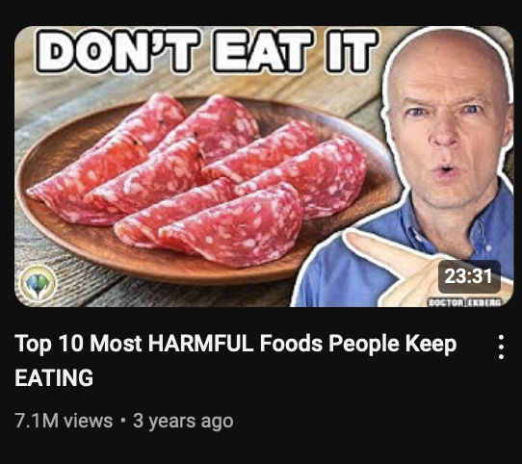

Curiosity = Clicks. Avoid plainly stating what your video is about—leave some mystery.

### **2. Feature a Clear Hero**

* The “hero” is the element in your thumbnail that grabs attention first.
* This could be a face, an object, or bold text, whatever matters the most to your audience.
* Use *frequency bias*: People notice things they’re already interested in (e.g., graphs in finance niches, before/after photos in fitness).
* It is very likely that your images only ever repeat 1-3 heroes over and over again in different ways

**Pro Tip:** If you’re a smaller creator, focus on the topic, not your face, as the hero. Larger creators can leverage their personal brand more.

### **3. Add Context**

* Make it obvious what the video is about at first glance.
* Use visuals or text to provide immediate clarity.
* Example: A thumbnail with “DON’T USE TAGS” and a YouTube logo instantly tells viewers the topic.

If your topic is abstract, add simple text to help clarify the context.

### **4. Keep It Simple**

* Avoid overcomplicating your design—don’t use visual metaphors or excessive Photoshop.
* Stick to 1–3 key elements (e.g., text + a face or object).
* Simple, clear designs perform better than overly creative or cluttered ones.

**Pro Tip:** Repetition works. If your pattern bank reveals consistent trends (e.g., graphs, bold numbers), lean into those even if it feels repetitive.

Thumbnail Strategies

## **6 Thumbnail strategies (That work really well)**

[**Click me for my thumbnail vision board.**](https://app.milanote.com/1T67YZ1Mm4WUc9?p=m24YFl8Nuyc)   
  
You don’t need dozens of thumbnail styles to succeed on YouTube.   
  
Stick to these proven strategies, used by top creators across niches, to grab attention and drive clicks. Its likely you will never use more than three.   
  
Here’s how to design thumbnails that work every time:

### **1. Cognitive Dissonance Thumbnails (I always try to think of this one first)**

**What It Is:** Use your thumbnail and title to challenge what people believe to be true, creating a “Wait, what?” reaction.  
  
**How It Works:**

* Raise curiosity by flipping expectations (e.g., “Stop Drinking Water to Live Longer”).
* Example: *“Look Poor”* or *“Eat Chocolate for Breakfast.”*

This style works because it forces viewers to resolve the contradiction by clicking.  
  
[**Click me for examples**](https://app.milanote.com/1T67YZ1Mm4WUc9?p=m24YFl8Nuyc)

### **2. Before and After (Transformation) Thumbnails**

**What It Is:** Highlight a dramatic transformation or comparison.  
**How It Works:**

* Use side-by-side images (e.g., before-and-after weight loss, financial growth).
* Make the contrast in the before and after clear and noticeable (if the contrast isnt dramatic this doesnt work)
* Examples: Weight loss transformations, posture corrections, or revenue increases with graphs.

This strategy is ideal for niches where transformations are central to success.  
  
[**Click me for examples**](https://app.milanote.com/1T67YZ1Mm4WUc9?p=m24YFl8Nuyc)

### **3. Result-Oriented Thumbnails**

**What It Is:** Showcase the result viewers want.  
**How It Works:**

* Use an image or text to directly tease the outcome of your video.
* Example: A guitar fretboard with the text *“Play 10x Faster.”*
* Keep it focused and specific to the problem your audience wants solved.

This is a go-to for educational or how-to content.  
  
[**Click me for examples**](https://app.milanote.com/1T67YZ1Mm4WUc9?p=m24YFl8Nuyc)

### **4. Social Hacking Thumbnails**

**What It Is:** Use a recognizable celebrity or figure in your niche to grab attention and build trust.  
**How It Works:**

* Feature the person prominently in your thumbnail.
* Ensure the video actually includes them (e.g., as an example or topic focus) to avoid clickbait.
* Examples: Featuring Elon Musk for entrepreneurship or Messi for sports tips.

**Caution:** This can skew your audience toward fans of the person, not your topic. Use sparingly.  
  
[**Click me for examples**](https://app.milanote.com/1T67YZ1Mm4WUc9?p=m24YFl8Nuyc)

### **5: Curiosity-Driven and Minimalist Thumbnails**

**Curiosity-Driven:**

* Use visuals and text to provoke questions like “How?” or “Why?”
* Example: A thumbnail with the text *“This Is a Lie”* pointing at an everyday object like a keyboard.

[**Click me for examples**](https://app.milanote.com/1T67YZ1Mm4WUc9?p=m24YFl8Nuyc)

**6: Minimalist/Cinematic Thumbnails**

* Use clean, cinematic photos with a polished look.
* Great for niches like productivity, self-help, and photography.
* Don’t attempt these without advanced photography or Photoshop skills (unless using AI)

### **Quick Summary of Thumbnail Styles**

* **Cognitive Dissonance:** Challenge beliefs to create curiosity.
* **Before and After:** Show clear, dramatic transformations.
* **Result-Oriented:** Focus on the outcome viewers want.
* **Social Hacking:** Leverage celebrities or trusted figures.
* **Curiosity-Driven:** Spark intrigue with intriguing text or visuals.
* **Minimalist:** Keep it clean, cinematic, and visually pleasing.

Thumbnail Creation Checklist

### **Thumbnail Creation Process Checklist**

#### Use this checklist every time you make a thumbnail

* By following these steps you will reduce the length of feedback time and move through the program faster

[**Click me for examples**](https://app.milanote.com/1T67YZ1Mm4WUc9?p=m24YFl8Nuyc)

#### **Step 1: Pick a Title Validated by Outliers**

* Choose a title based on your research and pattern bank.
* Ensure the title aligns with proven strategies (outlier data).

#### **Step 2: Create 3 Draft Thumbnail Strategies**

* Sketch three different thumbnail concepts based on your pattern bank.
* Use diverse strategies (e.g., Cognitive Dissonance, Result-Oriented, Comparison).
* For each concept, create two slight variations (e.g., change text, colors, or objects).
* Ensure you have a total of **9 thumbnail drafts** (3 concepts with 3 variations each).
* Add each to [thumbsup.tv](http://thumbsup.tv) with the title then screenshot and add to a vision board with yoru outliers

**Pre feedback checklist:**

* Are your thumbnail drafts based on outliers?
* Do they create curiosity?
* Do they have a clear hero?
* Do they give context to the topic?
* Do they appeal to the top of your umbrella?
* Have you added them to a vision board with the outliers
* Check out the “Thumbnail Design Rules & Mistakes” document to ensure you’re not making any.

#### 

#### **Step 3: Gather Feedback**

* Share the screen shot of your draft concepts with the outliers in the Discord

Get feedback to ensure:

* The thumbnails aren’t confusing.
* They align with the title.
* They create intrigue and are based on outliers.

#### **Step 4: Produce Thumbnails**

Using AI

* Upload references images to AI software.
* Edit AI-generated images to add text and make necessary adjustments.

If not using AI:

* Batch shoots photos with various expressions and lighting.
* Reuse high-quality images from previous thumbnails.

Design checklist:

* Your image isn't cluttered or over crowded?
* Your text has spaces around its edges so it's not rammed to the side?
* Is the gap between two lines of text too big? Keep text tight.
* Is anything in your image pulling attention away from the hero?
* What do you notice first? If it's not the hero, fix.
* Is there a lot of empty space in the image?
* Is anything important in the bottom right corner being blocked by the time stamp?
* Have you limited the text to no more than 4 words?
* Is the background overcrowded and stealing attention from other elements?
* Are you making an over the top expression? If so swap for a more authentic look.

#### **Step 5: Final Feedback Check**

* Submit final version for thumbnails to Discord for feedback
* Make any changes

Thumbnail Design Rules & Mistakes

### **Thumbnail Design Rules & Mistakes To Avoid**

### **1. YouTube and Design Are Not Black and White**

* **Key Insight**: There’s no single right way to design thumbnails. Some videos break the rules and succeed, but most don’t.
* **Goal**: Learn 8 design principles (guides) that help you make better thumbnails 90% of the time.

### **2 Rule 1: Use Space Effectively**

* **What to Do**:
  + Maintain **white space** around elements to make text and subjects stand out.
  + Avoid cramming text into corners or too close to the subject.
  + Leave room for rounded corners on thumbnails to avoid cutting off important elements.
* **Key Tip**: Create an invisible frame around items for balance.

### **3. Rule 2: Master Color Use**

* **What to Do**:
  + Use no more than **3 colors** in a thumbnail for clarity.
  + Leverage **contrasting colors** (use tools like the Adobe Color Wheel) to make key elements pop.
  + Consider **dark mode**: Colors like yellow and orange perform well on darker backgrounds.
* **Key Tip**: Don’t sacrifice color for brand consistency—prioritize what works best for clicks.

### **4. Rule 3: Choose Readable Fonts**

* **What to Do**:
  + Use **sans serif fonts** (e.g., Helvetica, Montserrat, Poppins) for better readability.
  + Limit text to **4 words max** per thumbnail.
  + Adjust **tracking (letter spacing)** and **line spacing** to make text visually appealing.
* **Key Tip**: Sometimes smaller fonts with proper spacing pop more than larger ones.

### **5. Rule 4: Avoid Cheesy Stock Images**

* **What to Do**:
  + Select high-quality, relevant images that align with your brand.
  + Edit stock images to adjust colors or remove unnecessary elements.
* **Key Tip**: Avoid low-resolution or overused stock photos.

### **6. Rule 5: Center or Offset Your Subject Thoughtfully**

* **What to Do**:
  + Placing your subject in the **center** can grab attention but may limit space for text.
  + **Offset** subjects (left or right) if it improves layout and avoids clutter.
* **Key Tip**: Ensure the most important element (your "hero") stands out first.

### **7. Rule 6: Focus on Sizing**

* **What to Do**:
  + Make critical elements larger to draw attention.
  + Avoid including small, unnecessary items that distract viewers.
  + Stick to a **3-item limit** per thumbnail for clarity.
* **Key Tip**: Commit to the size of elements—don’t make them too small or cramped.

### **8. Rule 7: Use Arrows and Visual Cues**

* **What to Do**:
  + Use **arrows** and circles to direct attention or create intrigue.
  + Make arrows the right size and use contrasting colors to make them pop.
* **Key Tip**: Keep arrows subtle but impactful; avoid making them too dominant.

### **9. Rule 8: Practice and Experiment**

* **What to Do**:
  + Create multiple versions of your thumbnails with slight tweaks.
  + Test different designs to see what resonates most with your audience.
  + Refer to the cheat sheet provided for quick reminders of all rules.
* **Key Tip**: Practice improves your ability to instinctively know what works.

### **10. Final Tips**

* **Keep Improving**: Use the walkthrough modules for in-depth tutorials on applying these principles.
* **Checklist Available**: Use the cheat sheet to ensure every thumbnail aligns with these rules.
* **Remember**: The more you apply these principles, the more effective and engaging your thumbnails will become.

### **9 Thumbnail Crimes to Avoid – Common Mistakes and How to Fix Them**

### **Common Thumbnail Mistakes**

#### **Mistake 1: Overcrowded Thumbnails**

* **Problem**: Too many elements (e.g., emojis, arrows, text) make the thumbnail cluttered and hard to focus on.
* **Solution**:
  + Remove unnecessary elements.
  + Focus on 1–3 key items.
  + Ensure the main subject is clear and has space to stand out.

#### **Mistake 2: Poor Hierarchy**

* **Problem**: No clear focal point—viewers don’t know where to look first.
* **Solution**:
  + Simplify the design.
  + Prioritize the most important element (e.g., subject or text).
  + Use size, contrast, and placement to guide the viewer’s eye.

#### **Mistake 3: Wrong Font Choice**

* **Problem**: Using serif or overly stylized fonts that are hard to read.
* **Solution**:
  + Use **sans-serif fonts** (e.g., Helvetica, Montserrat, Poppins).
  + Make fonts bold and clear.
  + Avoid more than four words in your thumbnail text.

#### **Mistake 4: Excessive Effects (Strokes, Shadows)**

* **Problem**: Overuse of strokes and effects like glows and shadows cheapens the design.
* **Solution**:
  + Minimize or eliminate effects unless they enhance the story.
  + Ensure the subject stands out naturally without unnecessary decorations.

#### **Mistake 5: Placing Elements in Problematic Corners**

* **Problem**: Critical information is placed where YouTube overlays icons (e.g., bottom right corner).
* **Solution**:
  + Avoid placing text or images in overlay areas.
  + Shift elements to the left or center for better visibility.

#### **Mistake 6: Using Inside Jokes**

* **Problem**: Thumbnails rely on references that only make sense after watching the video.
* **Solution**:
  + Ensure the thumbnail is clear and intriguing without prior context.
  + Communicate the video’s value upfront to encourage clicks.

#### **Mistake 7: Inconsistent Emotions**

* **Problem**: The facial expressions or tone in the thumbnail don’t match the video’s message or title.
* **Solution**:
  + Match the emotion in the thumbnail to the title and video content.
  + Take multiple photos during production and select the most relevant one.

#### **Mistake 8: Misaligned Composition**

* **Problem**: Poor placement of elements creates imbalance or confusion.
* **Solution**:
  + Use symmetry or rule of thirds to create a pleasing layout.
  + Avoid overcrowding or awkward alignment of subjects and text.

#### **Mistake 9: Too Much Text**

* **Problem**: Excessive text slows viewers down and makes the thumbnail less engaging.
* **Solution**:
  + Limit text to four words max.
  + Focus on visuals to convey the message faster.

### **3. Key Takeaways for Better Thumbnails**

#### **General Tips**

* **Prioritize Simplicity**: Reduce unnecessary elements and focus on the core message.
* **Use Contrast Effectively**: Make the subject or key item pop with contrasting colors.
* **Batch Production**: Take multiple photos during production to ensure you have options.
* **Test Different Versions**: Create several variations of a thumbnail and evaluate which one works best.

#### **Visual Tools**

* **Arrows and Highlights**: Use arrows and highlights sparingly to draw attention.
* **Emotion**: Ensure expressions and tone align with the video’s theme.

Planning a script

How to Plan a Video

### **How to Plan a Video**

Planning a video is like sculpting ice: you start with a block of ideas and chip away until it takes shape. This guide will help you structure your video plan step-by-step to reduce overwhelm, speed up the scripting process, and create content that resonates with your audience.

### **Step 1: Start with the Big Ideas**

* **Think of Headline Points**:  
  + These are the main topics or sections your video will cover.
  + Use tools like **Sky Scraper Bot** to generate ideas and combine them with your own points.
* **Arrange in a Logical Order**:  
  + Prioritize surprising or unexpected information early in the video to hook viewers. Info that feels new to people will get them very excited.
  + If unsure, use AI (like ChatGPT) to suggest a sequence:
    - *“My viewers are beginners. What order should these points go in to avoid overwhelming them?”*

### **Step 2: Chip Away at Each Point**

* **Break Down Each Section**:  
  + For every main point, add a few supporting bullet points in the planning template.
  + Avoid overloading the section with too much detail—keep it simple and concise.
* **Focus on Content, Not Transitions**:  
  + This phase is just about the main ideas. Transitions will come later during scripting.

### **Step 3: Plan to Show, Not Tell**

* For each point, think about how you can demonstrate or visually explain the idea rather than just talking about it.
* This will make scripting easier and keep your video engaging.

### **Pro Tips for Planning**

1. **Don’t Overthink the Order**:
   * It’s just words on a page—you can adjust during editing.
2. **Keep it Brief**:
   * Planning is about creating a roadmap, not an essay.
3. **Experiment with Methods**:
   * Some creators prefer writing without a plan, but this can make editing harder. A clear plan saves time in the long run.

### **Final Steps**

* Use the **planning document** for every video.
* Let **Sky Scraper Bot** or similar tools help you brainstorm and refine ideas.
* Stick to your plan when scripting, but be flexible as needed during editing.

Now you’re ready to create focused, actionable, and engaging videos with confidence!

Planning Template (Wireframe)

**Wireframe Plan:   
How to Plan a Script Using the Brick System**

Id recommend skyscrapering to help you plan what content you put in your video (see “Skyscraper planning doc + course video)

### **Plan your video points**

1. **List the points you want to cover**

Point 1  
Point 2  
Point 3  
Point 4  
Point 5

1. **Example Brick: What examples or stories can you think of to show not tell?**

**Assets:  
Writing prompts: Story prompts, Metaphor system**

Point 1 Eg, Think of a story that makes the point  
Point 2 Metaphor  
Point 3 Example   
Point 4 Story   
Point 5 Example

1. **Application Brick: What actionable steps can you give for each point?**

Point 1   
Point 2  
Point 3  
Point 4   
Point 5

Once this is planned, move on to writing the Intro + script

### **Summary of the Brick System**

1. **Intro Brick:** Hook → Transition → Setup → Credibility
2. **Middle Bricks:** Transition → Example → Application (Repeat for each point)
3. **End Brick:** Transition → Poke New Problem → CTA

By stacking these bricks, your script will flow naturally, stay engaging, and deliver results. 🎬

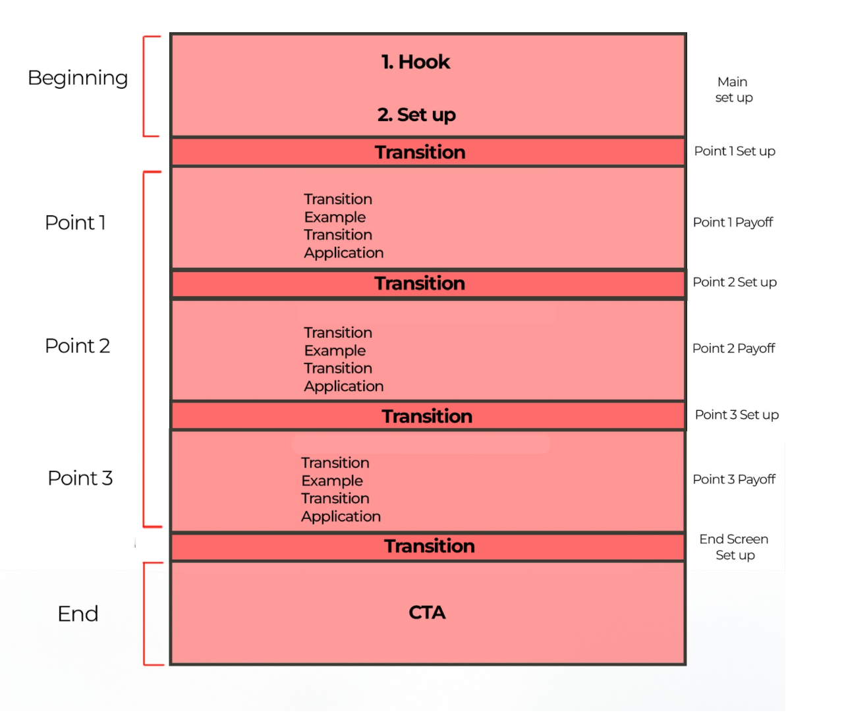

How To Skyscraper

**How To Skyscraper: A Step-by-Step Guide to Planning Videos**

The Skyscraper Method means taking what works from top-performing **outliers** (popular videos on your topic) and improving on them to create something **better**, **more engaging**, and **unique**.

### **How to plan a videos using the Skysraper method**

**Step 1: Find an Outlier on The Topic You Want To Cover**

* Start with the videos in your pattern bank
* Research YouTube if there isn't a good example

**Step 2: Analyze Outlier**

* **Watch the Video** (Recommended):  
    
  Note down:  
  + - The **main points** they covered.
    - Anything creative (stories, metaphors, visuals) that kept it engaging.
    - What worked well and what’s missing.
* **Use Skyscraper Bot (Optional)**:  
  + Download the video transcript using a [**Chrome extension.**](https://glasp.co/youtube-summary?ref=youtube-summary)
  + Copy up to **200+ comments** (text only) and the transcript into the [**Skyscraper Bot.**](https://chatgpt.com/g/g-WB8ISCLFq-skyscraper-bot)
  + Review the bot's summary:

⚠️ **Warning**: Don’t blindly follow comment suggestions. Use your judgment to filter what fits **your audience**.

**Step 3: Analyze Multiple Outliers (Optional)**

* For the **best results**, analyze **2-3 videos** on the same topic.
* If you’re overwhelmed, start with just one.

**Step 4: Wireframe Plan Your Video   
  
See Wireframe planner in “Writing templates**

1. **Bullet Point the Content**:  
   * List the points you’ll include (what the outlier video covered).
   * Add something that wasnt covered or the comments felt was missing missing
2. **Plan The Example+ Application Bricks**:  
   * Use the example section of each point toShow: Use stories, metaphors, examples, or visuals to make points.
   * Add creative hooks or unique presentation styles to differentiate your video and level it up past the outlier.
   * Plan actionable steps viewers can take in the application brick
3. **Refine the Order**:  
   * Option 1: Start with the most **exciting point** viewers will care about
   * Option 2: Save it until the end
   * Both can work, we Ready, Fire, Aim to learn which is best

**Step 5: Write the First Draft**

1. Open the wireframe plan document and the script template document side by side and write your script
2. **Set a Timer** for 1-2 hours and focus on getting to the end of the script.
3. Remember:
   * First drafts don’t need to be perfect.
   * You’ll refine and edit later
   * Once you get to the end you can then edit it and fix up the script.
   * **Present It Out Loud**: This helps spot waffle, confusing points, awkward sentences

**Step 6: Get Feedback**

1. Use Feedback Tools:
   * Paste the intro into the **Intro Bot** for suggestions.
   * Paste individual points into **Point Bot** to identify areas for improvement.
   * Ask the team

⚠️ **Don’t rely on AI for writing full scripts**, use it to refine and improve your own work.

Writing

**Writing section index:**

In this section we have everything you need to write and plan your videos.

1. **How To Skyscraper**

* Identifying and analyzing top-performing outliers
* Enhancing outlier content with creative and actionable additions
* Using wireframe planning to structure engaging videos
* Writing and refining scripts with a focus on unique value
* Leveraging feedback tools and team input for improvements

1. **Wireframe plan template** - Use this template to plan your videos before writing
2. **Intro Brick** - Use this guide + template to plan and write your intros
3. **Middle Brick** - Use this guide + template to plan and write your points
4. **End Brick -** Use this guide + template to plan and write your end
5. **Script Template** - Turn your plan into a written script following the template

Set Ups & Payoffs

**Set ups & Payoffs**

Your YouTube script has three objectives:

1. **Engage viewers**, keeping them curious and invested.
2. **Simplify complex information** so anyone can understand it.
3. **Build credibility** so viewers trust and want to return to you as their go-to source.

But how do you keep them engaged?   
  
The secret lies in mastering setups and payoffs to create and release tension

### **Tension and Release**

A great script is a game of building tension and releasing it repeatedly.

* Tension grabs attention
* Release satisfies curiosity.

Think of TV cliffhangers: they build suspense and leave you desperate for the next episode.   
  
Similarly, YouTube scripts must constantly build and release tension to keep viewers glued.

Even if your video is about something mundane, like reviewing brussels sprouts, your script’s structure must create curiosity and satisfaction.   
  
This cycle of tension (setup) and release (payoff) is the backbone of any engaging video and you create this using set ups and payoffs.

### **What Are Setups and Payoffs?**

#### **Setups**

A setup introduces an idea, question, or situation designed to spark curiosity. Like the opening of a joke, it hooks the audience:

* Example: “Why don’t skeletons fight each other?”

#### **Payoffs**

A payoff delivers the answer or resolution to the setup, satisfying the viewer’s curiosity:

* Example: “Because they don’t have the guts!”

In scripts, setups make viewers want to know more, while payoffs provide the information or resolution they seek. However, paying off too early can kill curiosity and lose viewers.

### **Crafting Effective Setups and Payoffs**

1. **Start Strong with the Intro**
   * Your intro is the first setup, promising viewers what they’ll learn.
   * Example: “In this video, you’ll discover why your team isn’t listening and how to fix it.”
2. **Use Questions to Hook Viewers**
   * Questions are powerful setups that make viewers crave answers.
   * Example: “What’s the one mistake destroying your productivity?”
3. **Tease Future Content**
   * Teases act as setups for later payoffs.
   * Example: “By the end of this video, you’ll know how to bake the perfect cake.”
4. **Avoid Early Payoffs**
   * Don’t reveal the answer too soon, or viewers will lose interest.
   * Example of a bad script:  
     + Setup: “Why doesn’t your team listen?”
     + Early Payoff: “Because you’re not writing instructions.”
     + Solution: Unpack the problem first, then provide the solution.

*The way I will teach you how to structure you’ll avoid early payoffs (See structure guide for more info)

1. **Structure Like a Rollercoaster**
   * Alternate between setups and payoffs to keep curiosity high:  
     + Setup: “Why don’t cakes rise properly?”
     + Payoff: “Because you’re not measuring ingredients accurately.”
     + Next Setup: “But how do you measure them perfectly?”

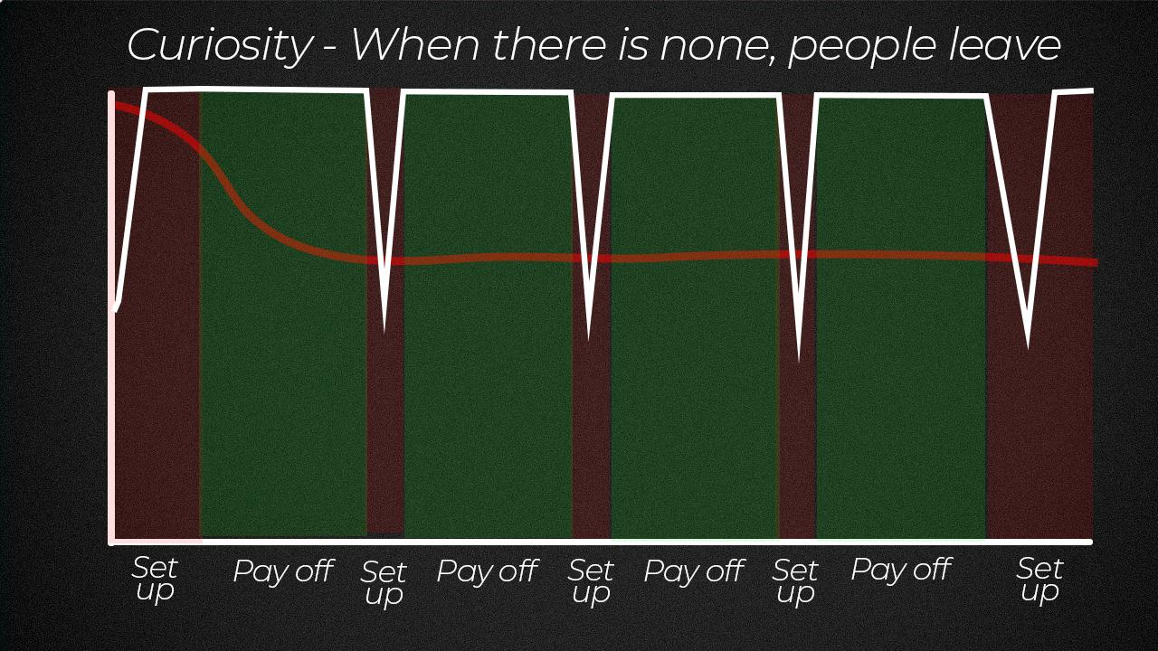

### **Types of Setups**

1. **Tease a Reveal**
   * Example: “By the end of this video, you’ll know the secret to perfect pancakes.”
2. **Ask a Question**
   * Example: “But how do you make jam that’s the perfect blend of gooseberry and gin?”
3. **Introduce a Problem**
   * Example: “I’m testing three productivity methods to see which works best.”
4. **List What’s Coming**
   * Example: “Next, I’ll show you how to pick the best gooseberries for your jam.”
   * Add why it matters: “So your cake doesn’t taste like dust.”

### **Where to Use Setups and Payoffs**

1. **Intro**
   * Set up what the video will cover in a way that sparks curiosity.
2. **Throughout the Script**
   * After every payoff, introduce a new setup to keep the viewer engaged.
   * Example: “Which brings us to the fifth method…”
3. **End Screen**
   * Use the end screen to set up the next video.
   * Example: “Want to learn the ultimate tip for raising credibility? Check out this video.”

### **Common Mistakes to Avoid**

1. **Paying Off Too Early**
   * Early payoffs kill curiosity. Instead, unpack the setup before revealing the answer.
2. **Forgetting Payoffs**
   * Failing to resolve a setup frustrates viewers and damages credibility.
   * Solution: Highlight setups in your script to ensure you pay them off.
3. **Clickbait Without Payoff**
   * Don’t promise something in your title or thumbnail that the video doesn’t deliver.

### **Mastering the Art of Setups and Payoffs**

Practice makes perfect. Over time, as you analyze your retention data, you’ll learn which setups resonate with your audience and refine your approach.

* **Track Your Setups**: Highlight them in your script for easy reference.
* **Experiment**: Test different setups and payoffs to see what works best.
* **Analyze Retention**: Use analytics to identify where viewers drop off and adjust accordingly.

### **Final Thoughts**

Your video’s job is to create curiosity and then satisfy it while continuously keeping viewers hooked. By mastering setups and payoffs, you’ll ensure your audience stays engaged, learns from your content, and trusts you as a credible source.

Now that you understand setups and payoffs, let’s move on to structuring your video for maximum impact!

Structuring a script

#### **Script Structure**

Writing a script can feel overwhelming when you don’t know where to start or what comes next.   
  
But with a simple, repeatable structure, scripting becomes much faster and easier.   
  
Over time, this approach I'm going to teach you helps you:

1. **Save Time**: Reuse the structure to eliminate guesswork.
2. **Improve Retention**: Analyze your video’s performance by identifying which sections hold or lose viewers.
3. **Deliver Consistent Value**: Keep your message clear and focused across all your videos.

### **The Basic Structure of a Script**

A great YouTube script is like a wall made of bricks.   
  
Each brick builds on the previous one, stacking together to form a cohesive beginning, middle, and end.

Here’s the basic structure:

1. **Introduction (Hook + Setup)**: Grab the viewer’s attention and set up the value of the video.
2. **Body (Points + Payoffs)**: Each point you make consists of:
   * The problem.
   * How you’ll solve it.
   * An example.
   * Application for the viewer.
   * A teaser for the next point.
3. **Conclusion (Final Setup + Call to Action)**: Recap the main points and direct viewers to the next video.  
     
   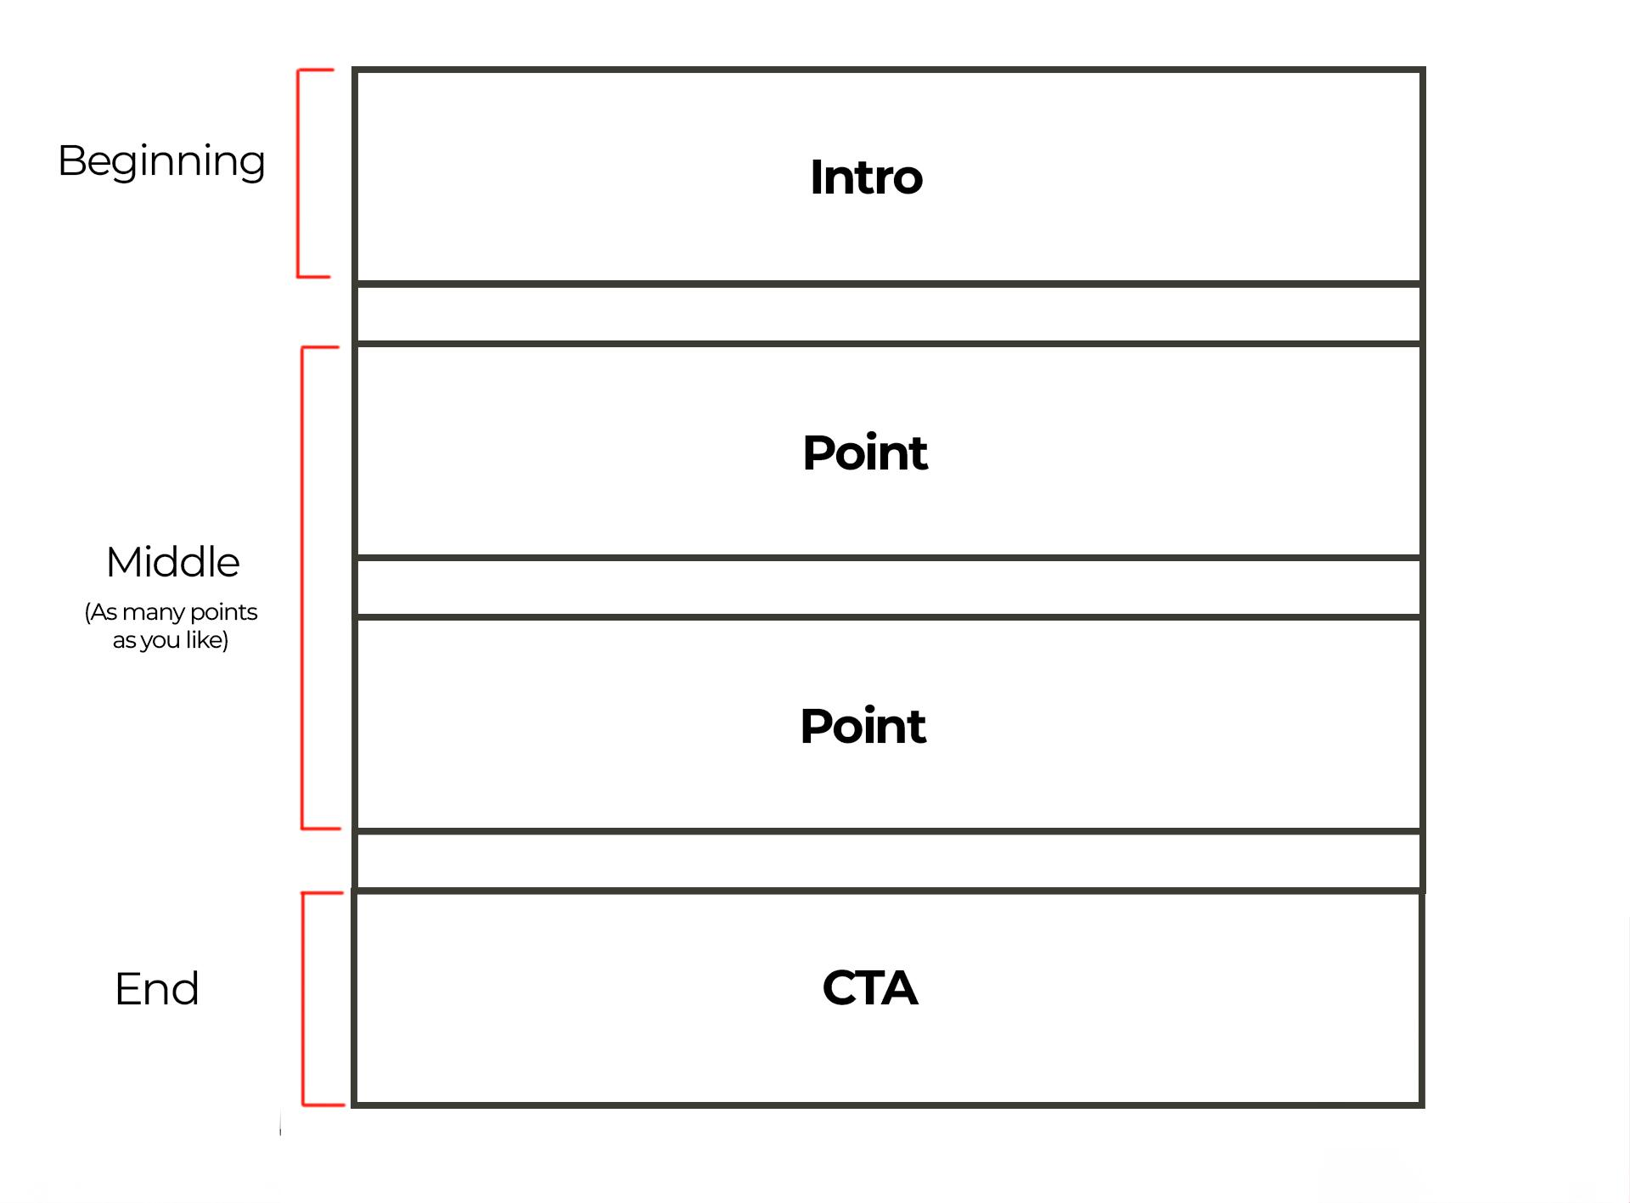

### **How It Works in Practice**

In its simplest form, every section of the video follows a repeatable pattern:

* **“You have a problem.”**
* **“Here’s how I’ll help you solve it.”**
* **“Here’s an example of how it works.”**
* **“Here’s how you can apply it yourself.”**
* **“Watch this next, because it’ll solve another problem you have.”**

#### **Example for a Script Covering 3 Points** (Please don't use this as a template, it's just a very simplified version to help you understand, )

**INTRO**:

* You have a problem.
* I’m going to help you solve it.

**Point 1**:

* You have a problem.
* I’m going to help you solve it.
* Here’s an example of how it works.
* Here’s how to apply it yourself.
* Watch this next because it’ll solve another problem you have.

**Point 2**: *(Repeat the same structure as Point 1)*

**Point 3**: *(Repeat the same structure as Point 1)*

**OUTRO**:

* You have a problem.
* Watch this next because it’ll solve another problem you have.

### **Why This Structure Works**

1. **Clarity**: It keeps your video focused and easy to follow.
2. **Scalability**: You can apply this structure to a single-point video or multiple points.
3. **Retention**: By addressing problems and teasing solutions, you encourage viewers to keep watching

### **The BENS Framework**

Each part of your script should incorporate BENS principles to keep it engaging:

* **B (Big)**: Make big claims that excite viewers about the value of your content.
* **E (Easy)**: Present your solutions in a way that feels simple and achievable.
* **N (New)**: Frame your advice as fresh and unique, even if it’s a new perspective on an old idea.
* **S (Safe)**: Write in a way that builds trust by simplifying complex topics and showing credibility.

### **Practical Tips for Success**

1. **Practice Makes Perfect**: Your first scripts might feel clunky, but practice will make the process faster and smoother.
2. **Use the Brick Wall Analogy**: Think of each part of your script as a brick that builds the foundation for your next video.

Write Without Overwhelm

### **Write Without Overwhelm**

Writing scripts can feel daunting, especially when you’re just starting out. But with the right mindset and process, it becomes easier, faster, and more enjoyable over time.

This guide will show you how to overcome the initial struggle, write efficiently, and refine your scripts to perfection.

### **The Writing Struggle is Normal**

* Writing at first feels slow, frustrating, and full of second-guessing.
* This happens because you don’t yet have feedback from your audience, making it hard to feel confident.
* Recognize this as part of the process, your goal isn’t to write perfectly but to **write consistently**.

### **The Secret: It’s Just a First Draft**

* Your first draft is just for you, nobody else will see it.
* Focus on **getting to the end as quickly as possible** rather than making it perfect.
* Once the core ideas are on the page, editing becomes easier and faster.

### **Step-by-Step Writing Process**

1. **Set a Timer**:
   * Dedicate one uninterrupted hour to writing.
   * Turn off distractions and focus solely on finishing the draft.
2. **Follow a Structure**:  
   * Use your wireframe plan or script template to guide you.
   * Write your intro, fill in the middle points, and end with a clear conclusion.
3. **Speak Instead of Write (Optional)**:  
   * Record yourself explaining the topic.
   * Transcribe the audio and edit it into a script.
4. **Present Your Draft Out Loud**:  
   * Present the script as if you were delivering it.
   * This will help you catch errors, awkward phrasing, or missing pieces.

### **Leverage AI for Feedback**

1. **Intro Bot**:
   * Paste your intro into the bot to get suggestions for improvement.
   * Incorporate feedback to strengthen your hook and clarity.
2. **Point Bot**:
   * Use the bot to analyze individual points in your script.
   * Get feedback on clarity, engagement, and alignment with your structure.

### **Tips for Writing Efficiently**

1. **Separate Writing and Editing**:  
   * Write without stopping or editing.
   * Once finished, spend time refining and polishing.
2. **Focus on Core Ideas**:  
   * Avoid overthinking, write simple, clear points first and refine later.
   * If you get stuck trying to think of a way to show not tell just move on
3. **Practice Regularly**:  
   * The more you write, the faster and better you’ll become.
4. **Go for a walk**

If you ever get stuck, go for a walk outside for 15 mins, the amount of problems Ive solved this way is mindblowing.

### **Why Editing is More Important Than Writing**

* Writing quickly helps you get ideas out, but editing is where you craft the perfect script.
* Spend more time refining your script after the first draft is complete.

### **The Bigger Picture**

* The skills you develop, storytelling, metaphors, and examples, don’t just grow your YouTube channel; they also apply to marketing and sales. So get good at them now and you’ll make more money.
* These techniques create more engaging content, drive sales, and improve your communication across other social media platforms too.

Intro Brick

**Intro Brick Index**

In this section we have everything you need to help you write intros

1. Intro brick template

2. Intro brick guide

3. Intro examples

Intro Brick Template

**🎬 Intro Brick Template**

## 

## **Intro template:** *Use this template to write your intros and check off each point to make sure you don’t miss anything out.*

## *Scroll down for examples and a more detailed explanation of each section.*

## *Make a new fresh doc and use this as a guide whilst you write*

## **Start Here: Pre writing:** Write down 3 questions your viewers might have when they see your thumbnail and title (Ideally a “why”, “why” or “how”)

**1. Hook: Question, Statement, Fact, Credibility**

* Did you write one line that makes people curious to know more?
* Did you choose a hook type? (Question, Statement, Credibility, or Fact)
* Is the hook short and engaging?

*Check out the hook bank for some inspiration.*

**2. Problem/Result: Set up a problem or result**

* Did you set up a problem that viewers can relate to, or highlight a result they want?
* Does the problem or result clearly tie into the video’s content?

**3. Set Up: Say up to three things the video will cover**

Turn the questions you think viewers have into “coming up” points.

* Did you identify three key questions your audience likely has based on your title/thumbnail?
* Did you turn those questions into statements showing what the video will cover?

**4. Transition to brick one: “So start let me show you X”**

* *Did you make it clear the problem or result the following information will solve/bring?*
* **Warning:**Don’t say “to start let me show you why you need to know this” or “why this matters” you just say the reason it matters in the transition.

#### **5 : Inject Credibility**

* Did you mention your expertise, client results, personal results, or research?
* Did you weave credibility into one of these sections? (Ideally it becomes part of the content not its own unique line)

#### **6: Final Checks**

* Does the intro align with the video’s title/thumbnail to avoid clickbait?
* Did you avoid repeating words or phrases multiple times?
* Will anyone be able to understand the words you use?
* Is your intro under 100 words/15 seconds? (Do not go over 30 seconds)
* Did you apply the BENS framework (Big, Easy, New, Safe)?
* Did you use AI to get feedback?
* Did you get feedback from the team?
* If you submitted feedback to the team, move on to work on something else whilst you wait for a response

### 

### 

### 

Intro Guide

### **Intro Guide**

Before you start writing your introwrite down up to 3 questions your viewers might have when they see your thumbnail and title (Ideally a “why”, “why” or “how”)

**1. Hook: Write one line that makes people curious to know more**

*See the hook bank on the left for inspiration*

Here are some options for hooks.

* *Question hook - Ask a question that makes viewers curious*
* *Statement hook - Make a bold statement*
* *Credibility hook - Lead with an amazing achievement (needs to be big)*
* *Fact hook - Hit them with a very surprising fact (must be surprising)*

*Examples*:

"Have you ever wondered why [problem] happens?"

"Did you know [shocking fact]?"

"I've [big achievement]—here's how."

*Reminder*: Keep it under **5 seconds**. Create **curiosity** and align it with your title/thumbnail.

**2. Problem/Result**

Next set up a problem or result, it is possible for your hook to set up a problem/result at the same time. If it does, don’t write another.

*Examples:”*

*“Knowing this will transform your Y”*

*“When you stop doing this you’ll X”*

*“When I stopped doing this I X”*

**3. Set up the value of the video to come**

Turn the three questions you think your viewers have based on your thumbnail and title into statements that say the video will cover them.

*Examples:*

*"In this video, I’m going to show you:*

*[Point 1]*

*[Point 2]*

*[Point 3]"*

*Reminder: Use* ***BENS****—Big, Easy, New, Safe.*

**4. Inject credibility**

Weave credibility into the hook, problem/result section or the set up.   
  
If you’re not sure what to say, here are some prompts to help you:  
 *1. Mention how long you've been an expert in your field*

*2. Mention how many people you’ve already helped solve the problem the video covers*

*3. Mention a big result you’ve got for yourself that relates to the videos topic*

*4. Mention off big results you’ve got off for your clients that relates to the videos topic*

*5. Make it sound like you put a hell of a lot of research into the video’s content*

*Example:*

*“So in this video im going to show you how I used this strategy to generate 10,000 new followers in a day”*

*“And I know this works because my clients have gone from complete beginners to performing on stage in 90 days using this:”*

**5. Transition to Middle**

End with a sentence to smoothly set up the value of the first point.

*Example*:

*"To start, let me show you how to [result/solve problem]."*

When you transition, it is critical the viewers know the impact listening to the following section will have on THEM.

If they don’t know how it'll impact their lives they won't care.

We never say “let me tell you why x matters” though or “let me show you why you need to know this”

The transition's job is to make that clear. For example:

“To start let me show you how to stop people unsubscribing from your email list so you don't lose out on income”

Viewers will know “why” this is important now.

### 

### 

Intro Examples

### **Example Intros**

**1. Hook:** Did you know Apple Notes can scan documents, turn handwriting into text, and link notes like a pro productivity app?

**2. Result or problem:** Most people don’t, so they end up using multiple apps, cluttering their workflow and wrecking productivity.   
  
**3. Set up + credibility:** To stop that happening to you, I’m going to reveal another 25 game-changing Apple Notes features I've helped hundreds of business owners use to 10x their productivity over the last 10 years.

**4.Transition:** First, I'm going to show you a massive mistake you must avoid that wrecks productivity even if you’re using the Apple Notes features

**1. Hook:** Do you hate making thumbnails?

**2. Result or Problem:** I do, but they’re the most important part of your video because if you can’t get a click It's game over for your video.

**3. Set up+ credibility :** So today i'm going to show you how I generated 30 million views with a boring thumbnail design, you’ll learn how to make them PLUS how to come up with image ideas 10x faster

**4.Transition:** To start I'm going to show you a time saving hack that’ll transform the rate you come up with killer thumbnail ideas.

Middle Brick

**🎬 Middle Brick**

In this section you’ll find

1. Middle brick Basics
2. Middle brick detailed writing guide
3. Middle template
4. Story guide
5. Metaphor guide
6. Frameworks guide

Middle Basics

**🎬 Middle Brick Guide - Making your points**

In the middle brick you make your points, pay off what you set up in the intro and add more if you like too.

The Middle Brick is where you deliver **value** by breaking your video into clear, structured **points**. You can cover **as many points as you like**, but follow this sequence for each point:

* Scroll down for examples and a more detailed explanation of each section.
* Make a new fresh doc and use this as a guide whilst you write

**How to make an amazing video**

Amazing video is

1. Actionable
2. Informative
3. Entertaining

Follow this structure to tick off all of these things in the middle brick.

#### **Why Making Viewers Feel Smart is the Key to Success**

The best videos make viewers feel **inspired, empowered, and capable** of applying what they’ve learned. When your content helps viewers get real results, you turn casual viewers into loyal fans and even buyers.

To achieve this, your job is to simplify complex topics into content that’s easy to understand and actionable. Think of it as untangling a ball of yarn and presenting a clear, smooth thread.

### **The Problem with Overcomplication**

1. **Complex Words and Theories**:
   * Long, technical terms or overly complex ideas make your audience feel lost.
   * Result: They click away, thinking, “This is too hard.”
2. **Overloading Information**:  
   * Giving too much information at once overwhelms your viewers, making them tune out.

Your goal is to simplify the information and present it in a way that makes viewers feel **smart**, not confused.

### **How to Simplify Your Content**

#### **1. Use Short Sentences**

* Break down big ideas into smaller, digestible chunks.
* Delete unnecessary words to keep your message concise.

#### **2. Avoid Jargon and Big Words**

* Don’t use industry terms unless you explain them clearly.
* Replace complex language with simple, relatable words to keep everyone engaged.
* **Remember**: Simplicity doesn’t make you look less smart; it makes your audience feel smarter.

#### **3. Show, Don’t Tell**

* Humans are natural storytellers. Instead of explaining everything, use examples, demonstrations, or visual aids to let viewers figure it out themselves.
* This engages their imagination, makes your points more memorable, and keeps them hooked.

### **Examples of “Show, Don’t Tell” in Action**

#### **Breaking Down Dating**

**Telling**: “Be charismatic to improve your personality.”

**Showing**: Analyze a celebrity clip to highlight specific behaviors, then explain how to replicate them.

#### 

#### 

#### **Product Review**

**Telling**: “The battery life on this is excellent.”  
  
**Showing**: Film a real test where the product is running, and periodically check in to show how long it lasts.

#### **Fixing Posture**

**Telling**: “Stand with a straight back to improve your posture.”  
  
**Showing**: Film a demonstration of the correct posture and show how it compares to common mistakes.

### **The “Show, Don’t Tell” Advantage**

1. **Engages Viewers**: When you show something, viewers feel involved and pay closer attention.
2. **Simplifies Understanding**: Visual examples help your audience connect the dots faster.
3. **Inspires Action**: Seeing an example makes viewers more likely to try it themselves.
4. **Makes Your Content Stand Out**: While others lazily explain, you actively demonstrate, creating a memorable experience.

### **Common Mistakes to Avoid**

1. **Overloading Your Video with Tools**:  
   * Don’t try to use every technique at once. Focus on what fits your point best.
2. **Expecting Instant Results**:  
   * These skills require practice. Just like learning an instrument, you won’t master them on your first try.
3. **Abandoning Too Soon**:
   * Even if a tool doesn’t work perfectly the first time, keep refining it. Great communicators like Steve Jobs and Einstein swore by these methods—they work with practice.

### **Mindset for Long-Term Success**

* Think of your journey on YouTube as a **long-term game**.
* Be patient with yourself and embrace the process of improving your communication skills.
* These tools are more than just video techniques—they can transform your entire approach to storytelling and education.

Middle Brick Writing Guide

### **Middle Brick Writing Guide**

**Step 1: Transition from intro to point (The intro template ends on this, if you’ve done it already, don't do it again”**

**Goal**: Set up why this point matters to the viewer.

* Does the transition explain **why this point is critical** or tease a **big result**?  
  + *Example*: “To start, let me show you how to [solve problem or get result].”
  + *Alternative*: “But here’s the thing—you’re probably making this mistake, and it’s costing you.”

**Prompt**: *Why should they care about this point? What’s in it for them?*

**Warning:**Don’t say “to start let me show you why you need to know this” or “why this matters” you just say the reason it matters in the transition.

**Step 2: Example Brick**

**Goal**: Show, don’t tell, make the point relatable, easy to understand, and engaging.

Ask yourself “How can I show something to make my point”  
  
Choose ONE of the following tools:

* **Story**: Show how someone (you, a client, a celebrity) solved the problem.  
  + Who had the problem?
  + What was the problem
  + Why did they need to fix it? (Stakes)
  + What conflict did they face?
  + How was the problem solved?
  + *Example*: “My client had 30 days to make $10k before they went bankrupt and no clue how they were going to do it, so they started calling every lead that have enquired over the last 4 years.........tell story”
* **Metaphor**: Compare the problem to something simple and relatable.  
  + Does the metaphor simplify the idea?
  + Is the comparison easy to understand?
  + *Example*: “Growing a YouTube channel is like building a chain. If one link breaks, the whole thing falls apart.”
* **Framework**: Use a structured process, acronym, or model to simplify the point.  
  + Did you break the concept into actionable steps or visuals?
  + *Example*: “The P.A.C.E. method: Plan, Apply, Check, and Execute. Here’s how it works...”

**Prompt**: *How can I SHOW the point using a story, metaphor, example or framework?*

**Step 3: Transition to Application**

**Goal**: Set up the actionable steps by connecting the example to what the viewer needs to do.

* Does the transition tease what the value to the viewer will be next?
  + *Example*: “Now that you’ve seen how this works, let me show you exactly how to do it yourself.”
  + *Alternative*: “Here’s how you can apply this to [get the result].”

**Prompt**: *What actionable steps will they need to follow next?*

**Step 4: Application Brick**

**Goal**: Deliver simple, clear steps viewers can take to achieve the result.

* Did you break the steps into **small, manageable actions**?
  + Step 1: [First action]
  + Step 2: [Next action]
  + Step 3: [Final step]
* Are the steps easy to understand and follow?

**Prompt**: *What can the viewer* ***do right now*** *to get the result?*

**Step 5: Transition to the Next Point**

**Goal**: Move smoothly to the next point by setting up a new problem or teasing a new result.

* Does the transition tease a **new problem or result**?
  + *Example*: “But here’s the thing—fixing this is only half the battle. Next, I’ll show you how to [solve the next big problem or achieve result #2].”

**Prompt**: *What’s the next logical problem or point to cover?*

**Step 6: Repeat**

Middle Template

**The Middle Brick Template**

**Step 1: Transition to the Point**

Move from the previous point into the next by letting viewers know the problem or result the following information will bring.

* Set up the problem or result the next point will solve/get the viewers in a sentence
* Check out the transition bank for inspiration

**Step 2: Example Brick**

Show how to solve the problem or get a result using one of the following:

* Story
* Metaphor
* Example
* Framework
* Check out the story prompts to help you some up with stories
* Check out the metaphor prompt to help you come up with metaphors
* This section could be one sentence it could be 2 minutes, there is no time limit

**Step 3: Transition to Application**

* Set up the problem or result the next point will solve/get the viewers in a sentence

**Step 4: Application Brick**

* Deliver simple, clear steps viewers can take to achieve the result.
* This section could be one sentence it could be 2 minutes, there is no time limit

**Step 5: Transition to the Next Point**

* **Goal**: Set up the problem or result the next point will solve/get the viewers in a sentence

**Step 6: General middle brick checklist**

* I avoided **complex language** (no jargon, technical terms, or long words)
* I kept **sentences short** and easy to follow.
* I simplified the point so that even a **beginner** could understand it.
* I used Point Bot for individual point feedback
* I didn’t repeat myself or summarise anything.
* I made sure the example was **relevant** to the viewer’s problem or goal.
* I included **clear steps** viewers can take to apply the point.



Story

**A guide to story**

What’s included in this guide

1. Introduction
2. Why Are Stories So Powerful
3. The Basics of a Story
4. Why Stories Work in Examples
5. Story Structure: The Building Blocks
6. Types of Stories to Use in Examples
7. How to Transition Between Sections
8. Common Mistakes to Avoid
9. Pro Tips for Better Storytelling
10. How to Structure a Story
11. Types of Endings
12. How to Find Stories
13. The South Park Storytelling Formula

Stories are a powerful tool for making your examples engaging and memorable. They keep viewers hooked, explain concepts clearly, and show how problems are solved in a way that’s easy to understand.   
  
In this guide, we’ll explore the three types of stories you can use, how to tell them and how to transition seamlessly into the application section of your videos.

### **Why Are Stories So Powerful?**

1. **Engages the Brain**: Stories activate regions in the brain responsible for sight, sound, taste, and movement, making information feel vivid and real.
2. **Enhances Retention**: Viewers remember stories better than raw information because they’re emotionally involved.
3. **Builds Credibility**: Stories show how you or others overcame challenges, proving your expertise without sounding like a sales pitch.
4. **Simplifies Complex Ideas**: A well-told story breaks down big concepts into relatable, easy-to-understand experiences.
5. **Creates Transformation**: Stories show growth, inspiring viewers to take action and solve their own problems.

### **The Basics of a Story**

At its core, a story is about **someone trying to solve a problem**.

1. **Relatability**: The problem must resonate with your audience. If they don’t see themselves in the story, they won’t care.
2. **Structure**: Every great story has a beginning, middle, and end.

### **Why Stories Work in Examples**

1. **Retention**: Stories often create the flattest parts of your retention graph, meaning viewers stay engaged.
2. **Relatability**: They connect with your audience by showing them how problems like theirs can be solved.
3. **Clarity**: Instead of explaining a concept, you demonstrate it through a narrative.

### **Story Structure: The Building Blocks**

Each story should include:

1. **Who**: The person or character the story is about.
2. **Problem**: What problem are they trying to solve?
3. **Why**: Why is solving the problem critical? (This is where stakes come in.)
4. **Conflict**: The obstacles or challenges they faced.
5. **Payoff**: Did they get what they wanted and what they needed?

Finally, transition into the **application** section, where you explain how viewers can use the lesson in their own lives.

### **Types of Stories to Use in Examples**

#### **1. Fictional Stories**

These are imagined scenarios designed to illustrate a point.

**Example Breakdown**:

* **Transition**: “Now let me show you 5 game-changing ways to build trust and credibility fast in your videos.”
* **Story**:
  + Who: You’re stuck in an elevator with Warren Buffet.
  + Problem: You want investment advice.
  + Why: He’s a financial genius, and you don’t want to waste the opportunity.
  + Conflict: He spends five minutes talking about his vacation instead.
  + Payoff: You still pay attention because of his credibility. He gives you what you want (a conversation) but not what you need (useful investment advice).
* **Application Transition**: “But how do you build that kind of credibility in your videos?”

#### **2. Stories About Others**

These involve telling true stories about well-known people, companies, or events.

**Example Breakdown**:

* **Transition**: “So what is this big mistake I'd say 99% of businesses make on YouTube?”
* **Story**:
  + Who: Michael, the founder of Dollar Shave Club.
  + Problem: Razors were too expensive.
  + Why: He wanted to offer a cheaper solution to disrupt the market.
  + Conflict: Nobody believed a $1 razor could be good, and the business struggled.
  + Payoff: Michael created a viral ad campaign that made Dollar Shave Club famous. He got what he wanted (a successful product launch) and what he needed (proof that creativity could solve market skepticism).
* **Application Transition**: “But how does this help you grow your YouTube channel?”

**Pro Tip**: Use unique, lesser-known stories to make your content stand out.

#### **3. Personal Stories**

These stories come from your own experiences, making them the most relatable and credible.

**Example Breakdown**:

* **Transition**: “Have you ever wondered why your traffic suddenly drops for no reason? Well, let me tell you a story.”
* **Story**:
  + Who: Me (Ed).
  + Problem: My sales plummeted after traffic dropped 90%.
  + Why: I needed to figure out why to keep my business afloat.
  + Conflict: After trying several fixes, I realized the problem was poor descriptions.
  + Payoff: I improved my descriptions, and sales rebounded. I got what I wanted (restored traffic) and what I needed (a better understanding of how to optimize descriptions).
* **Application Transition**: “So how do you write descriptions that get more sales? Here’s how.”

**Pro Tip**: Don’t be afraid to share failures—they show your human side and build trust.

### **How to Transition Between Sections**

1. **From the Previous Point to the Story**:
   * Tease the problem you’re about to solve.
   * Example: “So what’s the mistake you must avoid to grow your YouTube channel?”
2. **From the Story to the Application**:
   * Summarize the lesson from the story.
   * Tease the actionable steps viewers can take.
   * Example: “That’s the power of credibility—when people fully understand how useful you can be, they pay attention fast. But how do you do that?”

### **Common Mistakes to Avoid**

1. **Explaining the Point Before the Story**:
   * Don’t say, “Credibility is important, let me explain why.” Instead, start with the story and let viewers draw the conclusion.
2. **Dragging Out Stories**:
   * Remove unnecessary details that don’t contribute to the payoff.
3. **Weak Transitions**:
   * A weak transition can lose viewers. Make sure your transitions clearly connect the example to the lesson.

### **Pro Tips for Better Storytelling**

1. **Focus on the Stakes**:
   * The more urgent the stakes, the more engaging the story.
   * Example: “I had no money and was living in a dangerous neighborhood—I had to find a solution fast.”
2. **Keep It Relatable**:
   * Use problems your audience might face to make the story relevant.
3. **Test and Refine**:
   * Review your retention graph to see where viewers drop off. Adjust your stories and transitions accordingly.

### 

### **How to Structure a Story**

#### **1. The Beginning: Set Up the Problem**

* **Who**: Introduce the person the story is about.
* **What**: State the problem they face.
* **Why**: Explain why solving the problem is critical (stakes).

**Example**:  
*"I just quit college, had no money, and was living in a back alley in New York’s most dangerous neighborhood. I had to find a way to make cash fast."*

**Checklist**:

* Who: The storyteller (you or someone else).
* Problem: No money, no home.
* Stakes: Dangerous neighborhood, survival depends on solving the problem.

#### **2. The Middle: Show Conflict and Solutions**

* **Conflict**: Outline the challenges the person faced when trying to solve the problem.
* **Solutions**: Show how they tackled each obstacle and what they learned.
* **Engagement Tip**: Highlight conflicts your viewers might face so they see themselves in the story.
* This can be 90 seconds, 10 seconds, 20 minutes, the length is down to you. But only include information that impacts the final payoff.
* Ask Point bot to cut down any info in your stories that doesn't impact the payoff

**Example**:  
*"I tried selling my old clothes, but nobody was buying. Then, I discovered an online freelance platform, but I couldn’t get hired until I revamped my profile with these three changes."*

#### **3. The End: Deliver the Payoff**

* **Outcome**: Did they succeed? What did they learn?
* **Transformation**: Show how they changed by solving the problem—or what they learned from failing.
* **Retention Tip**: Tie the outcome back to the stakes introduced at the start.

**Example**:  
*"By following this process, I made enough money to get out of the back alley and rent my first apartment. It wasn’t just about money—it taught me how to create opportunities even when the odds are stacked against me."*

### **Types of Endings**

**1. The Hero Gets What They Want and What They Need**

* **Description**: This is a classic happy ending where the protagonist achieves both their external goal (what they want) and their internal transformation (what they need).
* **Example**:
  + *Titanic*: Jack and Rose both survive by sharing the door, living a happy life together.
  + *Why It Works*: Audiences love this type of ending because it’s emotionally satisfying and ties up loose ends.
* **When to Use It**: Ideal for stories that are meant to inspire or leave viewers feeling optimistic.

**2. The Hero Gets What They Want but Not What They Need**

* **Description**: The protagonist achieves their goal but misses out on deeper personal growth or a necessary change. This creates a bittersweet or ironic ending.
* **Example**:
  + *Titanic (Alternate Version)*: Jack and Rose survive the sinking and begin a life together. But over time, Jack’s free-spirited nature clashes with Rose’s desire for stability, and their relationship falls apart.
  + *Why It Works*: This ending feels realistic and adds complexity by showing that getting what you want doesn’t always mean true happiness.
* **When to Use It**: Great for stories that explore human flaws or provide a cautionary tale.

**3. The Hero Gets What They Need but Not What They Want**

* **Description**: The protagonist sacrifices their goal but gains the growth or transformation they truly needed. This ending often feels bittersweet but meaningful.
* **Example**:
  + *Titanic (Another Version)*: Jack dies, but Rose survives and goes on to live a full life, finding strength and independence she never knew she had.
  + *Why It Works*: This ending emphasizes personal growth and resonates deeply because the hero’s journey feels worth it, even without the external win.
* **When to Use It**: Perfect for stories about resilience, sacrifice, or personal transformation.

**4. The Hero Gets Neither (The Greek Tragedy)**

* **Description**: The protagonist fails to achieve their goal and doesn’t grow or transform. This creates a tragic ending that leaves the audience reflecting on loss or missed opportunities.
* **Example**:
  + *Titanic (Tragic Version)*: Jack and Rose both die in the freezing water, leaving behind only the memory of their love.
  + *Romeo and Juliet*: Both lovers die due to miscommunication and family conflict.
  + *Why It Works*: Tragic endings evoke strong emotions and often carry a powerful moral or lesson.
* **When to Use It**: Best for cautionary tales or when you want to leave a lasting emotional impact.

**How to Choose the Right Ending for Your Story**

1. **Consider Your Message**:
   * What takeaway do you want your audience to have?
   * Happy endings inspire; bittersweet endings provoke thought; tragic endings warn or emphasize consequences.
2. **Think About Your Audience**:
   * Will they appreciate a neatly wrapped-up story, or are they more likely to engage with a complex, bittersweet resolution?

### **How to Find Stories**

1. **Personal Experiences**: Reflect on challenges you’ve overcome that relate to your audience’s problems.
2. **Client Success Stories**: Document the successes of people you’ve helped.
3. **Research Unique Stories**: Use AI tools like ChatGPT to uncover true, lesser-known stories.
   * **Prompt Example**: *“Find a true story about someone who solved [specific problem].”*
4. **Social Media & News**: Save interesting stories you come across online for future use.

**See “Stopy prompts” in the “writing prompts” asset bank for questions that’ll help you find stories**

### **Common Mistakes to Avoid**

1. **Dragging Out Stories**:
   * Delete unnecessary details. Only include what’s essential to the payoff.
2. **Explaining the Point Before the Story**:
   * If you explain the lesson first, the story feels redundant. Lead with the story to hook your audience.
3. **Overloading Details**:
   * Focus on the big picture. Avoid overwhelming viewers with nitty-gritty specifics.

### **Pro Tips for Better Storytelling**

1. **Use Stakes to Build Tension**:
   * The higher the stakes, the more engaging the story.
2. **Engage the Senses**:
   * Describe sights, sounds, and emotions to make the story vivid and immersive.
3. **Keep Practicing**:
   * Storytelling is a skill that improves over time. The more you do it, the better you’ll get.

### **The South Park Storytelling Formula**

To simplify storytelling, follow this structure:

1. **“This Happened”**: Set up the problem.
2. **“Therefore”**: Show the logical next steps.
3. **“But”**: Introduce conflict or complications to keep it interesting.

### **Next Steps**

* Start practicing storytelling in the example section of your videos.
* Keep a “story treasure chest” of great stories you encounter for future use.
* Watch the next video to see a breakdown of stories in action and how to apply them effectively to your content.

By mastering storytelling, you’ll stand out in your niche, keep viewers engaged, and build a stronger personal brand.

Metaphor

**Metaphor Guide**

Metaphors are one of the most powerful tools you can use to make your content engaging and easy to understand.   
  
By comparing complex ideas to everyday objects or scenarios, you help viewers "get it" quickly.   
  
This guide will show you how to craft metaphors, use them effectively, and avoid common mistakes.  
  
Included in this guide:

1. What Are Metaphors?
2. Why Metaphors Are Powerful
3. When to Use a Metaphor
4. How to Create a Metaphor
5. Quick Tips for Creating Better Metaphors
6. Using Props to Strengthen Metaphors
7. Transitions: Introducing Your Metaphor
8. Metaphor in Action: Example Breakdown
9. Common Mistakes to Avoid
10. Using AI to Help You Come Up with a Metaphor
11. Final Thoughts
12. How to Use Metaphors to Simplify and Engage in Your Videos

### **What Are Metaphors?**

A metaphor compares two unrelated things by stating that one **is** the other. This comparison simplifies complex problems by relating them to familiar, everyday concepts.

**Example**:

* *Complex Explanation*: “Your channel needs consistent parts working together to grow.”
* *Metaphor*: “YouTube is a chain. If one link breaks, the whole chain fails, and your channel won’t grow.”

### **Why Metaphors Are Powerful**

1. **Simplifies Complexity**: Makes hard-to-understand concepts easy to grasp.
2. **Increases Engagement**: Viewers are more likely to stay tuned if they’re intrigued by a relatable metaphor.
3. **Boosts Relatability**: Helps your audience connect emotionally and intellectually with your message.
4. **Creates Retention**: Metaphors are memorable, so viewers remember your points long after the video ends.

### **When to Use a Metaphor**

1. **To Simplify**: When a concept is too complicated or abstract to explain directly.
2. **In the Example Section**: Metaphors work best when setting up a problem before the payoff.
3. **To Add Interest**: Use them sparingly; if something is already simple, don’t complicate it by forcing a metaphor.

### **How to Create a Metaphor**

#### **Step 1: Define the Problem**

* Write down the problem you want to simplify.
* Note how it feels or what it looks like to someone experiencing it.
* Example: The problem is frustration and failure when dating.

#### **Step 2: Define the Solution**

* Clearly state the steps or outcomes your solution provides.
* Example: The solution is asking the right questions to land better dates.

#### **Step 3: Find Analogies**

* For the **problem**, think of something in the world that matches its characteristics (e.g., chaos = a storm, failure = a wall).
* For the **solution**, find something relatable (e.g., success = a bridge, connection = a key).

#### **Step 4: Create the Metaphor**

* Combine the problem and solution into a statement:
  + *“Winning your dream date is like fishing. To land a great catch, you need the right bait, a strong line, and the ability to throw back the wrong fish.”*

#### **Step 5: Test and Refine**

* Say it out loud or write it down. Does it make sense? Is it clear?
* Refine until the metaphor feels effortless and relatable.

### **Quick Tips for Creating Better Metaphors**

1. **Use Familiar Objects or Concepts**: The simpler and more common the metaphor, the better it resonates.
2. **Keep It Short**: Avoid overly elaborate metaphors that confuse more than clarify.
3. **Engage Emotionally**: Choose comparisons that evoke feelings your audience can relate to.
4. **Practice Often**: The more you practice, the easier it becomes to generate metaphors on the spot.
5. **Get Feedback**: Share your metaphor with someone to see if it clicks.

### **Using Props to Strengthen Metaphors**

Many problems are invisible or abstract, but props make them tangible.

**Example**:

* Metaphor: “Trust is like water filling a glass. You need enough to reach the top before you can ask for something in return.”
* Prop: A glass and water visually show the audience what you mean.

**Why Props Work**:

* They make abstract ideas visible and easy to understand.
* Everyday objects like water, fruit, or cups are relatable and inexpensive tools.

### **Transitions: Introducing Your Metaphor**

Before using a metaphor, always transition smoothly by setting up why it matters.

**Example Transition**:

* “Let me show you a powerful way to think about building trust, which is the foundation of growing your business.”

Without context, a metaphor can feel random or disconnected. Always explain why the audience should care before diving into it.

### **Metaphor in Action: Example Breakdown**

**Scenario 1: Using Water to Explain Trust**

* **Transition**: “Let me give you the other big benefit anyone trying to grow a business would love.”
* **Metaphor**: “This water is trust, and you need to fill the glass to the top to make sales. The more trust you build, the more willing people are to buy.”
* **Application Transition**: “But how do you build trust to fill the glass? Here’s how.”

**Scenario 2: Selling Without Being Pushy**

* **Transition**: “What’s more important than your selling ratio is this.”
* **Metaphor**: “Think of your channel as a glass. To sell without ruining your reputation, you need enough goodwill to fill the glass before making an ask.”
* **Application Transition**: “So how do you know when you’ve built enough goodwill to start selling?”

### **Common Mistakes to Avoid**

1. **Forcing a Metaphor**: If the concept is already simple, a metaphor isn’t necessary.
2. **Overcomplicating**: Keep your metaphor short and relatable—don’t add too many layers.
3. **Skipping Context**: Always transition into your metaphor with a reason why it matters.
4. **Ignoring Props**: Physical props make metaphors clearer and more impactful.

### **Using AI to help you come up with a metaphor**

Keep in mind AI is not to replace our brains BUT it can be a fantastic tool for inspiring us and helping us to make our content more creative.

The free version of ChatGPT is unlikely to do a very good job, it's worth upgrading.

Prompt:

*"I need a metaphor to clearly explain [insert detailed concept], ideally avoiding cliches. My audience is diverse, with interests in sports, politics, crypto, whiskey, and music. Could you create three distinct metaphors, each relating specifically to one of these areas? I'm looking for metaphors that strike [specify tone: humorous/serious/inspirational], suited for [specify purpose: educating/persuading/entertaining]. Aim for a balance between brevity and engaging detail to keep them captivated."*

Here is what it spat out 👇🏼

### 

### 

### 

### **Final Thoughts**

Metaphors are transformative tools for simplifying complex ideas and keeping viewers engaged. They can turn abstract problems into relatable, actionable solutions, especially when paired with props.

By practicing and refining your metaphors, you’ll create videos that resonate deeply, retain viewers, and deliver lasting impact.

Frameworks

**Frameworks**

Frameworks are structured methods for organizing information, making complex ideas simple and actionable.

They fit under the storytelling umbrella but offer different approaches to simplify and engage your audience.

This guide explores various types of frameworks, how to create them, and when to use them effectively.

### **What Are Frameworks?**

Frameworks simplify information into structured, actionable steps. They can take many forms:

1. **Conceptual Frameworks**: Analogies or metaphors like the "YouTube Chain" or "Umbrella."
2. **Process-Oriented Frameworks**: Step-by-step guides or acronyms like BENS.
3. **Visual Models**: Diagrams, flowcharts, or ladders for easier comprehension.

### **When to Use Frameworks**

Frameworks aren’t necessary for every video. Use them when:

1. You’re explaining a complex idea.
2. The framework can simplify or clarify information.
3. You want to make something complex easy to remember
4. It fits naturally into your content.

### **Types of Frameworks and How to Use Them**

#### **1. Acronyms**

* **What Are They?**Acronyms simplify concepts into a memorable word, where each letter represents a step or idea (e.g., BENS).
* **How to Create One**:
  + Break your idea into its core components.
  + Use the first letters to form a word or phrase.
  + Adjust wording to make the acronym easy to remember.
* **Example**:  
    
  Teaching productivity with "TITS":  
  + T: Time Block.
  + I: Ignore Distractions.
  + T: Two-Hour Work Sprint.
  + S: Short Breaks.
* **Pro Tip**: Use AI to help generate acronyms based on your components.

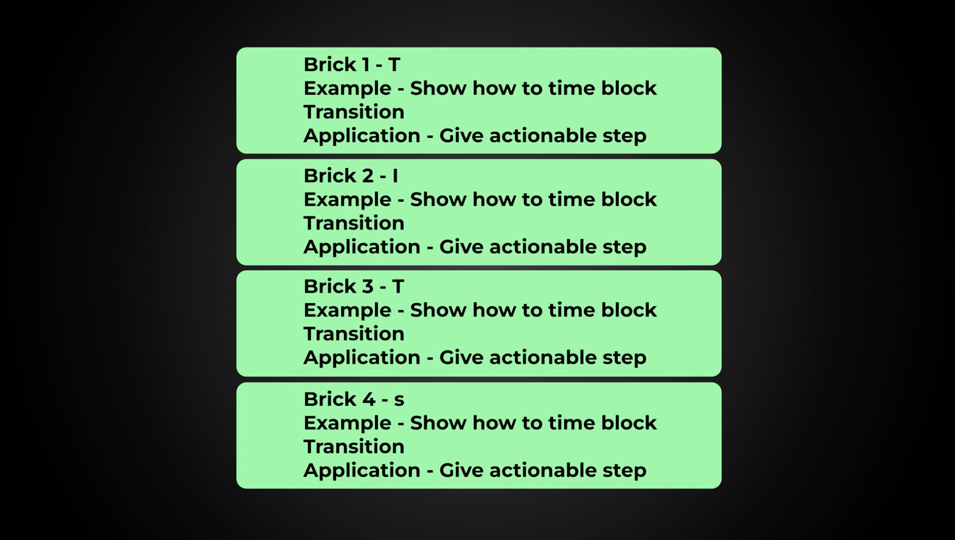

You could make each point of your video a letter then stick to the Example/Application structure for each one OR just use it as one point in your video.

#### **2. Conceptual Frameworks**

* **What Are They?**Analogies or metaphors that visually explain a concept, like an umbrella for overarching ideas or a ladder for progress.
* **How to Create One**:  
  + Identify the concept you want to simplify.
  + Compare it to something familiar that shares similar characteristics.
  + Design the framework (e.g., a tree for branching ideas).
* **Examples**:  
  + A sales funnel for customer journeys.
  + A target for goal-setting.
* **Pro Tip**: These are memorable but can be challenging to create. Use them sparingly for big, complex concepts.

#### **3. Processes**

* **What Are They?**Simple step-by-step guides that break down how to achieve a result.
* **How to Create One**:  
  + Write down all the steps needed to achieve a goal.
  + Remove unnecessary steps, leaving only critical actions.
  + Present it visually or verbally in a clear, logical order.
* **Examples**:  
  + A process for growing on YouTube: Research, Script, Shoot, Edit, Publish.
  + A checklist for effective thumbnails: Contrast, Clarity, Curiosity.
* **Pro Tip**: Processes are common, effective, and ideal for tutorials.

### **How to Decide Which Framework to Use**

* Ask yourself:  
  + Does this information need simplification?
  + Will a framework make the concept clearer or more memorable?
  + What style resonates with my audience?

### **Mistakes to Avoid with Frameworks**

1. **Forcing a Framework**: Only use one if it enhances the content.
2. **Overcomplicating**: Frameworks should simplify, not add confusion.
3. **Copying Others**: Adapt frameworks to your unique style and audience.

### **Using Frameworks with Examples**

Frameworks can act as:

1. **A Single Point**: Use it to explain one idea in the video.
2. **A Full Structure**: Base your entire video around the framework, with examples for each section.

### **Adjusting Creativity to Your Audience**

Not all audiences appreciate quirky or creative frameworks. For example:

* **Ed’s Style**: Over-the-top metaphors, humor, and sketches work for creators seeking inspiration.
* **Your Style**: May require straightforward explanations, clean visuals, and practical steps.

Use ready-fire-aim to test what resonates with your audience. Avoid replicating someone else’s style—focus on what works for your viewers.

Application Brick

### **How to Write an Effective Application Brick**

The **Application Brick** is where you turn inspiration into actionable steps, helping your viewers achieve real results. This builds goodwill, trust, and loyalty while cementing the value of your content. Here’s how to create one that works.

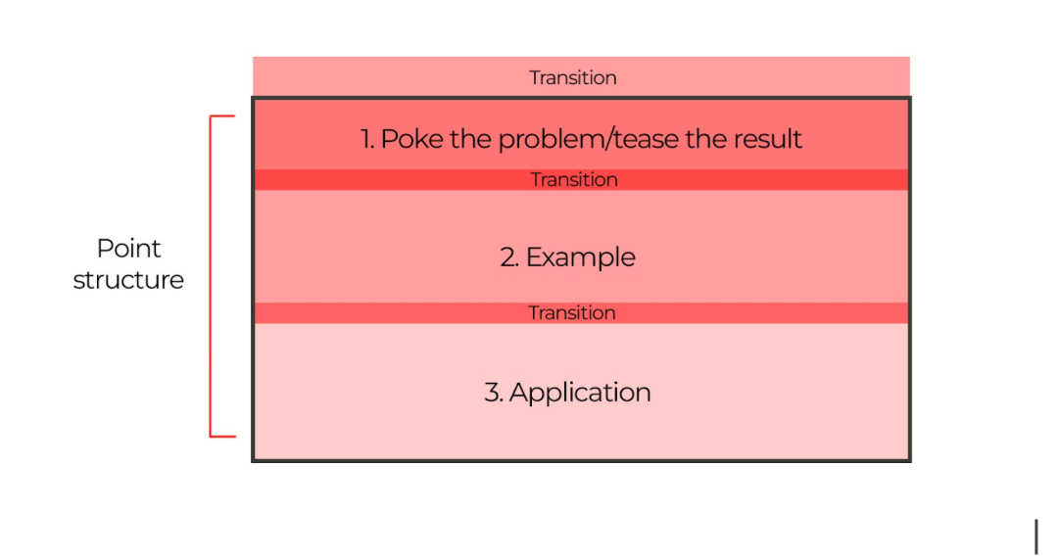

### **Step 1: Transition with Cement**

* **Purpose**: Smoothly move from the example brick to the application section.
* **How**: Use a simple line to bridge the gap:
  + *“But how do you do this yourself? Let me show you.”*
  + *“Next, let’s break down how you can apply this step by step.”*
* **Why It Matters**: A clear transition primes viewers to stay engaged and anticipate actionable value.

### **Step 2: Make It Big, Easy, and Specific**

* **Avoid Vague Advice**:
  + Bad: *“Follow your dreams!”*
  + Good: *“Block off one hour a day to work on your dream project.”*
* **Hit the Sweet Spot**:  
  + **Big**: Show steps that make a meaningful difference.
  + **Easy**: Make it feel achievable.
  + **Specific**: Provide clear instructions.

### **Step 3: Break It Down**

* **Slice Big Tasks**: Break overwhelming tasks into smaller, manageable steps.
  + Example: You wouldn’t eat a loaf of bread whole—you’d slice it up.
* **Use a Framework**:
  + Numbered steps.
  + Visual props.
  + Roadmaps or charts.
* **Test Simplicity**: Ask yourself, *“Could my nan follow this?”* (Your nan, not Ed’s—she’s unavailable.)

### **Step 4: Match Depth to Your Audience**

* **Beginners**: Simplify with clear frameworks and basic steps.
* **Experts**: Offer nuanced insights and detailed explanations.
* **Err on the Side of Simplicity**: Beginners often underestimate their lack of knowledge, so keep it accessible even if they consider themselves “advanced.”

### **Step 5: Show, Don’t Just Tell**

* **Why It Works**: The more you visually demonstrate steps, the easier it is for viewers to follow.
* **How**:
  + Use visual props, charts, or live demonstrations.
  + Avoid over-explaining when a visual can do the job.

### **Step 6: Transition to the Next Brick**

* **Don’t Summarize**: Avoid wrapping up the application section too neatly—it can signal to viewers that the video is over.
* **Set Up the Next Problem**: Tease what’s coming next:
  + *“Now that you know how to build trust, let’s tackle the next step: keeping viewers engaged.”*

### **What a Great Application Brick Looks Like**

* **Balanced Length**: Some application sections are short and punchy, while others are detailed and comprehensive.
  + Example 1 (Short): *“Even if you're the best in the world, viewers won’t believe it until you show proof of credibility and trustworthiness.”*
  + Example 2 (Long): Step-by-step instructions on creating a trust-building framework.
* **Result-Oriented**: Ensure the steps are actionable and capable of delivering results.

### **Common Mistakes to Avoid**

1. **Being Too Vague**: Don’t leave viewers wondering where to start.
2. **Overcomplicating**: Simplify advanced concepts for accessibility.
3. **Skipping Visuals**: Whenever possible, show your steps to increase understanding.
4. **Leaving Viewers Hanging**: Always transition to the next section to maintain engagement.

End Brick

# **🎬 End Brick Guide**

## 

The **End Brick** is where you:

1. Set up the **next problem** or curiosity your viewers have.
2. Give a **clear call-to-action** (CTA) to watch another video or take action.
3. Ensure your video doesn’t "end" but **funnels viewers into binge-watching** or interacting further.

**✨ The Purpose of the End Brick**

* Keep viewers **engaged** with your channel.
* Increase **watch time** by directing them to the next video.
* Set up a **natural flow** so viewers don’t drop off.

**What videos do you point people back to?**

* Don't overthink it, just point them back to a video that solves a problem that relates to the video they have just watched

**📋 End Brick Checklist**

### **1. Transition to the End**

* Did I introduce a **new problem** that the next video solves?
* Did I tease the **big result** of watching the next video?

*Example:“You now know how to fix [problem], but if you don’t [solve next issue], it’ll all fall apart, so watch this video next and I’ll show you how to [solve big problem/get big result].”*

### **Checklist:**

* Did I **tell viewers what to do next**?
* Did I say **why** they should watch it (benefit or result)?
* Did I point them to a **specific video**?
* Is the End Brick **short and to the point**? (Under 10 seconds is ideal.)
* Did I avoid unnecessary waffle or extra explanations?
* Did I avoid making it sound like the video was coming to an end?

## **📝 Example of a Strong End Brick**

“The thing is, even though you now know how to create thumbnails that get clicks, there’s one more thing you need to master because if you don’t it doesnt matter how amaning your images are, they still wont work   
.  
So watch this video next where I’ll show you how to write titles that work with your thumbnails to 10x your views.”

Script template

**🎬 Script template**

Now you have your plan, it's time to write.

* *Scroll down for some writing tips to help get this done faster*
* *Use the assets in the writing template section to help you in each brick*
* *Use the AI bots to help give fast feedback*
* *Understand that this will get faster the more you do it. Right now it's the hardest it'll ever be, one day this will all become second nature.*
* *Have your planning doc visible next to the doc you write your script in, it makes things easier*

**Intro**

Hook

Problem/result

Set up

Transition to brick one

**Point 1**

Example

Transition

Application   
Transition to next brick

Repeat this section for every point

**End**

Transition to end

Call to action

### **Writing tips to speed up your progress**

#### **1. Shift Your Mindset**

* Accept that **your first draft doesn’t need to be perfect**, just get to the end.
* Focus on finishing, not perfecting, in the first round.

#### **2. Set Up the Right Conditions**

* **Set a timer** for 1-2 hours.
* Turn off all distractions (notifications, phone, etc.).
* Commit to writing without stopping, even if it feels messy.

#### **3. Use your Wireframe plan to Guide You**

* Plan your script using the **brick system**:
  + **Intro**: Hook → Setup → Credibility
  + **Middle Points**: Transition → Example → Application
  + **End**: Transition → Call-to-Action
* Fill in the gaps quickly using this structure.

#### **4. Choose Your Writing Method**

* **Option 1**: Write directly, using the structure as a guide.
* **Option 2**: Record yourself speaking through the points, then transcribe and edit it down.

#### **5. Get Your Draft Finished Fast**

* Write without stopping to fix mistakes.
* Avoid overthinking – clarity comes in editing, not in the first draft.

#### **6. Test and Refine Your Script**

* After you have written, present your script **out loud** to spot:
  + Awkward phrasing
  + Missing information
  + Flow issues
* Paste your **intro** into the **Intro Bot** for instant feedback.
* Use the **Point Bot** to get AI feedback on individual points:
  + Identify issues to fix
  + Remove unnecessary fluff

#### **7. Focus on Editing**

* Once the first draft is done:  
  + Refine sentences for clarity.
  + Cut out anything unnecessary.
  + Simplify ideas and focus on **show, don’t tell**.

**8. Practise to Improve Over Time**

* Don’t expect perfection on your first try.
* The more scripts you write, the faster and better you’ll get.
* Embrace the overwhelm, it means you’re bettering yourself

**Summary:**

* Set a timer.
* Write fast and finish your draft.
* Use feedback tools to refine.
* Spend more time editing than writing.
* DO NOT TRY TO GET AI TO WRITE YOUR ENTIRE SCRIPT (Just use it for feedback)

Follow this system consistently, and you’ll write scripts faster while improving the quality over time. 🎬

Script breakdown 1

| This is a script from Creator Booth   I've highlighted each section so you can see the bricks in action  Intro  Transition  Example  Application  END  What separates your channel from the people in your niche who have no real experience in your topic and just make videos repeating what they heard online?  If you can't answer that instantly, it means you’re making one of the biggest mistakes on YouTube.  So today I'm going to show you 5 critical things businesses owners must say or do in every video, so that viewers instantly want to listen to them more than anyone else in their niche.  These 5 things have helped me generate hundreds of millions of views and tens of millions of dollars for my clients.  So what is this big mistake I'd say 99% of businesses make on YouTube.  Well it works like this  For over 100 years Gillette dominated the Razor market and as a result they put their prices up and up and up and up  But In 2011, this dude named Michael was getting kind of annoyed by the expense so He started trying to sell high-quality razors for just a $1,  The thing is even though they were fantastic, no one believed that such a cheap product would be any good so the business struggled...  Not to be defeated, he made a powerful change that landed his company 3.2 million customers followed by a billion-dollar sale in 2016.  But what did this tiny start up do to compete against the multi billion dollar competition?  Well many people will claim the success of dollar shave club was all down to this very funny viral advert that got millions and millions of views ..but it wasn't,  views alone can't solve this problem  The real genius was this,  Before they produced that viral video, they sent free razors to early adopters and asked them to share their honest thoughts on social media.  As positive reviews poured in, people started to see that a $1 razor could compete with Gilletes $30 option.  And then when the views of their viral ad exploded, their focus on getting as much proof from their buyers as possible meant even more reviews flew in  And as more reviews came in it generated more sales which generated more reviews and that made more sales.  This kept going and built undeniable proof that their cheap product was as good as the tried and tested Gillette and as a result people started to trust their brand and took them more seriously  So the mistake you must avoid if you want to grow your YouTube channel is thinking you’re Gillette  Even if you're the best in the world at what you do, viewers won’t believe it until you give them some proof that you are credible and trustworthy, otherwise they’ll just stick to watching the same channels they’ve respected for years  Trust at an all time low, anyone can start a channel and claim to be an expert so you gotta focus here 10 more than you think now  But how do you build trust and credibility so fast you become the YouTube dollar shave club in your niche?  Well let me show you the first of the 5 game changing things to say and do in your videos that will get you this powerful result.  Credibility builder one  Imagine if you were stuck in a lift with Billionaire investor Warren Buffet and you asked them “Warren, what stock should I buy next?”  And Warren spent 5 minutes talking about his amazing holiday to fiji first  Would you interrupt and say, "Yo, Warren, I asked about stocks, not snorkeling"? Of course not!  You'd hang on every word he said  Why? Because it's Warren Flipping Buffet!  Thats the power of credibility, when people fully understand just how useful you can be, they pay attention fast.  But how do you do that?  Well, in your intro casually flex the results you've gotten for yourself or other people so that viewers go “ok, this person clearly knows what they’re doing, teach me more”  But what do you say to achieve that result?  Well let's say the video you're about to make is teaching people to play the guitar, and the title is “5 Mistakes that Wreck Every Solo.”  Your intro might sound like this:  *“Have you ever wondered why you’ve never played a solo all the way through without a single mistake?*  ***Over the last 15 years teaching people to play the guitar,*** *I noticed 5 big mistakes they all make that wreck their performance*  *So today, I'm going to show you the same things* ***I’ve shown over 1000 of my guitar students that*** *solved it every time.”*  *​​​​​​​*  You see what I did there?   I mentioned how long I’ve been playing, teaching, and how many people I’ve helped but I baked it in to the intro so it was very fast and felt like a seamless part of it  This makes it clear I'm legit, professional, and can get results which instantly raises trust and credibility, but don't worry, if you're thinking “but i dont have results like this, i got you boo”  **But won’t adding in more words wreck viewer retention?**  Well Rian Doris put the same short clip that instantly raised his credibility into every intro he made and went to from 0-300k subs 18 months so keep that in mind.  The second credibility builder levels this up even more and it's so powerful it turned a struggling company into a multi billion dollar empire.  Back around 2007 this dude called Drew had a cloud storage software nobody would sign up for because, well back then telling people they could store things in a cloud made them look up at the sky in confusion  “But what if the data gets wet up there”  Realising the problem Drew ditched his complex pitches that explained the intricate details of his offer and created a simple and straightforward video that just showed him dragging a file from his desktop into the cloud  and boom they went from 5,000 on the waiting list to 75,000 overnight and Dropbox was born.  So If you want to build trust and credibility simply saying what kind of result you can get is ok, but showing visual evidence is next level because seeing is believing.  But how do you do that? well there’s many ways.  If you’re in the graph go up niches, basically you help people grow followings or businesses or invest, you add visual proof of your own earning results or your clients to your intro like I did at the start  If you’re teaching guitar, you play an epic solo as part of your hook like Doug does here  If you’re in a craft, arts or production niche you just show your own work like Kirsty did here <https://www.youtube.com/watch?v=VGpWagiF_34>  And if you’re in a niche that can't be represented by anything visual you just flash up short testimonials from your clients to back up your claims. like...Well i couldn't find anyone else doing this other than me so yea, like I did again here.  But does that mean you have to be world class at what youd do to get ahead on YouTube now?....  well I mean it helps but these next three things are going to build trust with viewers no matter who you are  Which brings us onto the more controversial trust building trick but I think I can please both sides of the argument by showing you how this actually works because there's some science behind it  So Let me ask you a question, would you turn up to a job interview like this  *I dressed like this because it's what i wear when im on my own and it's the authentic me,*  No of course not because they’d think you were unprofessional and a bit weird and smelly  Which brings us on to the controversial part.  A lot of people right now have seen the success off more stripped back creators growing fast and have been tricked into thinking that's all you need but the thing is.....it's not true  This approach only really works consistently well for those with the "Warren Buffet effect" -  Meaning they have achieved something so remarkable their viewers trust them no matter what  Videos of this nature also requires speaking skills and an understanding of how to simplify content, tell stories, and use metaphors to keep people engaged,  the people that do this well often have years of experience at a very high level teaching others how to do all of these things  If you don't have that level, producing a video that looks like it was shot on a potato, won't work for you  So what should you do instead so that you can make a first impression that instantly raises your trust and credibility?  Well you turn up to your job like this  SKETCH - White shirt, boring, simple  SO dont go spending $10,000 on new equipment i, not saying that  Really, you just need to keep your set up simple.  A white shirt to an interview probably wont cause anyone to question you, its the same here...but dont wear a white shirt on camera...thats not what im saying....even though im wearing one...  Get a bright softbox light and position it either behind the camera or slightly to the side to create a lighting effect similar to mine. This will make even the worst camera 10x better  And then remove any mess or clutter from behind you that people might judge negatively, like random papers or coffee cups.  Really this is about removing things that might put people off more than anything else.  Having said that, here’s some of the set ups my clients have produced over the last few months and it's hard to argue when you’re met with that it doesn't instantly raise their credibility  im so proud of you guys...  The thing is, the real magic of fixing your setup isn't about what the viewer sees it's actually more about you  And i've never actually heard anyone else talk about this before but after teaching hundreds of people to present I know the most powerful reason your setup will raise your trust and credibility actually works like this  Credibility 4  How do you feel right now watching this, a little awkward, a little bit frustrated you probably don't want to switch off because watching me squirm is making you squirm right?  When people step in front of a camera they instantly tense up, they hear voices in their head telling them people might judge the way they look,  they overthink the words they say rather than letting them naturally flow and as a result what comes out of their mouth doesn't reflect their true personality and they appear to lack confidence which destroys trust  But look what happens when that vanishes, i'm going to present that awkward line again  How do you feel right now watching this, a little awkward, a little bit frustrated you probably want to switch off because watching me squirm is making you squirm right?  Even though what I just said doesn't make sense anymore..the way I presented it makes the information feel more credible right?  And this is why your set is actually more important than you think because if you do light yourself properly and put a little more effort in you’ll go “wow, i look flipping amazing”  And this will start to make you feel more confident and that will translate in your presenting and raise your trust levels and credibility  Watch Codie Sanchez and listen to how she talks, she just exudes undeniable confidence in every word she says andIts very hard not to trust someone when they present like this  Which brings us on to the 5th way to build credibility pretty much all of the biggest personal brands in the world swear by it and it's all to to do with coffee  So In the early 90s this dude called Harold went to Milan and noticed the amazing vibes at the cozy little coffee shops, people were launching and chatting and doing anything other than actually working and he thought,  this is exactly what America needs  At this time he was working for a coffee company so he pitched them a dream that they should do the same thing and become a place between home and where people could relax and enjoy a cuppa moca joe  But his company said “we sell beans not dreams” and wrote it off  ok maybe they didn't say it exactly like that but it rhymed so i kept it in the script  Harold was convinced it would work though so he left and set up a coffee shop of his own and it was a massive hit  A while later the original company he worked for decided to sell up so Harold got investment, bought it and merged it with his idea to create the cut throat conglomerate that is known as Starbucks  The thing is, to raise money from investors he didn't give them any old business plan, he shared his journey—how he had experienced firsthand the social and cultural role of coffee in Italy and how had replicated that model in the U.S.  and this story provided proof he knew what he was doing, raised his credibility and convinced others to believe in his vision so they threw money at him.  Tony Robbins, Gary Vee, Russel Brunson, MAriea Forelo, Seth Godin, Chris Do, Simon Sinek....  Watch anything they do it'll become crystal clear they use the exact same strategy as Harold in every bit of content they make to build trust  and they achieve that when they tell stories that prove results and back up the points they want to make.  But how do you do that?  Well the ultimate credibility builder is to tell your own story that proves you got a result of some kind your viewers wants or a clients you’ve helped  But if you don't have either of them yet are you screwed?  Well no, because building credibility isn't just about proof, it's also about the way you make viewers feel and that means if you can find any story to make your point even if it's not about you or a client. itl make your content more engaging, your viewers will learn more and when that happens, you trust and credibility raises and viewers will come back  Drop box, dollar shave club, starbucks, even just mentioning Coide sanchez and how my clients have built amazing sets, these are all types of stories that help to proved my points  And this is where your retention will flatline, every time, if you tell a good one  The thing is, there is actually one other powerful way you can raise your credibility  Its a life changer that generated me tens of millions of views and dollars and channels who pull this off blow up their views and their businesses  Because its so incredible, i made an entire deep dive video about how to do it yourself so check out this video next and learn how to produce a video that could put you on the map as the most trustworthy, credible person in your niche |
| --- |

## Hook breakdown

Here are the hooks from your script, with an explanation of why each is effective:

1. **"What separates your channel from the people in your niche who have no real experience in your topic and just make videos repeating what they heard online?"**

- **Why it's a hook**: This hook challenges the audience to consider their unique value proposition, creating a sense of urgency and curiosity about how to differentiate themselves.

2. **"If you can't answer that instantly, it means you’re making one of the biggest mistakes on YouTube."**

- **Why it's a hook**: It leverages fear and urgency by implying that the viewer is making a critical error if they can't answer the question, motivating them to keep watching to avoid this mistake.

3. **"So today I'm going to show you 5 critical things business owners must say or do in every video, so that viewers instantly want to listen to them more than anyone else in their niche."**

- **Why it's a hook**: It promises valuable, actionable insights that the viewer will gain by continuing to watch, appealing to their desire for success and differentiation in their niche.

4. **"These 5 things have helped me generate hundreds of millions of views and tens of millions of dollars for my clients."**

- **Why it's a hook**: By establishing authority and credibility with impressive results, it encourages trust and interest, making the audience more likely to listen to the advice being offered.

5. **"So what is this big mistake I'd say 99% of businesses make on YouTube?"**

- **Why it's a hook**: It teases a specific mistake that most businesses make, creating curiosity and a need to find out what it is to avoid it.

6. **"But what did this tiny start-up do to compete against the multi-billion dollar competition?"**

- **Why it's a hook**: The contrast between a tiny startup and a massive corporation is intriguing and prompts viewers to want to learn the "David vs. Goliath" story and its lessons.

7. **"The real genius was this..."**

- **Why it's a hook**: The phrase implies there is a secret or unique insight that isn't obvious, which compels the audience to keep watching to discover what it is.

8. **"So the mistake you must avoid if you want to grow your YouTube channel is thinking you’re Gillette."**

- **Why it's a hook**: It provides a direct and provocative statement that challenges a common assumption, prompting viewers to rethink their strategies and learn the correct approach.

9. **"But how do you build trust and credibility so fast you become the YouTube dollar shave club in your niche?"**

- **Why it's a hook**: This hook draws on the story of Dollar Shave Club’s success, making it relatable and aspirational for viewers who want to achieve similar credibility and growth in their niche.

10. **"Well let me show you the first of the 5 game-changing things to say and do in your videos that will get you this powerful result."**

- **Why it's a hook**: It signals the start of valuable content and creates anticipation for the specific strategies to follow, ensuring the audience stays engaged.

11. **"Imagine if you were stuck in a lift with Billionaire investor Warren Buffet and you asked him 'Warren, what stock should I buy next?'."**

- **Why it's a hook**: It uses a vivid and interesting scenario that captures the viewer's imagination and sets up a point about credibility and authority, making the concept more relatable and memorable.

12. **"Why? Because it's Warren Flipping Buffet!"**

- **Why it's a hook**: It leverages the reputation of Warren Buffet to emphasize the power of credibility, using humor and an unexpected twist to maintain interest.

13. **"But how do you do that?"**

- **Why it's a hook**: This question directly addresses the viewer's likely curiosity after presenting a concept, making them want to stay to learn the answer.

14. **"But won’t adding in more words wreck viewer retention?"**

- **Why it's a hook**: It addresses a common concern among content creators, presenting a potential challenge and keeping the audience engaged to hear the solution.

15. **"So If you want to build trust and credibility simply saying what kind of result you can get is okay, but showing visual evidence is next level because seeing is believing."**

- **Why it's a hook**: It promises a deeper level of insight (moving from "okay" to "next level") that appeals to those looking to enhance their strategy.

16. **"But how do you do that?"**

- **Why it's a hook**: A repeat of the earlier question hook, it keeps viewers engaged by continually prompting them to think about how they can apply the advice.

17. **"But does that mean you have to be world-class at what you do to get ahead on YouTube now?"**

- **Why it's a hook**: It presents a common doubt or insecurity viewers might have, suggesting there will be an answer or reassurance to keep them watching.

18. **"So what should you do instead so that you can make a first impression that instantly raises your trust and credibility?"**

- **Why it's a hook**: This hook promises a solution to a critical problem (making a good first impression), maintaining interest in finding out the answer.

19. **"The thing is, the real magic of fixing your setup isn't about what the viewer sees it's actually more about you."**

- **Why it's a hook**: It introduces an unexpected twist, suggesting that the real benefit of the advice isn’t what viewers might assume, creating intrigue.

20. **"Which brings us onto the 5th way to build credibility pretty much all of the biggest personal brands in the world swear by it and it's all to do with coffee."**

- **Why it's a hook**: It hints at a surprising and unusual method for building credibility, using an everyday item (coffee) to create curiosity.

21. **"But how do you do that?"**

- **Why it's a hook**: Again, this recurring question keeps the audience engaged by making them think about the practical steps involved and ensuring they stay tuned to find out.

Each of these hooks serves to maintain viewer interest by either presenting a problem that needs solving, posing a question, or introducing an intriguing or unexpected twist that the viewer wants to learn more about.

Script breakdown 2

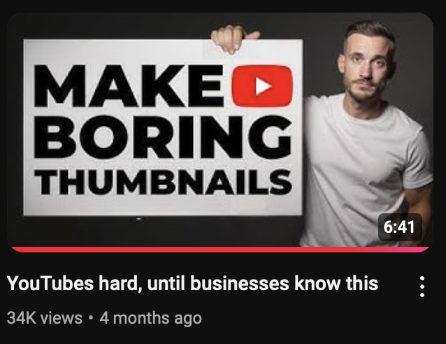

Intro

Transition

Example

Application

END

Can I tell you a secret?

I've worked with hundreds of YouTube creators over the years and discovered there's one type of thumbnail that's really easy and fast to make, performs VERY well, and it's potentially all you need to generate more views and sales for your business.

So today, I'm going to show you:

* Examples of channels blowing up using this simple style
* How to easily create it for yourself
* And how to get YouTube to tell you how effective your image

**To start lets look at a channel exploding using this method**

And you can see how effective its been from the social blade data on screen right now.

What’s great about their strategy is they keep their images so simple literally anyone could make them

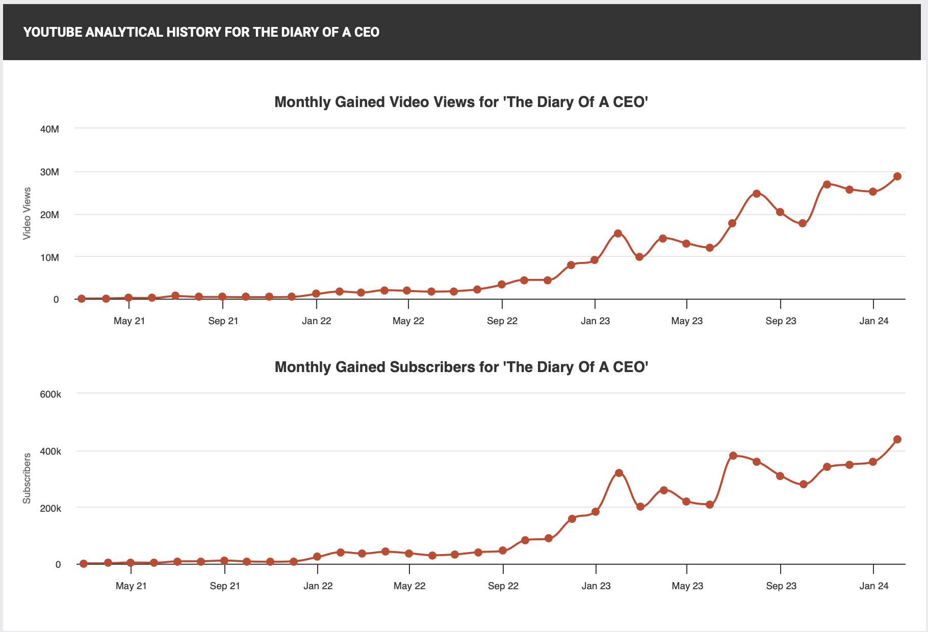

The channel is called The Diary Of A CEO and all they do is use a face and some simple text and thats it

BUT we need to go one level deeper, so to understand what's actually going on here im going to show you more channels blowing up using it and how to do it yourself

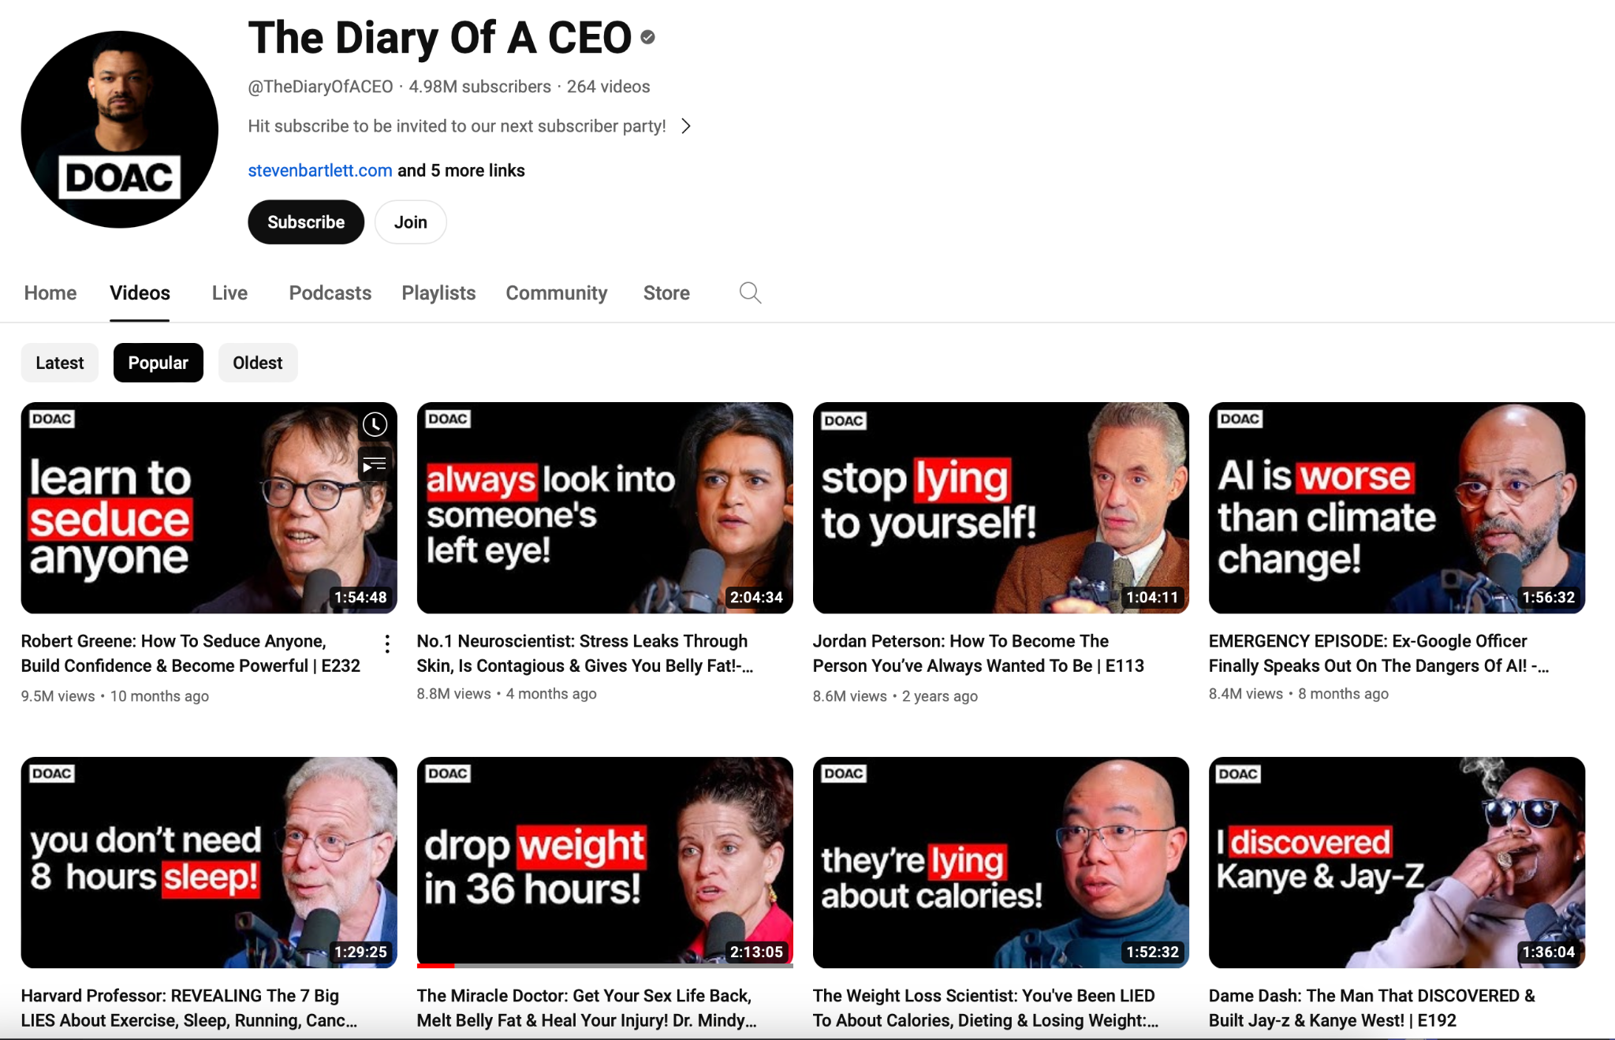

So This thumbnail in particular I want you to take note of👇🏼. 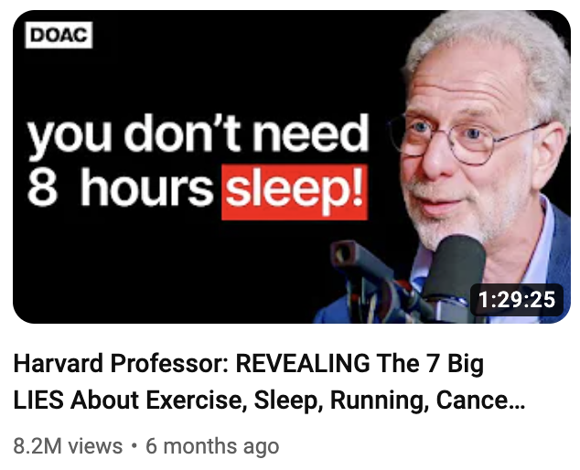

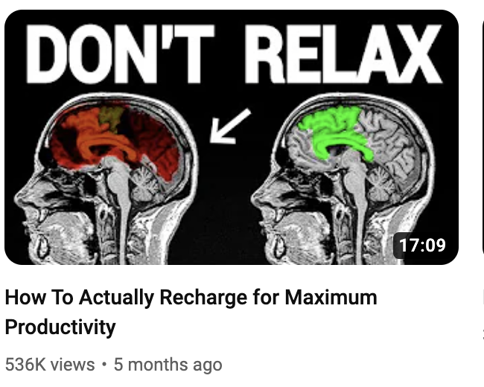

This image is again, very simple but it's using exact the same strategy as The Diary Of A Ceo as well as the one

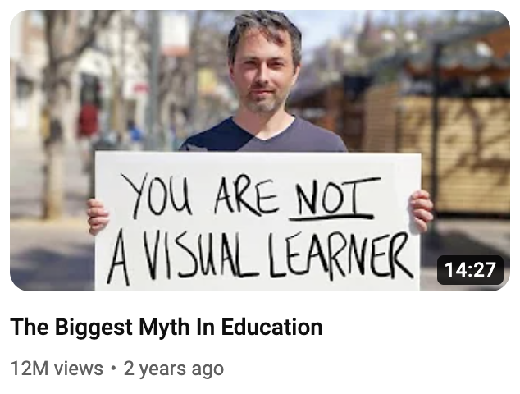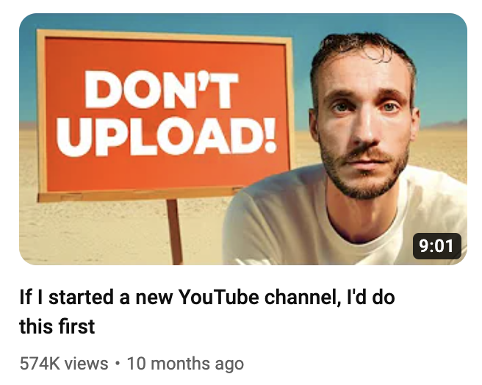

And one of videos from my old channel Film Booth

**SO Why are these so powerful for generating views?**

The reason these thumbnails have helped the videos explode comes down to a few things.

Firstly, they are very simple and are designed so that the text is the thing that stands out fast; if it didn't, what happens next wouldn't be as effective.

So its critical that when you try this, you don't over design them and make the text a secondary part of the image

The diary of the CEO thumbs do this so well because the highest point of contrast is black and white which basically means, the text probably couldn't stick out any more even if it tried

I mean look what happens when i use yellow and green and blue and red.

The next reason, and the most powerful, is due to this

When we see information that goes against what we believe, it makes us feel uncomfortable. This is called cognitive dissonance.

Cognitive dissonance is a big word to describe feeling uncomfortable when you have two different beliefs or when your actions don't match your beliefs.

SO for example we've all been told for ages that we need to have 8 hours sleep right….

And weve been told to relax and that were visual learners and of course to upload lots of videos

So you want to click to find out what the heck is going on here that challenges what we thought to be true

These thumbnails suggests that there is more to learn, that maybe we missed out something important and they're click magnets because it builds a curiosity in us which is key to getting clicks

But how do you **make this thumbnail style for yourself so you can blow up your views and your business?**

**Step 1: Ask yourself, based on the topic i want to talk about, what do most people believe to be true that isn't?**

If you're struggling for ideas, head over to Chat GPT and type, “I need some examples of things that could create cognitive dissonance in the music production niche.”

(You’d insert your own niche, of course.)

It’ll then fire out a list of examples, and do you know what... it's pretty good at it too!

Here are a few statements it came up with in relation to music production:

*"Good marketing can make any song a hit, even if the production quality is poor."*

*"You don't need to know music theory to make hit songs."*

*"Expensive gear doesn't make your music sound better; knowing your tools does."*

**Step 2: Work out how to get this statement down to 4 words or fewer.**

Although some of my examples don't do this, as a general rule of thumb, we want fewer words so the thumbnail is faster for people to read. DO NOT Turn your thumbnail in to a title.

**Step 3: Design so the text sticks out first.**

A few simple ways to do this are to:

* Make the text the highest point of contrast on the page which ive spoken about,
* Point arrows at the text.
* Keep the designs very simple so nothing competes with it.

**Step 4: Is all about context and complimenting**

Ryan’s team used a brain in the “don't relax” image as it tells the viewers straight away what the topic is related to

You could use an item, a person, or anything else that visually gives context to the topic. Or just keep it very simple like Diary of a ceo and let the words give that context

I dont recommend you do this. *“DONT DO THIS” with no context to the topic because it could be about anything right!*

If you’re in the image, make sure your expression matches the statement too; the days of over-the-top, mouth-wide-open photos are dead, so think about the emotion you want to convey and see how you get on.

There’s a few other things I think are really important here too

Firstly look at this, which one feels more credible to you?

Puling out stills from a video should only be something you do because you had no option, the smart move is just to batch shoot a tonne of photos of you making different expressions with a quality camera and quality lighting set up and then just use them on going

YOu’ll notice on a lot of channels they just use the same photo over and over again, this saves so much time and business tubers really dont have to reinvent the wheel for every vid

And then this next part is the genius part

If you want to grow your channel you have to learn about what appeals to your viewers and what doesn't

And one amazing way to do that is to make three versions of a thumbnail with different words on them.

Then pick the one you think works best then on launch wait a few hours and see how it performs, if it doesnt do well, you can switch it up to the next statement.

What can happen over the coming hours is you see the views spike and that means people are more interested in whatever the words were on the new image

When you learn this you can then reuse the same words in new titles or do a slight variation in future videos

So its a really simple way to discover what viewers care about without having to spend days designing multiple images,

There is one issue with this though. New and small channels, you guys dont really get enough impressions to learn from on release so you’ll have to be more patients and potentially wait days or weeks before you make a switch

its critical you always have at least 3 versions of an image though,

i mean look at this video, it was a 9/10 in the first few hours, i switched to this thumbnail and it didnt work, then to this and hey presto.

Having just one thumbnail is a death sentence for your content

But how is this going to make you more money ?

Well for those of you who have an offer already, more views should equal more email sign ups and more sales so long as you’ve got your marketing sorted thats why

But for those of you who don't, every video you make is training you to understand what your viewers are interested in, when you learn about what copy attracts them, you can use this same strategy all over the place

So for example you could use it as a hook in a post to drive attention towards your email list or when you do start making a landing page for an offer, use it as a headline hook to drive the viewers further down the page so they want to read more!

Theres small YouTubers all over the place using hooks of this nature to grow their channels and make big money and if you’d like to learn how else they generate 6 and 7 figures incomes from sometimes tiny views watch this video next to discover the secret to making money on YouTube

Writing prompts

**Writing prompts index:**

In this section we have everything you need to help make writing that little bit easier.

1. **Hook bank** - Get hook inspiration
2. **Transition bank -** Get transition inspiration
3. **Story prompts** - Cant think of a story? Use these to help you find one
4. **Metaphor creation template** - Use this to help you come up with a metaphor

Hook Bank

Hook bank

Below are some hooks you can use for inspiration.

### **Question-Based Hooks:**

* "[Have you ever wondered why…?"](https://www.youtube.com/watch?v=xYP_UVwQ-mw&t)  
  [How Long It Actually Takes To Make Money On YouTube](https://www.youtube.com/watch?v=esDrlH3O-Mo&t)
* "Are you making this X mistake…?"
* "Do you ever feel like…?"
* What would you do if....
* [Have you ever noticed that..?](https://www.youtube.com/watch?v=ndtdg1GUHNA)
* [If there was one INSERT THING that could INSERT RESULT would you do it?](https://www.youtube.com/watch?v=NK3nvetWqN4&t)
* [What separates you from INSERT OTHER PEOPLE](https://www.youtube.com/watch?v=nF40NtcolEo&t)
* [Can I tell you a secret?](https://www.youtube.com/watch?v=9ddL3A1zZ3U&t)
* [You want to know something crazy?](https://www.youtube.com/watch?v=M8W2wGRADIM&t)
* [Would you X if you knew it would Y](https://www.youtube.com/watch?v=L8Ye9kFwFZk)
* [How did this person X when this person Y’d](https://www.youtube.com/watch?v=HehHm86vFPI&t)
* [You want to hear something insane?](https://www.youtube.com/watch?v=RdAKXJlMIZM&t=2s)
* [Why is X doing Y?](https://www.youtube.com/watch?v=4tUE3mmSwIg)
* "Why is nobody talking about this?"
* [Do you struggle to X? Well, its not your fault](https://www.youtube.com/watch?v=qiZZbyHPHzc)

### 

### **Statement Hooks”**

* [I have found the X that nobody seems to be talking about](https://www.youtube.com/watch?v=fyzMbC8ktuM)
* [I'm a multi-millionaire and I don't own my house and I don't invest in any property but why isn't a house a great investment”](https://www.youtube.com/watch?v=hTy2Vh0GuIQ)
* X doesn't come from luck; it comes from consistent, deliberate actions.
* "It's time to rethink everything you know about [subject].
* This simple tweak can dramatically improve your [skill/ability].
* "This secret could change your life."
* This one strategy transformed my entire approach to [topic]."
* "You’ve been doing X wrong all along."
* "Here’s a truth no one wants to admit…"
* "This simple trick changed everything for me."
* "You won't believe what just happened…"
* "Stop doing [common action] right now."
* "Here’s why [popular opinion] is completely wrong."
* "You don’t need [common tool/advice] to succeed."
* "Why [widely accepted idea] is holding you back."
* "If you feel like giving up, watch this."
* "I dare you to try this for a week."
* "You need to know this right now."

### **Fact Hooks**

For a fact hook, just hit someone with a surprising fact, it needs to be surprising!

You will need to research your own topic to find one, heres some examples of it in action.

* [“On average, you make roughly 35,000 decisions per day.](https://www.youtube.com/watch?v=4EbItW7r3-s)
* [“Almost 80% of the world's millionaires are self-made and a large part of their success comes down to the tried and tested small habits that they've used to build wealth”](https://www.youtube.com/watch?v=y84xoRAtP5M)
* [“Do you know what day of the week you are most likely to die from a heart attack? Take a guess. I'll give you a second It's Monday care to guess what time it is between 8:00 and 9:00 a.m”](https://www.youtube.com/watch?v=M2NDQOgGycg)
* "Did you know that…?"
* "Studies show that…"
* "Most people don’t realize this about…"
* "80% of people are making this mistake…"

### **Credibility Hooks**

* [“I've been in business for 13 years I've sold nine companies my last company I sold for 46.2 million I own acquisition. comom which right now does about $17 million a month across our portfolio I'm going to compress 13 years of brutal business truths and lessons into this](https://www.youtube.com/watch?v=KhFlD54nQrY&t=14s)
* "Having authored three best-selling books on productivity, I know the strategies that deliver results. Let's dive into the techniques that can transform your daily routine."
* "With a PhD in neuroscience, I can explain how habits are formed and broken. Today, we'll explore the science behind building lasting habits."
* "As a certified nutritionist, I've guided hundreds towards healthier lifestyles. In this session, I'll reveal the key principles of effective nutrition."
* "After helping 500+ clients boost their online presence, I've discovered what truly works. Let's uncover the secrets to a successful digital strategy."
* "In my 20 years as a financial advisor, I've navigated clients through multiple market cycles. Today, I'll share insights on building a resilient investment portfolio."
* "As a former Olympic athlete, I understand the dedication required to achieve peak performance. Let's discuss the mindset needed for success."
* "With over 15 years in the tech industry, including leading teams at [Notable Company], I can provide an insider's perspective on innovation and leadership."

Transition Bank

Transition Bank

### **How to Use This Bank:**

1. Identify what you’re transitioning from and to.
2. Choose the best type of transition for your video’s flow (Problem? Result? Stakes? Cliffhanger?).
3. Adapt the phrasing to your style and audience.

This transition bank ensures your clients have the tools to keep videos flowing naturally and make each point feel necessary and exciting. 🚀

### **My Most Common Transitions**

It's very rare I reinvent the wheel, we really don't need to overcomplicate this, most of the time I just say:

* But how do you do that? Well let me show you so you don't [INSERT BIG PROBLEM]
* But how do you do that? Well let me show you so you can [INSERT BIG RESULT]
* This next part of my system will help you [INSERT BIG RESULT]
* This next part of my system will help you [INSERT BIG PROBLEM]
* Most people fail here because of [INSERT BIG PROBLEM]. But when you do this next step, it [INSERT BIG RESULT]
* “Next, I’m going to show you the exact thing that’ll [INSERT BIG RESULT] fast.”
* "Which brings us to the next big problem..."

Don't get cute with transitions, they shouldn't take more than 30 seconds to write

### **Other Transitions:**

Here’s some more options ive used over the years but the smart move is just to have 3-4 you use over and over again.

**Direct Promises or Teasers:**

* But how do you do that? Well let me show you so you don't [INSERT BIG PROBLEM]
* But how do you do that? Well let me show you so you can [INSERT BIG RESULT]
* Next, I'm going to show you how to [INSERT BIG RESULT]
* Next, I'm going to show you how to avoid [INSERT BIG PROBLEM]
* Now you know that, let me show you how to avoid [INSERT BIG PROBLEM]
* Now you know that, let me show you how to [INSERT BIG RESULT]

**Logical Progressions**:

* "So what does this mean for you? Well next ill show you"
* "That leads us on to how to [INSERT BIG RESULT]."
* "That leads us on to how to [INSERT BIG PROBLEM]”

**Story Setup or Example Introductions**:

* "To prove this point, let me show you..."
* "To show you how this works you need to understand how to [INSERT BIG RESULT]"
* "To show you how this works you need to understand how to [INSERT BIG PROBLEM]”
* "Take [famous example/story] for instance..."
* "Let me give you an example that simplifies this..."
* After a story: “But how can you do the same? Well now im going to show you”

**Result-Oriented Transitions**:

* "What happened next completely [INSERT BIG RESULT]""
* "What happened next completely [INSERT BIG PROBLEM]
* "And the results? They were mind-blowing, so now I'll show you how to do the same

**Simplification Reminders**:

* "Let me simplify this for you..."
* "Here's the easiest way to think about it..."

Story Prompts

**Story Prompts**

*Need to come up with a story? Use these prompts to help you think of one.****How to use:***

*Step 1: Start by coming up with the point you want to make*

*Step 2: Read the questions until a story jumps into your mind that’ll help make that point.*

**Personal Challenge or Failure**

1. Think of a time when you failed at the thing that is relevant to your point? What did you learn from it?
2. What’s a moment when you doubted yourself but pushed through that relates to your point? How did that experience shape you?
3. When was the last time you faced rejection? How did you handle it, and what happened next?

### **Life-Changing Decision**

1. What’s a decision you made that completely changed the course of your life or career?
2. Can you recall a time when you said “no” to something everyone thought you should do? What did it teach you?
3. What’s the scariest risk you ever took, and was it worth it?

### **Conflict or Disagreement**

1. Think of a time when you had a disagreement with someone important to you. How was it resolved, and what did you learn?
2. When did you stand up for yourself, even though it was difficult? What impact did it have?
3. Was there a time when you tried to avoid conflict, but it made things worse?

### **Moment of Realization**

1. What’s a moment in your life when you realized you were wrong about something? How did that change you?
2. Can you remember a time when someone’s small act of kindness shifted your perspective?
3. What’s the most valuable lesson you learned from an unexpected source?

### **Overcoming Fear**

1. Think of a time you were terrified to try something new but did it anyway. What happened?
2. What’s a situation where you faced your biggest fear? How did it change you?
3. When was the last time you surprised yourself by being braver than you thought you could be?

### **Success or Breakthrough**

1. What’s a win you’re most proud of? How did you achieve it?
2. Was there a time when something you’d been working on finally clicked? What led to that breakthrough?
3. What’s a moment when you exceeded your own expectations?

### **Struggle with Identity or Direction**

1. Think about a time when you felt completely lost. How did you find clarity?
2. What’s a situation where you felt like an outsider? How did you handle it?
3. When was the last time you had to reinvent yourself?

### **Learning from Others**

1. What’s the most valuable piece of advice someone gave you? When did it resonate the most?
2. Who has had the biggest influence on your life, and what’s one thing they taught you?
3. Think of a time when someone believed in you more than you believed in yourself. What impact did that have?

### **Moments of Humor or Lightheartedness**

1. What’s a funny mistake you made that taught you a valuable lesson?
2. When was the last time you laughed at yourself? How did it change your perspective?
3. Can you think of an embarrassing moment that turned out to be a great story?

### **Conflict Between Values**

1. When did you have to choose between two things you deeply care about? How did you decide?
2. Was there a time when you compromised on your values and regretted it? What did you learn?
3. What’s a situation where staying true to your beliefs was especially challenging?

Metaphor Template

Metaphor Template

The Beginner Metaphor Creation System

Use this system to help you come up with a metaphor

Step 1: Define the Problem Clearly

* Write down what the problem is.
* Note how it makes you or others feel.
* List any characteristic features of the problem.

Step 2: Define the Solution Clearly

* Write down the solution to the problem.
* Note the feelings or outcomes the solution provides.
* List the steps or characteristics of the solution.

Step 3: Identify Core Analogies

* For the problem, think of something else in the world that shares its characteristics (e.g., a storm for turmoil, a wall for an obstacle).
* For the solution, think of something else that embodies the feeling or outcome of the solution (e.g., a key for access, a bridge for connection).

Step 4: Create the Metaphor

* Use the analogies to form a metaphorical statement linking the problem to the solution.
* Remember, a metaphor asserts that one thing is another, so construct a phrase like "X is Y."

Step 5: Test and Refine

* Say it out loud or write it down and ask yourself, Does it make sense? Is it relatable?
* If it feels forced or unclear, go back to your analogies and try new ones.

🤖 AI Bot Instructions

AI Bot Instructions Index

1. How to use the thumbnail ai
2. How to use intro bot for intro brick feedback
3. How to use point bot for middle brick feedback
4. How to use Skyscraper bot for planning

Intro Bot

# INTRO BOT INSTRUCTIONS

**When to use:**

* Want instant feedback on your intro?
* Not sure if your intro is working and could be improved?
* Want some inspiration?
* Want new hooks

**Want instant feedback on your intro?**  
Step 1: Go to the intro bot channel   
Step 2: Type your video title

Step 3: Paste your intro and ask for feedback

Step 4: Don’t just blindly use its version, ask yourself if it is better. You don't have to action everything it says

Step 5: If you want improvement made, repaste the intro in and adjust your prompt, for example you might ask it to add more BENS this time   
  
🚨 Intro Bot has no memory, every time you ask it something, it wont have remembered the previous message you sent

Point Bot

# POINT BOT INSTRUCTIONS

When to use:

* When you want instant feedback (recommended) on one point in a video
* When you’re not sure if your metaphor or story is working
* Editing down your point
* DO NOT put entire scripts into point bot. Put in one point at a time. If you put in too much, it sucks

**How to get feedback from Point Bot (Recommended)**

Step 1: Go to the Point Bot

Step 2: Paste your point and ask for feedback

Step 3: Don’t just use feedback. Ask yourself if it is better. You don't have to action everything it says

Step 4: If you want improvement made, repaste the point in and adjust your prompt, for example you might ask it to add more BENS this time.   
  
🚨 Point Bot has no memory, every time you ask it something, it wont have remembered the previous message you sent

**Not sure if your metaphor or story is working?**  
Step 1: Go to the point bot

Step 2: Paste your point and ask if your metaphor or story could be improved.

Step 3: Don’t just blindly use its version, repaste the point in and adjust your prompt, for example you might ask it to add more BENS this time   
  
🚨 Point Bot has no memory, every time you ask it something, it wont have remembered the previous message you sent

**Editing down your point.**If you want to remove any waffle, try this.

Step 1: Go to the point bot

Step 2: Paste your point and ask it to remove anything that doesn't impact the payoff.

Step 3: Don’t just blindly use its version, repaste the point in and adjust your prompt, for example you might ask it to add more BENS this time   
  
🚨 Point Bot has no memory, every time you ask it something, it wont have remembered the previous message you sent

**How to implement Point Bots feedback**

* Don't copy and paste without reading it and adjusting it to make it sound like you
* Don't feel like you have to implement everything it says
* Be inspired by its ideas
* Don’t copy and paste the new version it writes for you without adjusting it to sound like you

IMPORTANT: This is about levelling you up faster, getting instant feedback and improving. Please don't use it to write scripts in full and not check them or adjust.

Skyscraper Bot

Skyscraper Bot Instructions  
[**Click me to watch the tutorial video**](https://www.loom.com/share/9300ad60e3414de89835a4f635945b71?sid=cc85d988-a433-4ab0-a39e-567e04331acd)  
  
**The Skyscraper Bot helps you analyze successful YouTube videos (outliers) to identify what works and what you can improve. Here’s how to use it:**

Skycraper Bot can be found [**here**](https://chatgpt.com/g/g-WB8ISCLFq-skyscraper-bot)  
  
It is not in Discord due to the volume of text it requires.

## **Step 1: Gather Your Materials**

1. **Find an Outlier Video:**
   * **Choose a video on your topic that:**
     + Has high views (e.g., 1M+).
     + Is less than 2 years old.
     + Has lots of comments for insight.
2. **Install the Chrome Transcript Plugin:**
   * Download and [install a Chrome extension](https://glasp.co/youtube-summary?ref=youtube-summary) to get video transcripts (e.g., YouTube Transcript tools).

## **Step 2: Extract the Video Transcript**

1. Open the selected YouTube video.
2. Use the Chrome plugin to copy the video transcript.
3. Paste the transcript into Skyscraper Bot. (Don't hit enter yet)

## **Step 3: Copy Viewer Comments**

1. Scroll through the comments section of the video and load up to 200.
2. Highlight up to 200 comments.
3. Paste Plain Text Only:  
   * Use Command+Shift+V (Mac) or Ctrl+Shift+V (Windows) to avoid copying images or formatting.
   * Pasting images may break the bot, so this step is important.

## **Step 4: Run the Skyscraper Bot**

1. Paste the comments under the video transcript into the bot.
2. Hit Enter to run the bot.

**🚨** If the video transcript is too long it will crash the bot. If this happens.

* 1. **Paste the transcript in to ChatGPT then ask it to summarize**
  2. **Paste the summary along with the comments into the bot.**

## **Step 5: Review the Results**

**The Skyscraper Bot will analyze the data and provide:**

* Key points covered in the video.
* Techniques used to make the video engaging.
* What viewers liked (based on comments).
* Questions or gaps that appeared frequently in the comments.
* Suggestions on what you should include to make your video better.

## **Step 6: Use the Insights (Important)**

1. Review the bot’s suggestions carefully.
2. Be Cautious with Comments:
   * Comments may suggest overly specific or irrelevant topics.
   * Always ensure the suggestions align with the top of your umbrella (what your channel stands for).

3. Now plan your scripts wireframe using the planning document using this data.

## **Quick Recap**

1. Find the Outlier Video (high views, recent).
2. Copy the Transcript using a Chrome plugin.
3. Collect Up to 200 Comments (plain text only).
4. Paste Transcript + Comments into the Skyscraper Bot.
5. Review Insights: Key points, gaps, suggestions.
6. Use Your Brain: Decide what aligns with your channel goals.

Thumbnail Bot

# **Thumbnail Bot AI Training for Image Generation: Best Practices and Usage Instructions**

* [Watch my tutorial here](https://www.loom.com/share/b4bb200994104e748ed38d28ae8913c2?sid=43a626f7-ca57-4058-931c-e9d3ef93d695)
* [Watch set up tutorial here](https://youtu.be/r7R5IAveG3g?si=4cqGyEP-Cn8W3hOe)
* [Thumbnail Grabber](http://youtube-thumbnail-grabber.com) (Download thumbnails from YouTUbe)

This guide consolidates the most effective advice for training AI models to generate realistic images for thumbnails or other outputs, based on community experiences. Follow these steps to optimize results, troubleshoot issues, and avoid common pitfalls.

## **Step 1: Prepare Your Training Data**

This might feel like a lot of work but once set up, things speed up, your quality will be world class and you’ll save hours never having to be able to take photos again.   
  
Ask in the AI in Discord as you get stuck. As a community we’ve been working this out together.

### **Number of Images**

* **Put in 30-40 photos of yourself**. Results are often better with fewer, high-quality images rather than hundreds of inconsistent ones.

### **Types of Images**

* **Variety is key**: Use photos in **different environments**, lighting, and poses.  
  + **Close focal length**: Chest-up shots.
  + **Full body shots**: Include 5–8 images to help AI recognize body shape.
  + **Different environments**:  
    - Studio shots (against plain white paper).
    - Outdoors in harsh sunlight.
    - Outdoors in shaded areas.
  + **Candid and posed photos**: Include natural, unposed images alongside professional-looking shots.

### **Resolution**

* Use **high-resolution images** as your training data.
* If needed, upscale photos:  
  + Use tools like **Photoshop** to increase resolution (e.g., from 720p to 1080p or higher).

✅ **Tip**: Avoid using the same background repeatedly. The AI might replicate that background unintentionally.

Once you have your photos:

1. **Rename Your Images**
   * Ensure every image filename includes the subject’s name.  
     + Example: john_smith_01.jpg, john_smith_02.jpg.
   * ✅ **Mac Users**: Use the bulk rename tool.
   * ✅ **Windows Users**: Use a file renaming tool like **Bulk Rename Utility**.
2. **Compress the Images**
   * Select all your images, right-click, and choose **“Compress”** to create a .zip file.
     + Name it something like training_data.zip.

## **Step 2: Set up AI Image Generation Model Using Flux** [**Watch Me For This Part**](https://youtu.be/r7R5IAveG3g?si=4cqGyEP-Cn8W3hOe)

1. **Go to the Website**
   * Visit [Replicate.](https://replicate.com)
2. **Create an Account**
   * Sign up for an account using your email.
3. **Set Up Billing**
   * Connect your billing details.
   * Training costs **$2–$5**, after that you pay by use, ive spent 8 hours using this and it cost **$10**

## **Step 3: Upload Your Training Data to Replicate**

1. **Log in to Replicate**
   * Ensure you are logged into your account with available credits.
2. **Create a New Model**
   * Click **“Create a New Model”**.
   * Name your model (e.g., john_smith_generator).
   * Set it to **Private** if you don’t want others to access it.
3. **Upload the Training Data**
   * Click the **Upload** button and select the .zip file you just created.
4. **Set the Trigger Word**
   * This is the word you’ll use later to tell the model who to generate.
   * Use the subject’s name (e.g., john).
5. **Leave Settings on Default**
   * The default settings are optimized for most use cases.
6. **Start Training**
   * Click **“Create Training”** to start the process.
   * Training takes about **20–25 minutes**.

## **Step 4: Generate Images with Your Trained Model**

1. **Run Your Trained Model**
   * Once training is complete, click the **“Run Trained Model”** button.
2. **Enter a Prompt**
   * Write a detailed description for the AI to follow.
   * **Example Prompt**:
     + “Dynamic portrait of [trigger word], highly detailed, cinematic lighting, dramatic expression.”
   * You can use a **prompt generator** for consistency.
3. **Set Your Parameters**

* + - **Output ratio**: Set to **16:9** for thumbnails.
    - **Output format**: Use **JPG** for clean, high-quality results.
    - **Output quality**: Set to **100%** for maximum clarity.
    - **Num_inference_steps**: Increase to **50** for more detailed images.
    - **Guidance scale**:
      1. Start with a scale of **2** or lower (e.g., 1.8) for more realistic results.
      2. Adjust up or down based on trial and error—some models perform better at slightly higher scales.
  + **Generating Outputs**
    - Generate batches of 2–4 images at a time.
    - While the batch uses one seed number, outputs may still vary slightly.
  + Leave everything else the same

1. **Generate Images**
   * Click **Run** to generate your images.
   * Review the outputs and pick the best results.
   * If you like an image, save it, then add it as the reference image and ask for more

✅ **Tip**: Expect a mix of hits and misses. Focus on refining prompts and using high-quality training data for better results.  
  
<https://youtube-thumbnail-grabber.com/>

5. **Add reference images**

* + Load an outlier thumbnail in to ChatGPT, ask ChatGPT to generate a prompt so that an AI could remake this image
  + Copy the prompt in to the AI thumbnail software, change it so your name appears in it
  + Add the reference image to the software
  + Generate

✅ **Tip**: Take outlier thumbnails and use the AI to recreate it. Add text and edit the image after.

## **3. Troubleshooting Common Issues**

### **1. Likeness Isn’t Accurate**

* **Solution**:  
  + Use fewer, higher-quality photos (30-40).
  + Ensure the images have **consistent focal lengths** (e.g., chest-up shots).
  + Include a mix of studio and natural shots.

### **2. Babyface Effect**

* **Solution**:  
  + Lower the **guidance scale** (e.g., try 1.8).
  + Generate multiple images and pick the least "baby-faced" result.
  + Retrain the model with better variety in expressions (e.g., showing teeth, stronger facial angles).

### **3. Repeated Backgrounds**

* **Solution**: Avoid using the same background (e.g., plain white paper) for all training images. Add variety:  
  + Indoors, outdoors, and in-depth-of-field environments.

### **4. Poor Image Resolution**

* **Solution**:
  + Ensure training photos are **high-res**.
  + Use tools like **Photoshop** to upscale low-res images before uploading.

### **5. Outputs Aren’t Matching the Style You Want**

* **Solution**:  
  + Use **reference images** of the desired style.
  + Write detailed prompts or use ChatGPT to analyze and break down reference images.

## **4. Key Tips for Best Results**

* **Train from Scratch**: Instead of adding to an existing model, build a **new model** with better-quality images.
* **Keep It Simple**: Prompts don’t need to be overly complex. The reference image guides the style.
* **Trial and Error**: Small changes (e.g., in guidance scale or seed settings) can have a big impact. Be patient.
* **Focus on Faces**: Include various facial expressions (e.g., smiling, neutral, teeth showing).

## **5. Common Observations from the Community**

* Fewer, high-quality images (30-40) outperform hundreds of lower-quality or repetitive photos.
* Mix different lighting conditions, poses, and backgrounds for the best likeness.
* AI models tend to perform worse with overly staged “studio shots.” More candid, natural photos work better.
* Outputs are influenced by **input resolution**—always upscale training photos for better results.

## **6. Final Notes**

* Results will vary between models and inputs. Don’t get discouraged—tweak settings, retrain with better images, and experiment.
* AI-generated images are a game-changer for thumbnails and creative visuals. By understanding how to train and refine models, you can create outputs that are both realistic and uniquely yours.

Happy generating! 🚀

Email Bot

**Email Bot instructions**  
  
Follow these steps to get the most out of the Email Bot for creating or refining emails.

## **Option 1: Get Feedback on Your Email**

### **Steps:**

1. **Go to the Email Bot**
2. **Write your email headline**
3. **Paste Your Email**
   * You can paste the entire email, I would recommend doing it in sections as the feedback is far superior
4. **Type Your Prompt**:
   * Example:
     + Can you give me feedback on this email?
     + Then paste your email or section of the email.

## **Important Notes**

* **Word Limit**: The bot is programmed to keep emails under **800 words**.

## **General Tips**

* **Don’t Blindly Use the Bot’s Suggestions**:
  + Always review and refine the feedback or draft provided.
* **Iterate with New Prompts**:
  + For better results, adjust your prompt and repaste the content.
  + Example: Ask the bot to focus on a specific section or add more clarity.

🚨 **Email Bot has no memory**:  
  
Every time you interact with it, the bot doesn’t remember your previous messages.

By following these steps, you can effectively leverage Email Bot to refine and create impactful emails! 🚀

Filming checklist

**Filming checklist**

Use this checklist before you film to stop those annoying things that always go wrong, going wrong

**24 Hours before filming**

* Charge camera batteries (charge all of them)
* Charge mic
* Back up any data on SD cards and Format it (This means delete everything on the card, formatting the card inside the camera is also going to make it less likely to randomly corrupt)
* Copy scripts on to teleprompter app
* Check teleprompter controller has battery left

**Pre filming checks**

**Lighting**

* Shut curtains and block natural light coming in
* Set up key light
* Set up hair light
* Set up background lighting

**Framing**

* Set the background
* Set up tripod + camera
* Insert SD card to camera (make sure you formatted it)
* Add teleprompter and phone to lens
* Frame the shot

**Sound**

* Plug mic into camera
* Turn on mics
* Check levels are not peaking or too low

**Test shot**

* Hit record and present 2 lines
* Watch back **on a computer** (You won’t spot mistakes watching back on the camera’s screen)
* Are you happy with the framing?
* Is the video in focus?
* Are you happy with the sound levels/quality?
* Are you happy with the lighting?
* Make any adjustments

**Film**

* Film your scripts
* Keep an eye on the camera/mic battery

**Backup**

* As soon as you finish, back up your SD card on to your hard drive
* Scan the footage to make sure nothing went out of focus
* Reshoot anything that needs to be taken care of

Editing checklist

**Editing checklist**

This is the simplest editing system. We used to make 1,000s of videos.

* Import Your A-roll & Cut Out Mistakes and Pauses
* Cut out anything that is making the video drag on too long
* Add Music + Adjust Levels (if you use music, I don't recommend most people do)
* Add Relevant B-Roll/Screeshot (if required)
* Add Graphics (if required)
* Add text to sections of video that require it
* Export

Data & Measurement

**Data & Measurement Index**

In this section we have everything you need to help upload, measure and react to your videos

1. **Upload checklist**  - Follow this for every upload you make
2. **Measurement system -** Use this to work out your key data benchmarks
3. **Understanding Data** - Use this to understand what your data means
4. **Retention graphs**  - Use this to help analyse your retention graphs

Upload checklist

### **Upload checklist**

Follow this process every time you upload a video:

* Upload video
* Add title
* Add three thumbnails to the split tester
* Add email/product links to top of description with call to action
* Write short description of what video is about under links
* Add chapters below (optional)
* Set up ads
* Add end screens (only use one)
* Make video unlisted
* Comment on your video with a link to your offer, email sign up or another video to watch then pin it.
* Schedule the video to post at a time when your target viewers are online
* Set a thumbnail winner
* Test the variations of the thumbnail (if the video is performing very well, don't do this)

Copy of Upload checklist

**Writing a YouTube Description**   
  
**1. Pick a Goal for Your Video**

* Decide what you want viewers to do after watching every new video .
* Your goal determines what you prioritize in the description.
* Pick an option from below based on your goal

#### **2. No Offer or Email Yet?**

* Add a call to action that directs viewers to a related video.
* Example: *"Watch me next to grow on LinkedIn 10x faster - CLICK ME."*
* Keep it simple, just use the end screen video you point to as your CTA.

#### **Write a Short Description at the top**

* No more than **4 lines**
* Do it after links
* Lots of people don't do this now

#### **3. Want to grow your email?**

* Put this at the top of your description Link to your lead magnet or sign-up page.
* Use the headline from your signup page as the call to action.
* Keep it compelling and short.
* Write it as a comment to and pin it (Video must be unlisted not scheduled to do this)

#### **4. Want to promote an offer?**

* Keep it results-based and to the point.
* Example: *"Lose 10lbs in 30 days."*
* Place it above the fold (so viewers see it without clicking "Show More").
* Write it as a comment to and pin it (Video must be unlisted not scheduled to do this)

#### **5. Multiple Products, Emails, or Lead Magnets?**

* Prioritize your videos goal
* Email growth-focused? Put that at the top
* Want sales? Put that at the top
* Want views? Keep people on YouTube by linking to a video.
* Put your prioritised link as a comment to and pin it (Video must be unlisted not scheduled to do this)

#### **7. Understand the Creator Growth Levels**

* Newer creators: Prioritize growth and keeping people on YouTube.
* Established creators: If optimizing for sales or emails, it’s a different strategy.

**8. Automate description population**

* Put all links into default description
* Set up tracking links
* If you want [**RevTrack**](https://www.getrevtrack.com) use code YTGS for 50% off

**9. Adding chapters**

Add clickable chapters to your video if it's “helpful” for your viewers (dont do this if its a full on story or challenge video)

* Start with 0:00 as your first chapter (otherwise it wont work for the others)
* Don't name the first one “intro” call it something more interesting (people will just skip)
* [Download your transcript using AI](https://tactiq.io/tools/youtube-transcript)
* Paste it in to ChatGPT (with time stamps) and ask it this  
    
  *“Take my transcript and turn it into YouTube chapters to be added to the video’s description. Please only focus on the sections that make up the main points”*

You will need to check it + adjust but its the fastest way to do it.

**10. KEEP YOUR DESCRIPTION CLEAN!!!**

* Its its not going to grow your email, make you sales or get your video watched, delete it from your description
* If it makes you good affiliate money, keep it. But keep in mind, links that don't impact you potentially wreck your business and your channel

Measurement system

**Measurement system**Track your videos performance to build up an idea of your benchmarks

**Assets**

* **Data and measurement: Retention graphs**
* **Data and measurement: Understanding CTR**
* **Note down your 3 hour data:** [Open this sheet](https://docs.google.com/spreadsheets/d/1O4OWKa0M3-Oqg2uV7ekY1Axh_blj6YlTNIkjRX0-ilw/edit?usp=sharing) Browse CTR  
  Browse Impressions  
  Suggested CTR  
  Suggested Impressions
* **Note down your 24 hour data:**

Browse CTR  
Browse Impressions  
Suggested CTR  
Suggested Impressions

* **Note down your 7 day data:**

Browse CTR  
Browse Impressions  
Suggested CTR  
Suggested Impressions

* **Retention analysis (Will load after two days)**   
    
  Look at drops, ask why?  
  Look at flats, ask why?

**When to measure retention**

**24-48 Hours:** The data will load after a day or two. When it loads, screenshot the graph and ask yourself what worked and what didn't for your initial viewers. (For those who are newer channels, you won't get much data here, so it's a luxury those with an existing audience have.)

Your initial viewers will mainly consist of 'core' and 'fans,' so this data will often be the best our graph ever looks.

**2 Weeks Later:** Screenshot the graph. This will now show you what the wider audience thought and the less 'hot' viewers.

Compare the graph to the 48-hour graph to see if there were any elements that put off colder viewers more than core viewers.

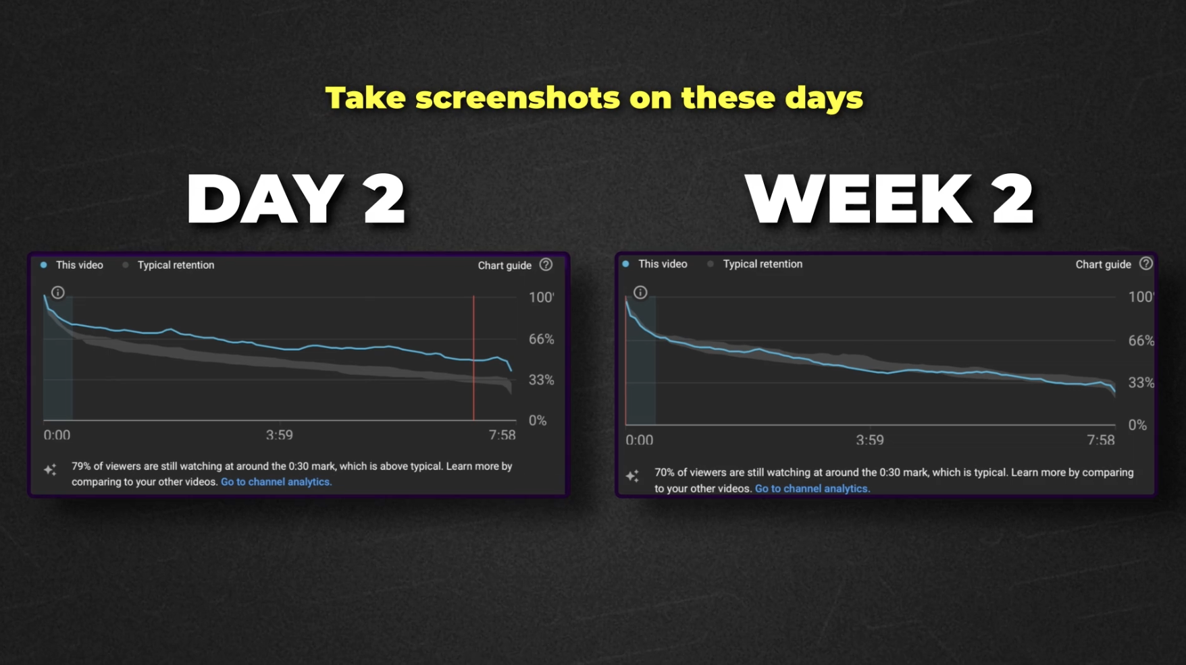

Understanding Data

# **Understanding Data Guide to Measuring YouTube Data: Understanding Your Video Performance**

Before you go in to the YouTube studio ask yourself this  
  
“Am I going in so that I can make changes that will give me a 10x result?” If the answer is no. Don't go in.   
  
Otherwise, when you launch a video, it’s critical to measure the right data to understand **what the video is doing**:

* Is it bringing back your **community** (return viewers)?
* Is it attracting **new viewers**?
* Or is it doing **both**?
* What can I do to improve in the future?

This guide will break down **how to measure performance**, what data matters most, and how to use it to make decisions for future videos.

## **1. What Happens on Launch?**

### **Three Scenarios for Video Performance**

1. **Option 1: Brings Back the Community**
   * **High CTR** and **high retention**.
   * **Low impressions**: YouTube mainly shows it to your core audience.
2. **Option 2: Brings in New Viewers**
   * **Lower CTR** and **lower retention**: Cold viewers are less likely to click and watch.
   * **High impressions**: YouTube pushes the video to new audiences.
3. **Option 3: A Mix of Both**
   * A **mixed bag** where the video attracts both core viewers and new audiences.

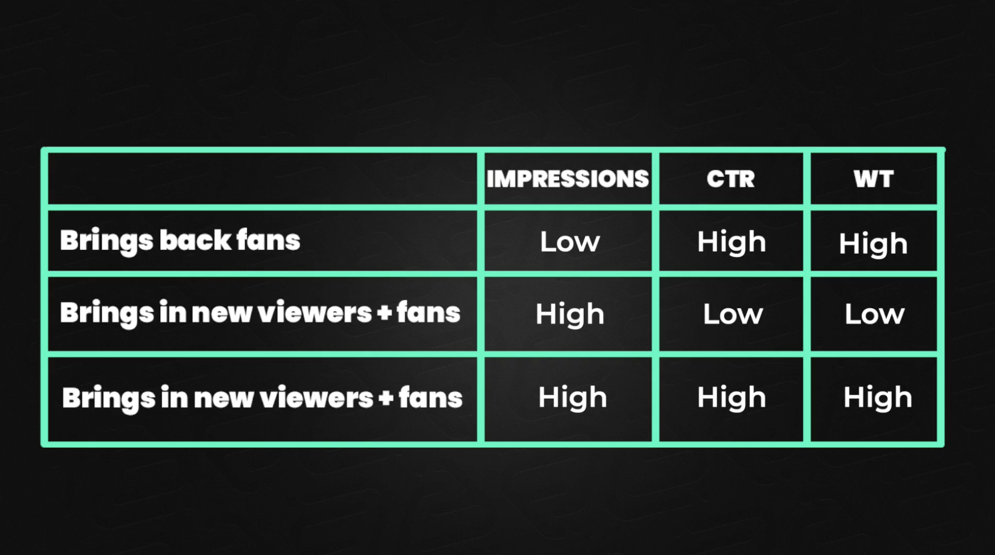

This data is hard to interpret because there are so many different types of viewers that could watch.   
  
Really I just look and go:

* Views low = Didn't work for my fans, warm or cold (one or all of them)
* Views high = Took with my fans, warm or cold (One or all of them
* Views off to a fast start then slowed down = Took with some buckets which eventually depleted.

In most cases you won't have views because of these reasons:

* The way you positioned your video wasn't of interest
* You left the system and didn't base your video on outliers
* Your packaging wasn't very strong, looked unappealing and didn't create curiously
* Your videos are not that great yet
* The script wasn't that good
* Your editing is offputting
* Your presenting isn't strong enough
* You made a video that only appealed to a smaller audience in the first place

### **What to Expect in the First Few Weeks**

* **Smaller Channels**: It’s unlikely much will happen immediately.
* **Established Channels**:
  + Core viewers will dominate early performance.
  + Some core viewers may return after being absent for a long time.
* **Trend/News-Based Videos**: These can buck the trend and attract lots of new viewers early.
* **YouTube Testing**: In the first few weeks, YouTube will test the video with different audiences. You’ll see performance bounce around. The views graph can move up and down.

**Key Insight**: If you see high views on launch, it’s because you have a **community**.

* Videos from average-performing channels rely heavily on their community.
* Without a core audience, those videos would have **zero views**.

This is why **relating to your viewers** and consistently delivering value is key—they’ll keep coming back.

## **2. Steps to Measure Video Performance**

### **Important Note**

There’s no universal “good” or “bad” data. What matters is how the video performs **relative to your channel**.

### **Step 1: Views**

* **Ask**: Are views **higher** or **lower** than expected?
* Keep in mind that some topics naturally have less interest, so lower views might still be normal.

### **Step 2: Impressions**

* **Ask**: Are impressions **high** or **low** compared to your usual timeframe?
* High impressions mean YouTube is testing the video with a larger audience.

### **Step 3: Watch Time**

* **Ask**: Is the watch time higher or lower than your norm?
* Watch time depends on video length, so compare videos of similar duration.

### **Step 4: CTR (Click-Through Rate)**

* **Ask**: Is the CTR high or low relative to the impressions?
* High CTR + low impressions = Likely performing well with your **community** only.
* Low CTR + high impressions = Video is being tested with **new viewers** who are less likely to click.

**Important**: DO NOT make decisions based on CTR alone.

### **Step 5: Engagement**

* **Check**: Likes, comments, shares, and subscribers.
  + **New Audience Indicators**:
    - A spike in **new subscribers** often means the video reached a new audience.
    - Negative comments are also more common from new viewers.
  + **Community Indicators**:
    - Comments and engagement often come from your **core viewers**.

## **3. Key Takeaways**

* **Understand What Your Video is Doing**: Is it bringing in return viewers, new viewers, or both?
* **Views Matter Most**: Start with views, then analyze other metrics to see why they are high or low.
* **YouTube Will Tell You**: Use YouTube Studio data to guide your decisions.
* **Avoid Overreacting to CTR Alone**: CTR is just one metric,always look at the full picture.

## **5. Measuring Checklist**

Use this checklist to analyze your video’s performance:

1. **Views**
   * Are views higher or lower than expected?
2. **Impressions**
   * Are impressions high or low compared to normal?
3. **Watch Time**
   * Is the watch time strong relative to video length?
4. **CTR**
   * How does the CTR compare to impressions?
5. **Engagement**
   * Are comments, likes, shares, and subs higher or lower?
   * Did you gain new subscribers (a sign of new viewers)?
6. **Comments**
   * Are comments mostly from core viewers (community) or new viewers?
   * Negative comments often signal the video reached a **new audience**.

Retention Graphs

# **Retention Graphs The Ultimate Guide to Measuring Retention**

Measuring retention is the key to understanding how well your video is holding your audience's attention.  
  
It’s not about obsessing over every drop but instead understanding the **patterns** in your graph over time and making adjustments that align with your audience's preferences.

This guide will break down how to analyze retention using the **hook**, **example**, **application and end screen** sections of your script, and how to ask the right questions when drops occur.   
  
You'll also get a retention checklist to use after every upload.

## **1. What is Retention and Why Does It Matter?**

Retention measures the **percentage of viewers who keep watching your video** over time. YouTube provides this data as a **retention graph** in YouTube Studio.

* **Flat Sections**: Indicate content that is holding attention.
* **Drops**: Show where viewers lose interest and leave.

### **Retention ≠ Viewer Satisfaction**

* Retention isn’t used by YouTube as a direct satisfaction metric, it’s for *you* to analyze.
* A video with massive drops can still get tons of views and perform incredibly well.  
    
  **Rule**: If your video gets big views, don’t stress about the change to the retention graph. Cold views = worse retention.

The goal is to learn **one thing** from your graph after every upload and improve over time.

## **2. Understanding Viewer Types and Retention Pattern**

**Different audiences respond differently to content sections:**

* **Casual Beginners**: Love stories + big picture ideas.
* **Enthusiasts**: Love stories + deeper, in-depth information.
* **Learners**: Prefer simplified information with more details.
* **Experts**: Want deep, high-level information without fluff.

Analyzing retention helps you see which sections, story, example, or application, are holding viewers' attention based on your audience type.

I nearly always see the application section drop in the retention graph and the example section stay flat, this could be different for you.   
  
If over the **long term you:**

* Notice the example section holding viewers, make your videos more example heavy
* Notice the application section holding viewers, make your videos more application heavy

Always remember:

* Don’t judge a single video’s drop-off and assume, *“Story/Metaphor doesn’t work for me.”*
* A **bad, pointless, boring, or confusing story** will naturally put viewers off.
* Track retention trends over **multiple videos** before making adjustments
* If **new/cold viewers** come in, retention will drop (this is normal).
* If only **hot viewers** watch, retention will look much better.

Your goal: **Eliminate steep drops** in future videos.

## **3. Key Sections of Your Script to Analyze for Retention**

### **1. The Hook (Intro)**

The first 30 seconds are critical. If you lose too many viewers here, the video will suffer. Your retention graph will always drop here some benchmarks to aim for:

**First 48 hours:** This is when your hot viewers will have watched the videos

* Intro below 60% = Make drastic changes (Get in faster, felt like click bait, bad presenting)
* Intro 60-70% = Improvements can be made (Usually means get in faster)
* Intro 70-80% = Good job
* Above 80% = Call yourself Mr Beast

**Questions to Ask**:

* Did the hook set up a clear **problem** or **result**?
* Did the intro match the viewers expectations?
* Was the hook weak and not much of a hook?
* Did you set up enough value in the video?

### **2. The Example Section**

This is where you **show** your point, often with a story, metaphor, or example.

**What to Watch For**:

* If retention is flat here, the example is engaging and holding attention.
* If it drops:
  + Was the story boring or too drawn out?
  + Did the transition fail to explain the reason the story mattered to the viewers?   
    (This is a common problem, if you don't make it clear the reason they need to listen to the story, they wont care)
  + Did you pay off your point too soon?
  + Did you waffle or go on too long?
  + Did you go on a tangent?

**Pro Tip**: Place your example **before** making the point, not after. If you pay off the point first, viewers lose curiosity and leave.

### **3. The Application Section**

This is where you give viewers actionable **information** to apply.

**What to Watch For**:

* Retention often drops here if:  
  + Viewers don’t care about the steps (common with casual audiences).
  + The steps are too long, complex, or poorly explained.
  + The videos becomes more of a tutorial than the viewers wanted (common)

**Example Insight**:

* *My viewers tend to drop off after examples because they prefer big-picture ideas over step-by-step details. But I still include steps because they drive sales and provide value.*

### **4. The Ending**

The ending often sees natural drop-offs because viewers feel like the value is over. The trick is to never wind down a video or summaries. Just set up a new problem and then tell them the next video solves it.

**Questions to Ask**:

* Did I wrap up with value, or was the ending rushed?
* Did I give viewers a clear reason to stay till the end?

## **4. How to Analyze Your Retention Graph**

* Your graph is unlikely to load in less than 48 hours
* If your video has under 200 views, the graph is often not accurate.

**To access your graph:** Click the video > Analytics > Scroll to the bottom of the “overview” section until you see the graph > Click “See more” > Select “New and returning viewers” from the “segments drop down”

You can now see the retention from hot and cold viewers to see how each reacted.

We then look at drops that are obvious.

(Unless you want to be the next Mr Beast or you have a massive abundance of time, don't bother looking at micro drops)

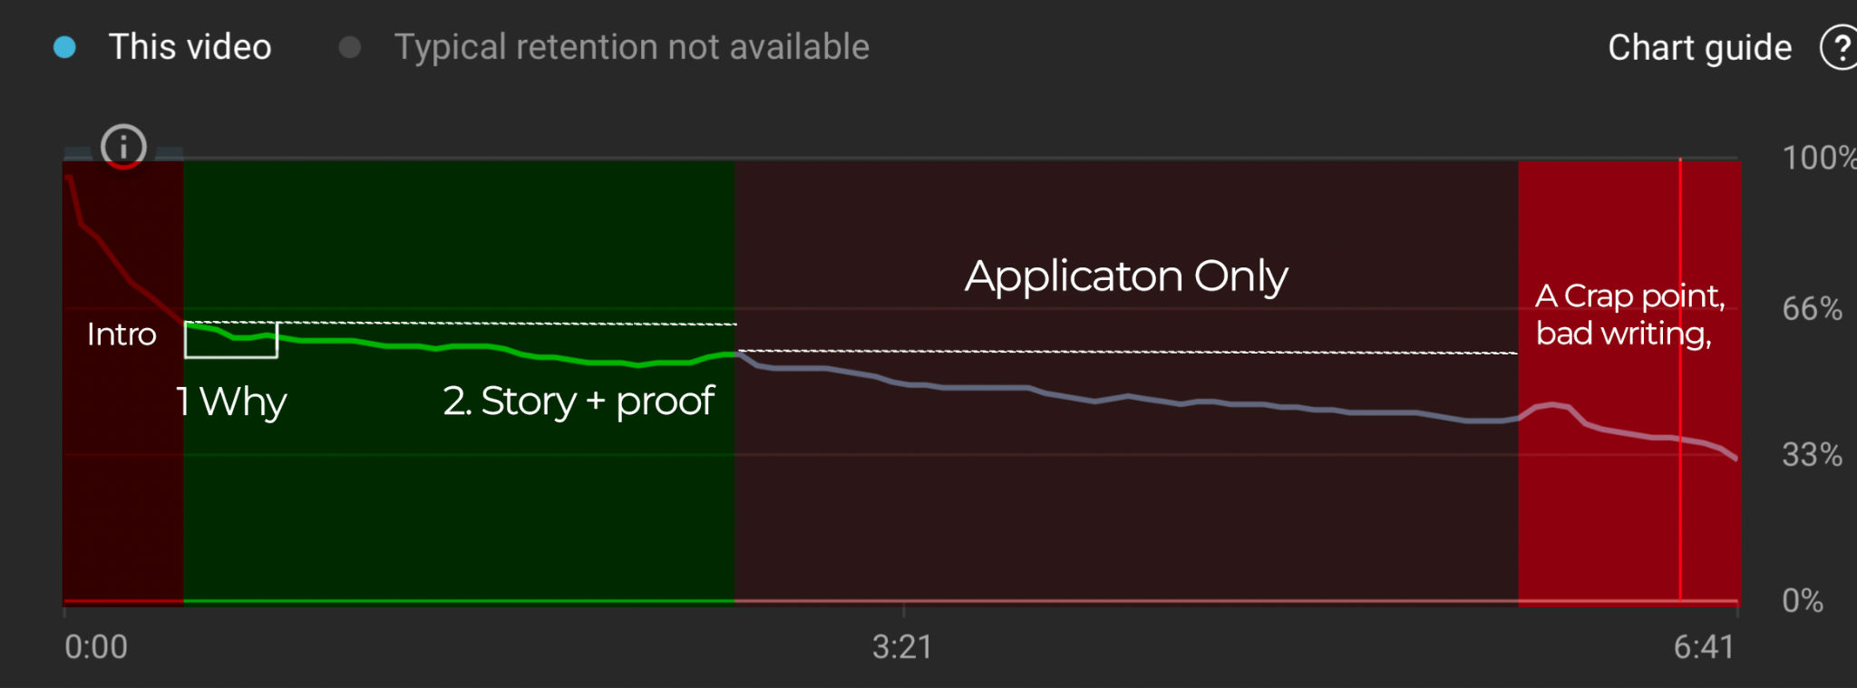

### **Ask These Questions for Every Noticable Drop**

| **Section** | **Questions to Ask** |
| --- | --- |
| **Intro** | - Did I set up a clear problem or result? |
|  | - Was the hook engaging and relevant to the viewer?  - Was the intro too long  - Did the intro not match the expectations of the viewers  - Was my presentation poor |
| **Example** | - Did I pay off my points then give an example? (Common) |
|  | - Was the example/story too long, boring, or irrelevant?  - Was the story one the viewers are likely to have heard before?  - Did my metaphor complicate rather than simplify? |
|  | - Did I fail to write a transition into the example that explained why it mattered to the viewers |
| **Application** | - Were the steps too complex or unnecessary for this audience? |
|  | - Did I lose momentum because of a weak transition from the example?  - Did I waffle on or include info the viewers wouldn't care about?  - Did I pay off the section too soon and leave nothing for the viewers to anticipate? |
| **Overall** | - Did I pay off my points **too early**? |
|  | - Did I draw out any section longer than necessary? |
|  | - Did I fail to keep curiosity alive throughout the script?  - Did I over edit?  - Did I talk too slow?  - Is my presentation up to scratch? (Beginners and smaller channels, this will really impact you a lot until you have more practice, I think a lot of people massively overestimate how good they are on camera) |

## **5. Final Tips: Don’t Overreact to Drops**

Nobody died, stay calm!!!

* **Drops Happen**: No video will have perfect retention. Even the best creators see retention drop-offs.
* **Flattest Sections**: Focus on what’s working, these are often your strongest segments but always look at if this retention was caused by hot, warm or cold viewers. Low views and a flat retention graph means something about the video was of putting (Often the way it was presented/packaged)
* **Great Views Trump Retention**: If a video performs well overall, don’t obsess over minor retention issues.

## **6. Summary: Learn, Adjust, and Grow**

Retention is a **long-term learning process**. Each video you post helps you understand your audience better:

* Where do they lose interest?
* Which sections hold attention?
* What content structure works best for them?

Use your retention graph as a **tool for insights**, not as a reason to panic. Over time, you’ll refine your scripts, improve your retention, and grow your channel.

**Next Step**: In the next module, we’ll cover **how to plan what goes into a video using data** so you can compete with the best creators on YouTube. 🚀